Press release

Date: 2 February 2018

Concealed door hinge carries aluminium door leaves with a weight of up to 140 kg / Self-lubricating bush / Burglar inhibiting door equipment in accordance with RC 2 / Corrosion-resistant according to DIN EN 1670 Class 5 / New FixClick function enables the leaf to be hinged quickly and securely / Optional assembly aid kit / Centrally adjustable / Installation video

Elegant aluminium main doors with the concealed Roto “Solid C 7.140” door hinge

Leinfelden-Echterdingen – Door manufacturers have been producing both reliable and durable connections between door leaves and frames with surface-mounted and butt hinges from the Roto Solid product range for many years. With the “Solid C 7.140” Roto now also offers a concealed door hinge for aluminium main doors. The specialist for door technology develops individual solutions adapted to the aluminium profile for manufacturers who want to work with this door hinge that is visionary in terms of its aesthetics. The new door hinge is available in the colours silver and black.

Impressively powerful
Roto “Solid C” carries aluminium door leaves with a weight of up to 140 kg and an opening angle of up to 110°. The complete product name – Roto “Solid C 7.140” – gets to the heart of the new hinge’s essential features: “C” for concealed, “7” for the durability corresponding to Class 7 of DIN EN 1935 and “140” for the maximum leaf weight. The concealed door hinge has proven its effortless durability even at 400,000 cycles. Its impressive functional life is therefore far beyond the value set by the standard. Thanks to the self-lubricating bush, the Roto Solid C moves any aluminium door without ever requiring maintenance.

The door hinge is suitable for burglar inhibiting door equipment in accordance with RC 2 and is corrosion-resistant according to DIN EN 1670 Class 5, thereby maximising the utility for the builder.

Door installation made easy
The new addition to the product range reveals its other strengths during door installation. The new FixClick function enables the leaf to be hinged quickly and securely and permanently holds the door in the support-bracket. Hinging and unhinging the leaf is made even easier by using the optional assembly aid kit. It contains an air cushion, which facilitates the handling of heavy leaves and protects them from damage, and locking wedges, which aid installation. The wedges fix the hinge supports in position, so that they do not move during hinging.

Centrally adjustable
Once the door leaf is hinged, the height is adjusted between –2 to +4 mm centrally and quickly only at the bottommost hinge. Thanks to the good accessibility of all hinges, the later adjustment of the height and gasket compression (±1.2 mm) as well as the lateral adjustment (±3 mm) are possible without any problems. The assembly tool – also included in the assembly aid kit – can also be used to loosen the spring clip again, if the leaf needs to be unhinged again. The locking cap is also fitted conveniently with the tool after hinging. It is possible to order the components in the assembly aid kit individually.

Installation video
The door hinge expert Roto also shows how to install and adjust the “Solid C” online, with a QR code that can be found on every door hinge. If installers or facility management employees scan this code with their smartphone, the Roto Solid C installation video opens. It gives detailed instructions on how to install and adjust the main door easily and quickly, and is always on hand.

Captions
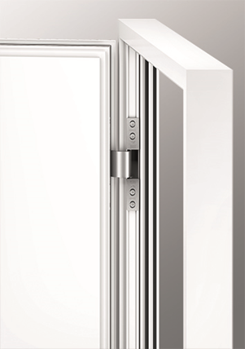

Thanks to the self-lubricating bush maintenance-free, easy to install and centrally adjustable: with the new concealed Roto “Solid C 7.140” door hinge for aluminium main doors, door manufacturers create an aesthetically appealing, secure and durable connection between leaf and frame.

Photo: Roto Roto_Solid_C_7.140_montiert.jpg

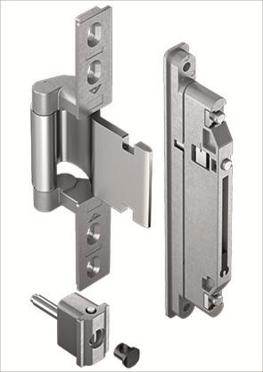

The new concealed door hinge Roto “Solid C 7.140” for aluminium main doors with self-lubricating bush: maintenance-free, easy to install, centrally adjustable.

Photo: Roto Roto_Solid_C_Rahmen_und_Fluegelband.jpg

Print free – copy requested

Publisher: Roto Frank AG • Wilhelm-Frank-Platz 1 • 70771 Leinfelden-Echterdingen • Germany • Tel. +49 711 7598 0 • Fax +49 711 7598 253 • info@roto-frank.com
Editor: Dr Sälzer Pressedienst • Lensbachstraße 10 • 52159 Roetgen • Germany Tel.: +49 (0) 2471 92128-65 • Fax: +49 (0) 2471 92128-67 • info@drsaelzer-pressedienst.de

