Press release

Date: 07 July 2017

'Roto Patio Lift' – the cost-effective easy-to-use aluminium lift&slide system hardware solution / With extension kit, suitable for sashes up to 400 kg overall weight / Optional small gap ventilation sliding system components can be integrated / Espagnolette prepared for the standard inclusion of a profile cylinder / Minimal logistics expenditure in window production

'Roto Patio Lift' for aluminium sliding systems
Strong hardware – strong windows

Leinfelden-Echterdingen – The 'Roto Patio Lift' range offers exceptionally cost-effective and at the same time long-lasting and convenient aluminium lift&slide system hardware. If an extension kit is used, sashes up to a weight of 400 kg can be realised. 'Roto Patio Lift' is therefore also suited for large, triple-glazed sash systems, as are increasingly in demand in central and northern Europe. Lift&slide systems can be created with one or two movable sashes.

Compared with turn-only sashes, sliding systems save space in the room, and protect the window reveal and decoration against damage resulting from uncontrolled slamming of a window sash. The fact that the room-height systems also let a lot of light into the living space is also boosting demand. A sliding window and door manufacturer’s challenge, however, is often in providing favourably priced systems which are yet also robust and convenient to use.

The standard 'Roto Patio Lift' hardware is ideally suited for the production of such systems, because it considerably relieves the burden on production logistics: heavier weight sashes are simply realised with an extension kit and an integrated comfort espagnolette, but with the standard hardware. With 'Roto Patio Lift', manufacturers can thus create sliding sash heights and widths up to 3,000 mm and with a weight up to 400 kg. With a single-sashed variant, it is possible to choose between diagram A (DIN left and right) and G, and with a double-sashed variant between diagrams C, D and K.

Strong, functional, versatile
As standard, 'Roto Patio Lift' opens and closes a sash via lifting, sliding, dropping and locking. Optional centre-closer frame interlocks can be integrated, also enabling the manufacture of a sliding system with night ventilation. Precisely aligned functional components ensure simple and secure operation of the sliding door. The convenient espagnolette for window sashes with a weight from around 300 kg stops the handle from slamming down uncontrollably when the sash drops.

High-quality bogie technology with ball bearing rollers makes the sash smooth-running, and ensures low-noise operation. Every part of the 'Roto Patio lift' is precision made from tested and highly robust materials. For example, the rollers are made from high performance PVC. The bogie and espagnolette housing components are manufactured from stainless-steel and zinc diecast. They thus comply with class 3 corrosion protection requirements in accordance with DIN EN 1670.

Configured for the customer
A lift&slide door fitted with 'Roto Patio Lift' can be provided adapted to various security requirements, at no detriment to window production logistics or installation time. The 'Roto Patio Lift' espagnolette is already prepared as standard for accommodating a profile cylinder, and so fulfils various security requirements – with the minimum of window production logistics expenditure. Window fabricators can add their own company logo using an info clip. The sliding handles in the attractive 'Roto Line' design are available in a choice of colours. Tilt&turn window handles are also available in the same design.

Roto hardware fabricators, as well as their customers, benefit from comprehensive services and practical technical documentation, for example concerning 'Roto Patio Lift'. If customer-specific solutions are developed, Roto documents the hardware configuration developed, and provides fabricator installation and maintenance instructions, as well as end user/customer operating instructions.

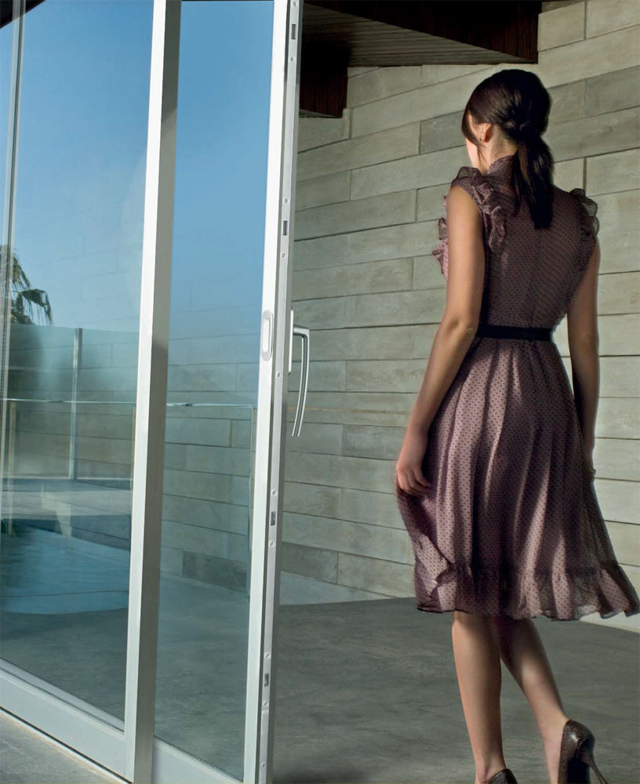
The 'Roto Patio Lift' hardware product range enables aluminium window fabricators to create long-lasting and convenient lift&slide doors exceptionally cost-effectively. If an extension kit is used, this range can also be used for extremely heavy sashes, such as triple glazed sashes, weighing up to 400 kg. Thanks to the convenient espagnolette, end customers find the 'Roto Patio Lift' sliding solutions particularly secure and convenient to operate.

Photo: RotoRoto_Patio_Lift_1.jpg

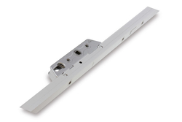
The 'Roto Patio Lift' espagnolette is already prepared as standard for accommodating a profile cylinder. It thus fulfils various security requirements – with the minimum of window production logistics expenditure.

Photo: RotoRoto_Patio_Lift_2.jpg
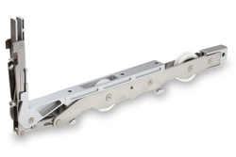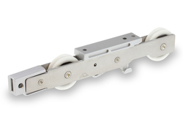
The high-quality 'Roto Patio Lift' bogie technology with high performance PVC ball bearing rollers ensures that sliding doors run smoothly and whisper-quiet. The bogie and espagnolette housing component is manufactured from durable stainless-steel and zinc diecast.

Photos: Roto Roto_Patio_Lift_3.jpg / Roto_Patio_Lift_4.jpg

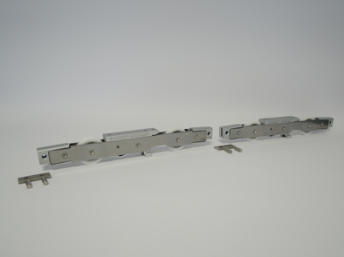
With the new extension kit, Roto offers the opportunity to manufacture lift&slide systems in a variety of sizes, and weight classes up to 400 kg with the 'Roto Patio Lift'. There is no tool changeover time in the production, and less pressure on production logistics.

Photo: RotoRoto_Patio_Lift_5.jpg

Text and image materials are available for download:
http://ftt.roto-frank.com/de/presse/pressemitteilungen/

This is a free reprint article. However, we ask that you send us a copy for our files.
Dr Sälzer Press Service, Lensbachstrasse 10, 52159 Roetgen

Publisher: Roto Frank AG • Wilhelm-Frank-Platz 1 • 70771 Leinfelden-Echterdingen • Tel.: +49 711 7598-0 • Fax: +49 711 7598-253 • info@roto-frank.com
Editor: Dr Sälzer Press Service • Lensbachstrasse 10 • 52159 Roetgen • Tel.: +49 2471 92128-65 • Fax: +49 2471 92128-67 • info@drsaelzer-pressedienst.de

