Press release

Date: 13th/14th November 2018

Roto Roof System Technology: from a product manufacturer to a system service provider / Taking account of the changed needs of market partners / Point of view of professional customers is the critical factor / What craft and trade expect from the “perfect industry partner” / Innovative product range and accompanying expertise to offer added value / From property sales to the “new performance class” //
Current premium generation / Set apart thanks to “Designo R6 / R8 Quadro” / Roof windows systematically further developed / Progress through assembly aids, quality, energy efficiency and variety / Strong demand

Making good even better every day

Kalsdorf / Graz / Bad Mergentheim – “Customers need a business partner, not a supplier”: in mid-November 2018 in Graz, Austria, this is how Christoph Hugenberg explained the fact that craft and trade have an increasingly all-encompassing requirements profile as a result of changed market conditions. Roto Roof System Technology is meeting this demand by continuously developing from a product manufacturer to a system service provider, explained the Member of the Board of Directors to journalists from 16 different countries during the 13th International Trade Press Day held by the construction supplier. This involves a continuous process that is based on the willingness and ability to “improve day after day.” This requires a systematic focus on professional customers and the issues which are relevant to them. Constant dialogue and “active listening” form the basis of this. This is the only way of truly identifying needs and basing your own work around them.

By way of example, Hugenberg referred to the situation in the specialist trade sector, which is exacerbating the pressure for change. He listed important factors which are making their impact felt, such as capacity bottlenecks caused by the serious shortage of skilled labour and the increasing complexity of projects on construction sites. At the same time, digitisation is providing roofers and carpenters with the possibility of new forms and approaches for customer support. Industry, as a partner, is also called on to find and offer suitable solutions here. The same applies to general trends. Examples of this include the desire for speed and simplicity, the integration of roof windows into the entire home automation system, the expectation for installation services and support with professionalisation on the whole.

Systematic investments

The Roto Member of the Board of Directors emphasised that it is only possible to answer the question “what makes the perfect industry partner?” by taking different perspectives into account from the point of view of each target group. Craftspeople value simple installation, good product quality, high energy efficiency and a comprehensive installation and after-sales service. By contrast, when choosing a manufacturer, tradespeople primarily ensure that the services offered will fully win over their professional customers. This applies to the product range, customer care and support in equal measure. It goes without saying that the legitimate interests of private customers, for instance when it comes to “professionalism”, should not be forgotten either.

This is why Roto is systematically investing in an “innovative product range” and in “accompanying expertise to offer added value”. In his overview of the “status quo”, Hugenberg listed steps including expansion of property sales to assist customers in project handling (2013), the establishment of an in-house after-sales service organisation (2015), the acquisition of Swiss company Dachfenster Keller to safeguard a high level of service provision (2018) and the provision of digital support tools such as the professional configurator for craftspeople (2018). Another major step will follow in 2019 with the launch of the “new performance class”. This initially extends to focussing on internal sales and service at headquarters in Bad Mergentheim. The result is simple, fast and efficient (end-to-end) processes for craft and trade. In future, Roto will continue to follow its strategy of collaborating with professional customers in order to develop and produce complete solutions which are in line with market requirements and ideal for use in practical applications. This is “simply the best way of dealing with changes positively.”

New “masterpiece”

The principle of “we do what is relevant from our customers’ point of view” is currently being embodied by the “Designo R6 / R8 Quadro” series of roof windows, according to Stephan Hettwer. As the Director of Customer and Markets at Roto Roof System Technology shared, the innovation launched in 2018 represents the systematic further development of the premium range, which is available in timber and PVC versions. It takes account of the needs of the craft sector, which were ascertained in advance, and specifically the important criterion of ease of installation. This is how the manufacturer has managed to “make a really good product even better”.

By doing so, the highest class in the product portfolio, “Masterpiece”, now features a new top-of-the-range model. Here, just like in the other two product ranges “Craft” and “Benchmark”, the aim is to be “better than the competition” when it comes to aspects that are crucial for professional customers, namely ease of installation, product quality and energy efficiency. Tests performed by TÜV Rheinland also documented this for the “Q” and “Designo” series.

Kurt, Karl and other aids

In addition to the above-average product quality, as proven by this comparative study, Hettwer reported that three other features of “R6 / R8 Quadro” set the product apart in practical use. This firstly applies to the ease of installation, which has been “well thought-out”. A new duo of carrying and crane lifting aids integrated into every window as standard ensures safe handling right up to installation in the roof opening. While the two loops on “Kurt” guarantee full control when transporting roof windows, “Karl” offers outstanding comfort when carrying windows up to 180 cm long, while protecting the fitter’s back at the same time.

The Director of Customers and Markets cited energy efficiency as an additional important advantage. Thanks to the new “blueline Comfort 8C” glazing type, a Uw value of 1.1 W/m²K is achieved even in the basic version. Lastly, the “top model” stands out with its impressive range of variants. This makes it possible to handle any installation situation by taking an approach tailored to the task at hand. In “difficult cases”, Roto is also able to custom-produce the product according to requirements. For market partners, this means that they can demonstrate undoubtedly better expertise in their relationship with customers. Hettwer’s conclusion is that “overall, the advantages offered by ‘R6 / R8 Quadro’ simply provide our professional customers with more security. The popularity of this series, backed up by the encouragingly strong demand, is equally positive.”

Captions

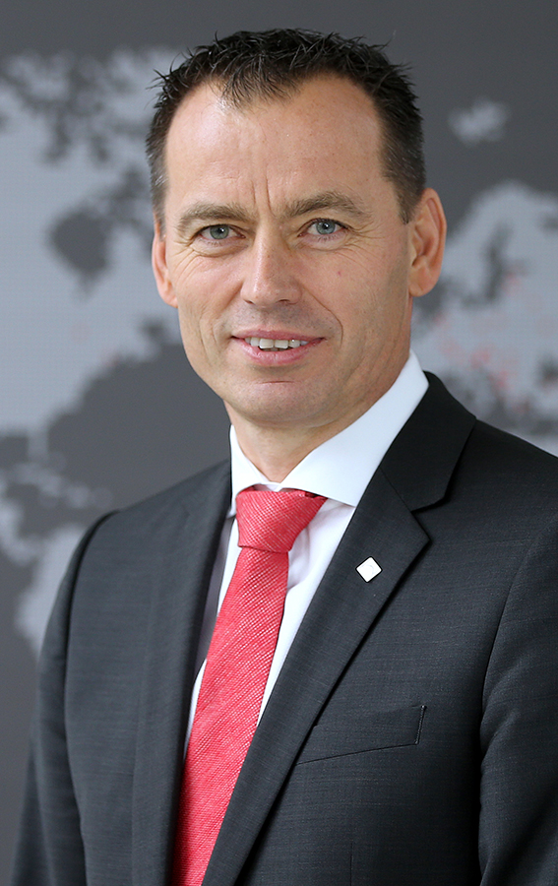
“Professional customers need a business partner, not a supplier”: in mid-November 2018, this was how Christoph Hugenberg explained the fact that craft and trade have an increasingly all-encompassing requirements profile. Roto Roof System Technology is meeting this demand by continuously developing from a product manufacturer to a system service provider, explained the Member of the Board of Directors during the 13th International Trade Press Day held by the construction supplier in Graz, Austria.
Photo: Roto Christoph_Hugenberg.jpg

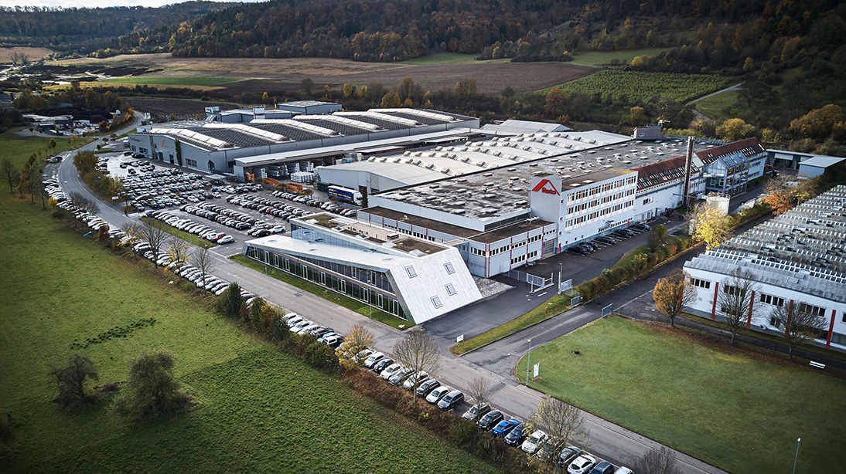
Consistent strategy: roof window specialist Roto aims to continue collaborating with professional customers in future in order to develop and produce complete solutions which are in line with market requirements and ideal for use in practical applications. This is “simply the best way of dealing with changes positively.” The photo shows the German company’s headquarters in Bad Mergentheim.
Photo: Roto Luftaufnahme_Bad_Mergentheim.jpg

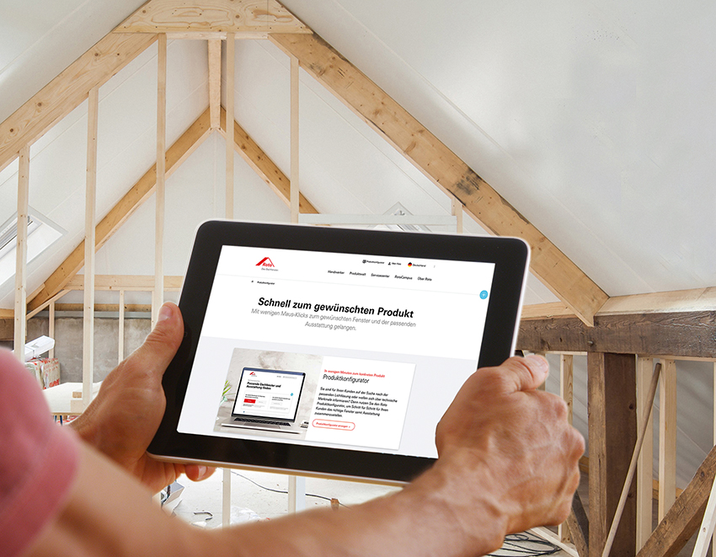
Example of “accompanying expertise to offer added value”: in 2018, Roto added digital support tools to its extensive range of services. This way, roofing professionals are able to use a product configurator, wherever they need it.
Photo: Roto Produktkonfigurator.jpg

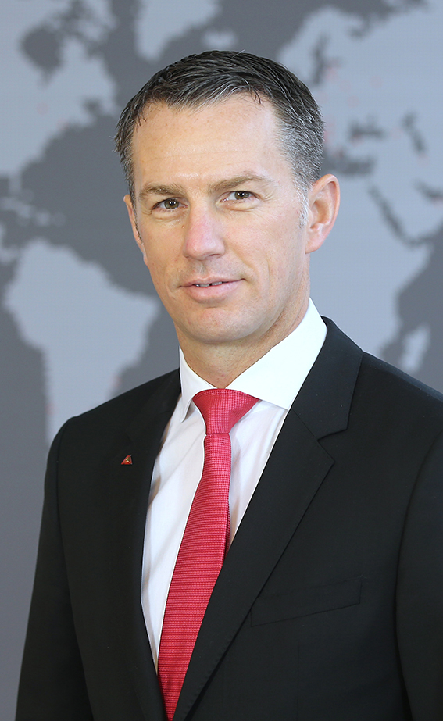
“We do what is relevant from our customers’ point of view”: Stephan Hettwer believes that this principle is also embodied by the “Designo R6 / R8 Quadro” series of roof windows. As the Director of Customer and Markets at Roto Roof System Technology shared in front of specialist journalists from 16 different countries, the innovation represents the systematic further development of the premium range, which is available in timber and PVC versions.
Photo: Roto Stephan_Hettwer.jpg

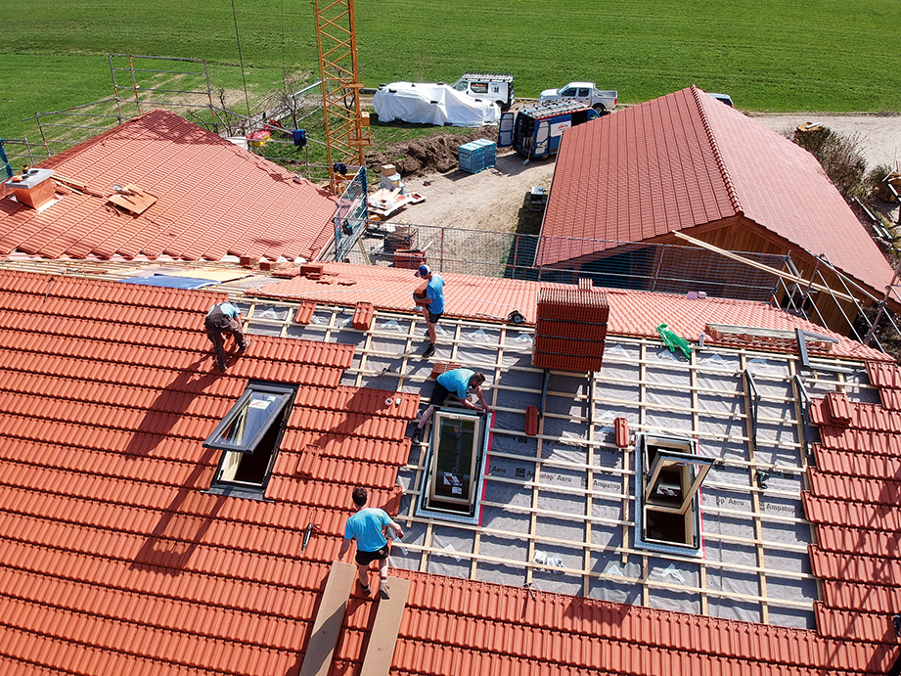
Simply more security: this is how Roto described the totality of the practical advantages offered by the “Designo R6 / R8 Quadro” roof window innovation. Going into more detail, the manufacturer points out intelligent assembly aids, the high product quality, the particular energy efficiency and the impressive range of variants. As the “encouragingly strong demand” proves, these four advantages have quickly impressed market partners.
Photo: Roto Quadro_R8_Einbau.jpg

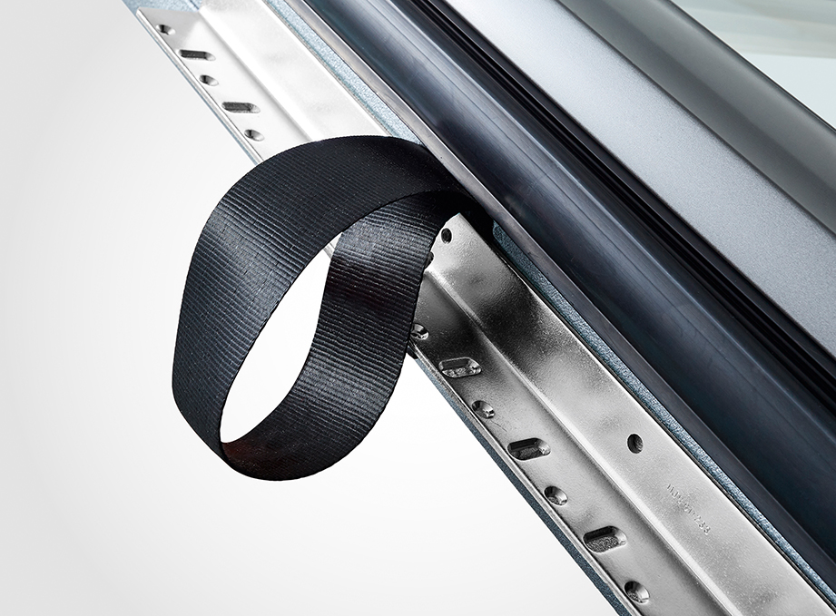
Ease of installation, which is crucial for the craft sector, has been “well though-out”: according to Roto, a new duo of carrying and crane lifting aids integrated into every roof window as standard ensures safe handling right up to installation in the roof opening. While the two loops on “Kurt” (photo) guarantee full control when transporting windows, “Karl” offers outstanding comfort when carrying windows up to 180 cm long, while protecting the fitter’s back at the same time.
Photo: Roto Kurt_Detail.jpg

Print free – copy requested

Publisher: Roto Dach- und Solartechnologie GmbH • Wilhelm-Frank-Str. 38-40 • 97980 Bad Mergentheim • Germany • Tel. +49 7931 5490 414 • Fax +49 7931 5490 90 414 • laura.ley@roto-frank.com • www.roto-dachfenster.de
Editor: Linnigpublic Agentur für Öffentlichkeitsarbeit GmbH • Koblenz office • Fritz-von-Unruh-Straße 1 • 56077 Koblenz • Germany • Tel. +49 261 303839 0 • Fax +49 261 303839 1 • koblenz@linnigpublic.de; Hamburg office • Flottbeker Drift 4 • 22607 Hamburg • Germany • Tel. +49 40 82278216 • hamburg@linnigpublic.de

