Press release

Date: 7th November 2018

Roto’s multilingual team of expert advisers at BAU 2019 / Product innovations from the “experts” for aluminium windows, sliding systems and doors / Exhibits demonstrate property-specific hardware solutions / Roto Object Business advises on standard and special solutions

“The experts”: Roto Aluvision at BAU 2019

Leinfelden-Echterdingen – BAU in Munich is one of the most important international meeting points for everyone involved in designing aluminium facades, windows and doors. This is why, for this trade fair, hardware and component manufacturer Roto will once again be putting together a multilingual team of expert advisers in an “experts area” who can also respond to questions about property-specific special solutions. Many new products and the aluminium specialists from the Roto Group can be found in Hall C1, Stand 319 at the trade fair from 14th to 19th January 2019.

Close exchange with architects, facade designers, system providers and metal constructors characterises the work of the Roto Aluvision business area all year round. During the BAU trade fair in Munich, many threads come together. “Roto Aluvision is relied on all over the world as a partner for design engineers, investors, building element manufacturers and facade manufacturers – from the initial idea through to implementation,” explains Jordi Nadal, Managing Director of Roto Aluvision Europe and Americas. “We are looking forward to learning more about interesting new projects from our business partners at the trade fair stand in 2019, too.”

Property-specific solutions
Thanks to an especially extensive and high-quality standard product range, Roto Aluvision is able to provide even customised solutions for groundbreaking projects. “The Roto Aluvision team understands the visions of architects and design engineers. This is what makes finding ideal solutions for these projects simple for us,” explains Nadal. “We hope that as many trade fair visitors as possible let us take them with us into the world of Roto’s expertise.”

Modern hardware for groundbreaking facades
Facades created by well-known architects are presented in short film sequences on large projection surfaces on the external walls of Roto’s stand at the trade fair. Inside the stand, which is around 260 m² in size, the Roto Aluvision team provides information about new additions to the standard product range and numerous special solutions that have been developed over the last two years for properties planned by well-known design engineers. The “panel of experts” gives visitors the opportunity to find out which projects inspire them and which of their own projects the “expert company” Roto can assist with.

Wide range – comprehensive service
“In Munich, we are impressing with the projects we have carried out,” states Nadal. “Since we now offer an incredible number of quality-relevant components for aluminium windows and doors, with our hardware, handles, locks, glazing methods and sealing profiles, a visit to our trade fair trade is definitely worthwhile for anyone who designs or produces aluminium building elements or facades. Roto Aluvision provides fast, flexible, reliable, face-to-face support – and all this on a global scale, whenever and wherever customers need us.”

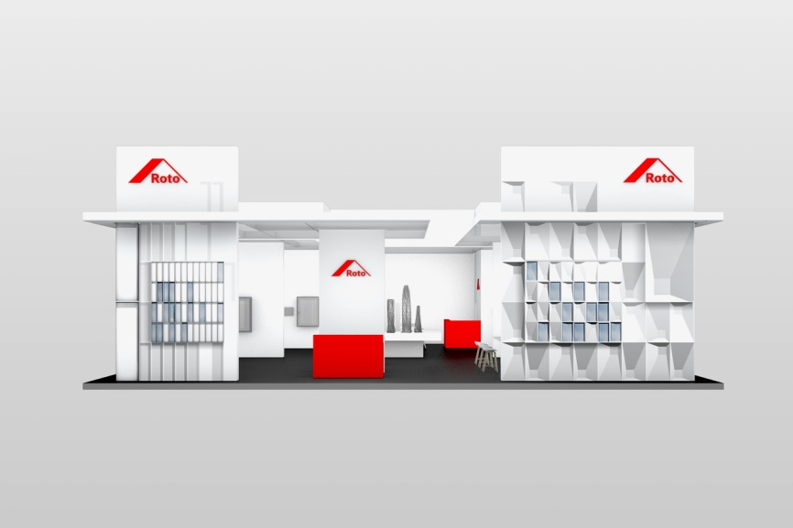
At BAU 2019, Roto Aluvision will once again be putting together a multilingual team of expert advisers who can provide valuable advice also about property-specific hardware solutions as part of the “panel of experts”. Many new products and the aluminium specialists from the Roto Group can be found in Hall C1, Stand 319 at the trade fair from 14th to 19th January 2019. The motto of this year’s stand is “The experts”. The Roto Group offers an incredible number of quality-relevant components for aluminium windows and doors with hardware, handles, locks, glazing methods and sealing profiles. Jordi Nadal, Managing Director of Roto Aluvision Europe and Americas, is certain that this makes a visit to the trade fair stand worthwhile for anyone who designs or produces aluminium building elements and facades.

Photo: Roto Roto_BAU_2019.jpg

Text and images are available to download:
http://ftt.roto-frank.com/en/press/

Print free. Copy requested.
Dr. Sälzer Pressedienst, Lensbachstraße 10, 52159 Roetgen, Germany

Publisher: Roto Frank AG • Wilhelm-Frank-Platz 1 • 70771 Leinfelden-Echterdingen • Germany • Tel.: +49 711 7598-0 • Fax: +49 711 7598-253 • info@roto-frank.com
Editor: Dr. Sälzer Pressedienst • Lensbachstraße 10 • 52159 Roetgen • Germany • Tel.: +49 2471 92128-65 • Fax: +49 2471 92128-67 • info@drsaelzer-pressedienst.de

