Press release

Date: 12th / 13th November 2019

Roto Frank Fenster- und Türtechnologie: stable in 2019 despite major market fluctuations / Differing developments in the regions / Turnover at the level of the previous year: a success “all in all” / Product strategy takes account of global trends / Priority for tangible customer benefits / Comprehensive range of hardware as the industry benchmark / Growth through performance / “Roto NX” Tilt&Turn system further expanded / Hinge side T for timber windows available / Smart Home ready with wireless sensor / Upcoming market launch of new V cam / Also used on sliding systems

Hardware specialist at home in any market

Bad Mergentheim / Leinfelden-Echterdingen – (rp) With an up-to-date status report, information on the product strategy and a new man at the helm, Roto Frank Fenster- und Türtechnologie GmbH (FTT) presented itself as an independent division in the restructured group for the first time at the 14th International Trade Press Day in mid-November 2019. At this event, Marcus Sander, the Chairman of the Board of Directors at the company since the middle of the year, rated the global development of the hardware specialist with its around 3700 employees around the world as “stable on the whole” in 2019. Against the background of significant market fluctuations, often caused by geopolitical factors, this should be judged as a success all in all.

Based on various studies* and resulting calculations or estimates, Roto put the global market volume of the hardware industry for 2018 at €3.41 billion. According to this, the three most important segments were Tilt&Turn with €882 million (25.8%), Door with €862 million (25.2%) and Sliding with €747 million (21.8%). “It’s obvious that, as a global manufacturer of hardware technology for windows and external doors of all opening types and frame materials, we go to great lengths to cultivate individual markets in each region,” explained Sander. We achieve this in 15 factories around the world, with 28 logistics and distribution centres, as well as with 26 sales sites and the support of additional distribution partners.

Differentiated image

It is apparent from the results up to 30th September that in 2019 the FTT division achieved a level of turnover equal to that of the previous year overall. Although this fell short of expectations, this was primarily due to geopolitical factors over which the company has no influence. According to Sander, these factors resulted in major market losses and therefore also business losses in some cases. He named China as the most striking example of this. Here, the trade dispute with the USA is causing a dramatic market downturn, meaning that Roto “could not achieve its ambitious goals.”

On the other hand, the results for North America were extremely positive. Here, strong growth in turnover and market shares has been recorded, which was mainly down to “extremely successful new customer business.” Helped by good market positioning, there was a considerable turnover increase in Southern Europe too in 2019.

The Head of FTT reported a “solid performance” on the whole for the rest of Europe. With regard to the situation in Germany in particular, a slight decrease in turnover was noted at the end of October. This can be explained by the generally disappointing market development. This is shaped by an overdue new building boom and a weak renovation business due to a lack of trade capacity. As Roto has already addressed multiple times in recent years, Sander also emphasised that: “the variable for our business is, as is well known, the German producer market. As a result of the continuously increasing import pressure, it may once again be in decline in 2019.”

Two examples and a general conclusion

In addition to an overview of the economic situation, the Chairman of the Board of Directors also addressed the current and future product strategy of the window and door technology specialist. The hardware product range must primarily ensure tangible customer benefits, for manufacturers and end users alike. To reliably offer the ideal products with specific benefits, knowledge about usage habits, individual needs and therefore ultimately global trends is indispensable.

This includes increasing life expectancy. This automatically and continuously leads to growing interest in user-friendliness and accessibility. Intelligent hardware technology, such as the comfort window and the accessible Tilt&Turn balcony door from the “Roto NX” range or the “E-Tec Drive” electric window drive-unit, provides outstanding solutions for this.

Another example is extreme weather situations, which are becoming increasingly frequent due to climate change. These expose windows to extreme loads in terms of tight sealing and strength while the trend for ever larger and heavier elements is also gaining ground. With the “Patio Inowa” sliding system, Roto has a product to respond to this challenge that has already won an award in the USA for its outstanding performance.

As a result of these trends and others, Sander is of the opinion that Roto has to offer the full spectrum of hardware technology for the smallest windows through to large and very heavy windows on the one hand, and affordable standard elements up to high-end solutions on the other. In his words, the company is responding to the challenges of the “extreme differentiation” with sophisticated product ranges: “we see ourselves as the benchmark in the industry.” FTT member Deventer also underlines this. The precise matching of gasket and hardware, which is ensured from the very outset, offers customers crucial added security.

The new Head of FTT concludes by stating that: “I’m certain that, in future, we will still be able to offer our customers around the world a superior package of products and services. At the same time, this is the best concept for sustainably exploiting our own opportunities for growth in turnover and market shares.”

New additions from the new flagship

The “Roto NX” Tilt&Turn hardware system introduced two years ago plays a crucial role in this strategy. In Bad Mergentheim, the headquarters of the Roof System Technology System division, Hartmut Schmidt informed the international specialist journalists about the division’s “continuous further development” in addition to the “steps taken so far” in expanding the product range. A new development is that it has also been available for timber windows since October 2019. According to the Director of Product Innovation, “the first customers in Germany and Switzerland are already beginning the changeover process.” The hinge side T is designed for a sash weight of up to 150 kg and therefore for contemporary, large window designs. It also impresses with the same practical advantages as its PVC counterpart. Concealed screws, cover caps with an optimised shape and powder-coated surfaces in numerous colour variants such as “titanium” characterise the attractive design.

The integrated night ventilation in the standard version helps ensure greater comfort and an improved room climate. In addition, when the “TiltSafe” window is used in conjunction with additional components, burglary inhibition in accordance with RC 2 can be achieved in the tilt position. Besides long-term functional performance class H3, the “Roto Sil Level 6” surface based on an innovative coating technology with microcrystalline structure guarantees special security and durability. It is used for connection components subject to high stress, such as rivets, bolts and sliding elements, and offers corrosion protection beyond the requirements of the standard, especially in critical zones.

“NX”, however, is not just Tilt&Turn hardware; it is a system with added value. This can be seen, for example, in the state-of-the-art “Smart Home ready” capability. This is centred around the new “Com-Tec” wireless sensor for installation in the corner drive. In contrast to many other models, it can detect whether a window is actually locked or only on the latch by scanning the hardware. A vibration sensor alerts of any attempts to break in through the window. This advance for greater security and comfort is available in three different versions and also for the “Patio Alversa” sliding systems. What’s more, the product range also includes wired sensors in addition to the wireless ones. According to the Director of Product Innovation, they are ideal for installation in properties and can be coupled with VDS-certified burglar alarms, for example.

Even better and more robust

In the first quarter of 2020, the hardware series will be expanded to include another module in the form of the new V cam. Its further enlarged rebate-clearance tolerance range facilitates rapid installation, as it requires less configuration and adjustment work. The integrated fine-pitch thread makes precise height adjustment possible, while minimising the risk of collision with other components. The high and uniform gasket compression, achieved thanks to the minimal cam movement, also prevents energy loss. Outstanding protection against burglary rounds off the many benefits. All of this makes the new locking cam even more robust and reliable.

Schmidt lastly highlighted the fact that the comprehensive “NX” range is also used on the “Patio Alversa” and “Patio Inowa” sliding systems. This results in less complexity and a reduced number of items. Both of these factors are likewise from the “tangible customer benefits” category.

* Germany Trade & Invest, Euroconstruct, Interconnection, CAB, OKNA Marketing, VFF, Drucker Report

Captions

Marcus Sander answered journalists’ questions for the first time during the 14th International Trade Press Day. The new Chairman of the Board of Directors at Roto Frank Fenster- und Türtechnologie GmbH rated the global development of the hardware specialist as “stable on the whole” in 2019. Based on a “superior portfolio of products and services”, he expressed his conviction that the company will be able to consistently exploit the future opportunities for growth.
Photo: Roto / Marcus_Sander.jpg

“It’s obvious that, as a global manufacturer of hardware technology for windows and external doors of all opening types and frame materials, we go to great lengths to cultivate the market in each region,” explained the Chairman of the Board of Directors at Roto Frank Fenster- und Türtechnologie to an audience of international specialist journalists in mid-November 2019. One result of this is many case study properties across the globe. The photo shows the Marienturm (centre) in the financial centre of Frankfurt am Main. This building is equipped with 4300 Turn-Only windows with the “AL Designo” concealed hardware and 1675 ventilation flaps with projecting scissor stays from the “PS Aintree” range.
Photo: © Pecan Development GmbH / Marienturm.jpg

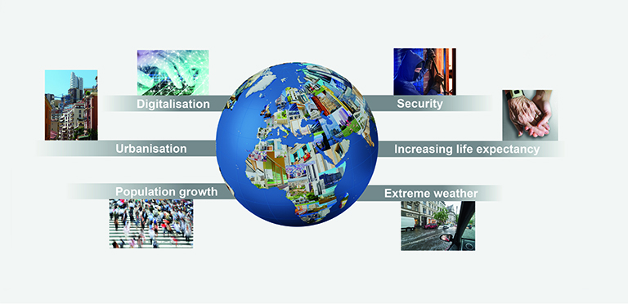

Hardware product ranges which improve quality of life and create tangible customer benefits require a knowledge of global trends, among other things. As was explained during the 14th International Roto Trade Press Day, these include the sharp increase in extreme weather situations and increasing life expectancy.
Photo: Roto / global_trends.jpg

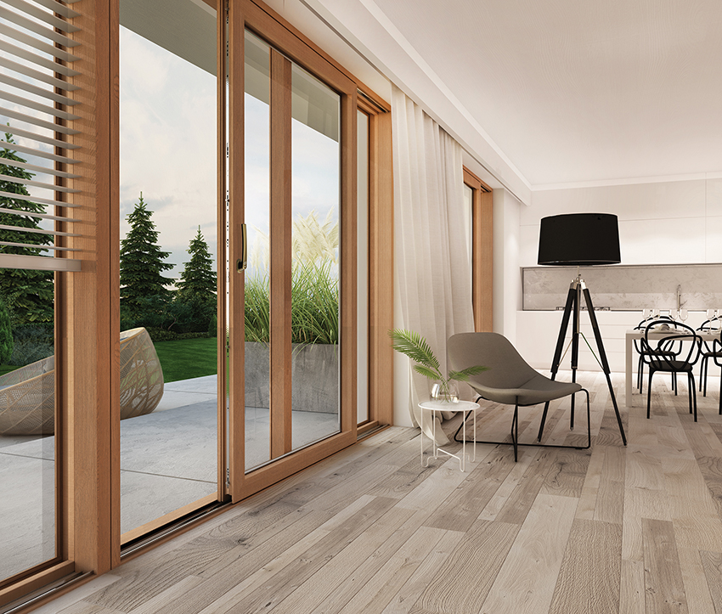

International window and door markets are shaped by “pronounced differentiation.” To address the associated challenges, the hardware specialist’s product portfolio covers the full spectrum of the necessary technologies. An example of this is the “Patio Inowa” sliding system (photo) which recently won an award in the USA for its outstanding performance in terms of tight sealing and strength.
Photo: Roto / Roto_Patio_Inowa_housing_situation.jpg

In mid-November 2019, Hartmut Schmidt presented to international trade press further developments to the “Roto NX” Tilt&Turn hardware system launched two years ago. As the Director of Product Innovation stated, these include the hinge side T for timber windows and the “Smart Home ready” function supported by the “Com-Tec” wireless sensor. While these two new products are already available on the market, the launch of the V cam is planned for the first quarter of 2020.
Photo: Roto / Hartmut_Schmidt.jpg

The new hinge side T from the “Roto NX” range is designed for timber window and balcony door designs with a sash weight of up to 150 kg. According to the manufacturer, the night ventilation that is integrated even in the standard version of the Tilt&Turn hardware system helps ensure greater comfort and an improved room climate. In addition, when the “TiltSafe” window is used in conjunction with additional components, RC 2 burglary inhibition can be achieved in the tilt position.
Photo: Roto / Roto_NX_hinge_side_T_TiltSafe.jpg

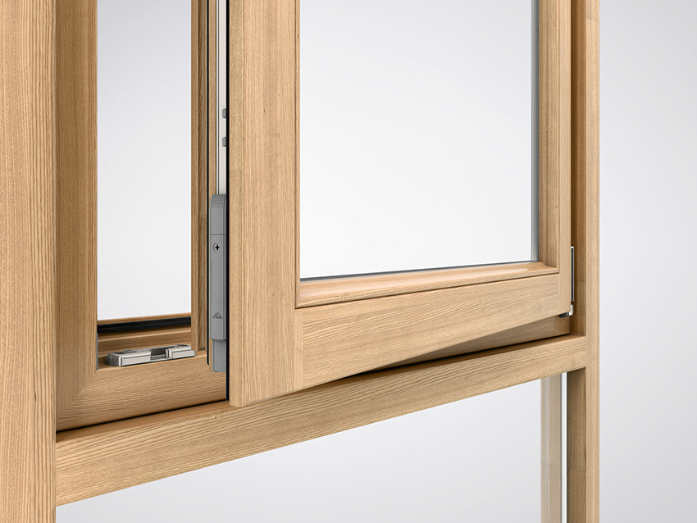

The manufacturer describes the “Roto NX” Tilt&Turn hardware generation as a “system with added value.” This can be seen, for example, in the state-of-the-art “Smart Home ready” capability. The basis for this is the new “Com-Tec” wireless sensor for installation in the corner drive.
Photo: Roto / Roto_Com_Tec_wireless_sensor.jpg

In the first quarter of 2020, the “Roto NX” hardware series will be expanded to include another module in the form of the new V cam. As the producer reports, the list of positives includes a further increased rebate-clearance tolerance range. It requires less configuration and adjustment work and therefore facilitates rapid installation.
Photo: Roto / Roto_NX_V_cam.jpg

Print free – copy requested

Text and photos are included on the press kit stick in the form of Word and JPEG files. They are also available to download at:
https://ftt.roto-frank.com/en/press/press-releases/

Publisher: Roto Frank Fenster- und Türtechnologie GmbH • Wilhelm-Frank-Platz 1 • 70771 Leinfelden-Echterdingen • Germany • Tel. +49 711 7598 0 • Fax +49 711 7598 253 • info@roto-frank.com
Editor: Linnigpublic Agentur für Öffentlichkeitsarbeit GmbH • Koblenz office • Fritz-von-Unruh-Straße 1 • 56077 Koblenz • Germany • Tel. +49 261 303839 0 • Fax +49 261 303839 1 • koblenz@linnigpublic.de; Hamburg office • Flottbeker Drift 4 • 22607 Hamburg • Germany • Tel. +49 40 82278216 • hamburg@linnigpublic.de

