Press release

Date: 12th / 13th November 2019

Roto Frank Dachsystem-Technologie: momentum generated by the company itself / Moderate turnover increase in 2019 in difficult markets / Renaissance for renovations? / Growth in Germany too / Positive results throughout Europe / Systematic professional strategy / “New performance class” for even greater customer satisfaction / Concept implementation at every level / Success through standing out from the competition / Journalists experience a “somewhat different factory tour”

“Full focus on customer benefits”

Bad Mergentheim / Leinfelden-Echterdingen – (rp) “Since the markets are not giving us any momentum, we have to create it for ourselves. On the whole, we managed to achieve this in 2019 once again.” This is how Christoph Hugenberg summarised the current development of the Roof System Technology division (DST) during the 14th International Roto Trade Press Day in mid-November. As the Chairman of the Board of Directors of the roof window producer explained at its main site in Bad Mergentheim (Germany), this is reflected in a “moderate turnover increase” compared to the previous year. To remain on a growth course in future, what matters most is “satisfied and, in the best-case scenario, enthusiastic customers.” The company, with around 1200 members of staff, is consistently focused on this motto. The basis for this is continuous investment in products, services, digitalisation, modernisation and fast, streamlined and efficient processes.

According to studies by the B+L Institute, the general construction volume in Western and Eastern Europe will only show a slight increase over the next few years. There is, however, good reason to hope that the growth, which has until now mostly been driven by new buildings, will once again move more towards the renovation market, which is relevant to Roto. This is indicated by a housebuilding study, which, in some cases, reports much greater investment in renovation than in new buildings for important core countries. This applies especially to Germany, but also to Italy, the United Kingdom and France.

A look at the figures for roof windows, meanwhile, paints a “rather sobering picture.” The numbers show a dramatic decline in roof windows in Europe from 2012 to 2018. This is down to the dominance of flat roofs in new buildings, while roof windows are mainly used in renovations. Although Germany still takes number 1 place, it has lost some ground to France.

Virtually only positives

In this market environment, which is difficult on the whole, Roto DST was able to record “satisfactory economic development within the company” according to Hugenberg. To go into more detail, at the end of September 2019, he reported a “good single-digit turnover increase” for Germany, which continues to be the most important market by a significant margin. This is thanks to factors such as an “optimised product mix.” In his words, the year was shaped by a strong first quarter and two weak months (May and June) followed by a resurgence in the third quarter.

In Western Europe, the figures are at the same level as the previous year. From a positive point of view, this is particularly remarkable because “we withdrew from the United Kingdom.” This decision, which will certainly entail sacrificing some turnover, was not motivated by Brexit but due to aggressive online sales and the resulting departure from professional window installation.

Business in Eastern Europe is offering much more positive prospects for the Head of DST. A “dramatic turnover increase” was recorded here, as in 2018. The producer is therefore very happy with the single-digit growth in Southern Europe, as this meant that it could buck the negative market trend in Austria and Switzerland. Lastly, in the classic export business, the good development in Ukraine, Croatia and other eastern countries should also be highlighted. Hugenberg: “now our task is to consolidate what we achieved in the fourth quarter and perhaps even further improve on it.”

In general, the priority is to find the ideal solutions for these “challenging market conditions.” These include shortage of staff and staff qualification (tradespeople capacity), the price pressure caused by increasing transparency (securing margins), new technologies (Smart Home), increasing expectations for products and services (e.g. preassembly, energy efficiency, logistics) and, in particular,y changed sales channels (online shops, etc.). This approach matches up with Roto’s strategy of always developing and implementing the necessary concepts to the benefit of the roof professionals in trade and retail. In a nutshell: “full focus on customer benefits.”

Specific examples

According to Stephan Hettwer a diverse package of measures known as the “new performance class” currently embodies this motto. The Director of Customers and Markets explains that faster and more efficient processes at every level are behind this. Whether product innovation, product manufacture, service, marketing or sales, what really matters is placing the customer’s point of view at the forefront.

Hettwer demonstrated the practical implementation of the concept using several examples. In the “presales and ordering” sector, Roto is providing increased support to market partners with digital instruments such as a product configurator and a chatbot dedicated to “sun protection.” The latter is a text-based dialogue system which offers a free consultation service that is available 24 hours a day with associated product recommendation. The new online tool makes it much easier for tradespeople and retailers to provide tailored information to builders, while saving time in the process. The range of digital tools is being gradually expanded.

Another important field for the “new performance class” is customer support. For instance, the “training truck”, which has been used since 2019, provides roof professionals with information about Roto’s entire range “on-site”, while also allowing them to arrange individual product training. The opportunity to “experience partnership first-hand” received an extremely positive response. This also applies to specific project support, which results in impressive joint solutions for planning and implementing challenging projects.

Everything for satisfied customers

In the “products” category, the Director of Customers and Markets went into greater detail using “Designo i8 Comfort” as an example. The electric Top-Hung pivoting window, which is currently the only one of its kind on the market, is in line with the company’s motto of making the customer’s point of view the basis of its actions, thanks to the outstanding ease of installation and “Smart Home ready” quality, among other features. Hettwer announced that a further improved operating concept for the series would be introduced in spring 2020. This also results from the practice of “incorporating customer feedback.”

While the individual elements may differ, the “new performance class” ultimately only has one objective: to continuously increase customer satisfaction by standing out from the competition. This is the key to the company’s own growth. Roto will therefore continue to take this knowledge into account in future.

Information event for select guests

At the start of the event, a “somewhat unique factory tour” was on the agenda for the international specialist journalists. Its motto: “from the product idea to product manufacture.” Experts from the company demonstrated its implementation using the “Designo i8 Comfort” as an example. The tour started in the innovation centre, which is around 1600 square metres in size and features striking architecture so that visitors can see how this building embodies creativity and team spirit from its appearance alone. Product development and marketing work in close collaboration here in order to turn market and customer requirements into practical solutions.

The next stop leads the media representatives into production. In the Bad Mergentheim factory, which has already won multiple awards, the company demonstrated how a product idea is turned into the actual product – including test installations and quality tests. The information event concluded in the “Campus” training centre with a presentation of the electric roof window, which was the focal point of the whole tour.

The division’s central site covers an area of around 70,000 square metres in total. Around 35,000 square metres of this site are dedicated to production, storage and logistics, while administration and displays take up around 5500 square metres. PVC roof windows, sun protection accessories, insulating glass and flashing are produced in Bad Mergentheim.
Captions

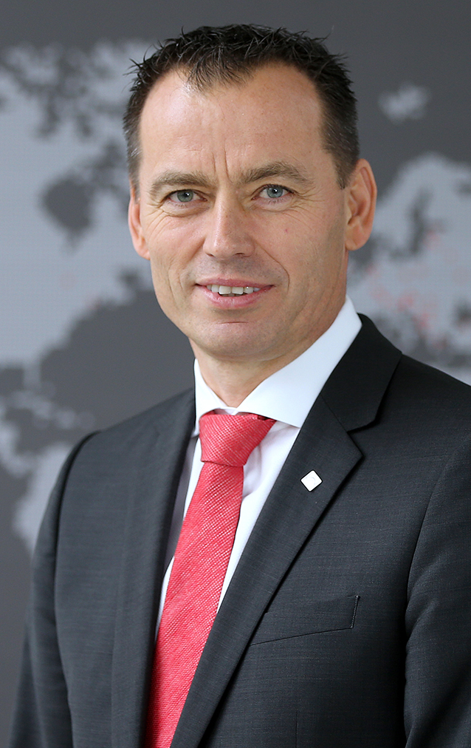
“Since the markets are not giving us any momentum, we have to create it for ourselves. With a moderate turnover increase, on the whole, we managed to achieve this in 2019 once again.” This is how Christoph Hugenberg summarised the current development of the Roof System Technology division during the 14th International Roto Trade Press Day in mid-November. The Chairman of the Board of Directors explained that, in future, the roof window producer is hoping to remain on a growth course.
Photo: Roto / Christoph_Hugenberg.jpg
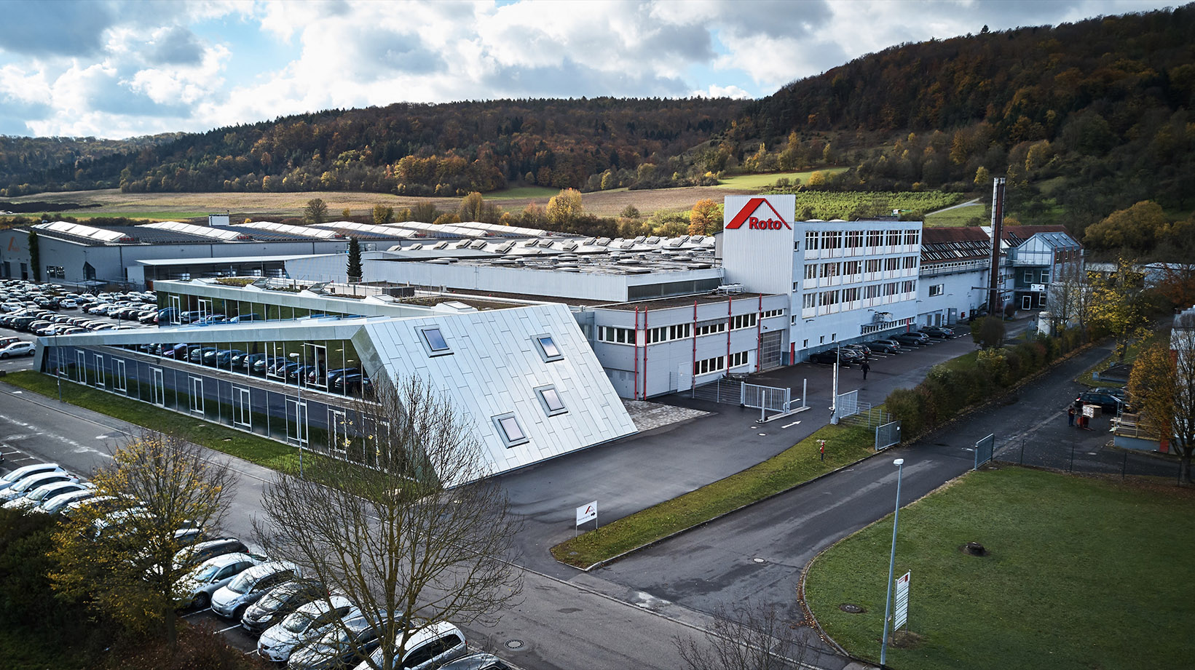
Venue for the 14th International Trade Press Day: the headquarters of Roto Frank Dachsystem-Technologie in Bad Mergentheim. The area covering around 70,000 square metres houses production, storage, logistics, administration, displays, the “Campus” training centre and the innovation centre (in the foreground).
Photo: Roto / headquarters_Bad_Mergentheim.jpg

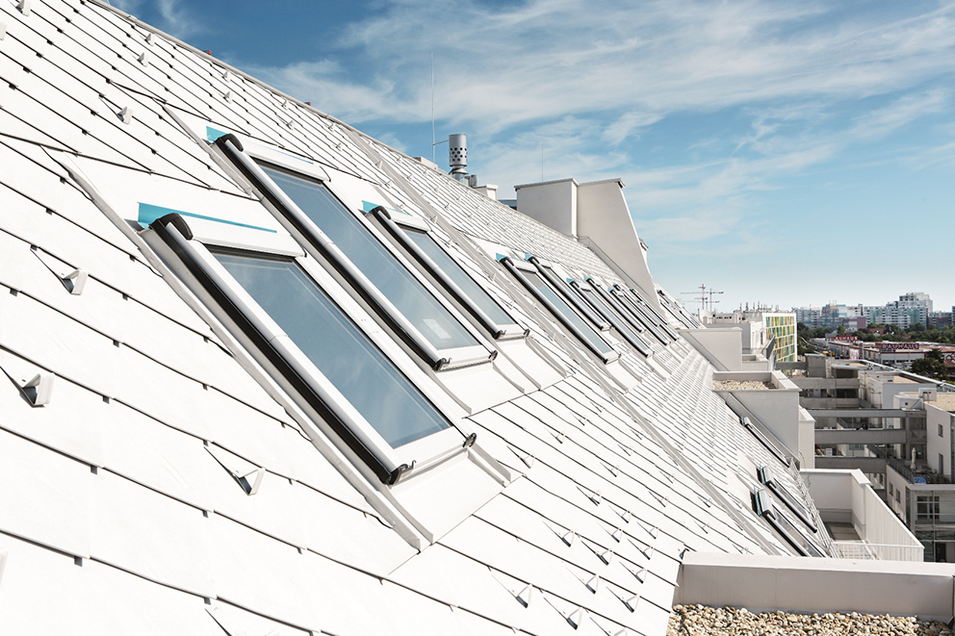
Roto Frank Dachsystem-Technologie reported “satisfactory economic development within the company” for 2019. This applies both to business in the core market of Germany as well as the performance throughout the rest of Europe. The image shows a property in Vienna that is equipped with the “Designo R8 / R6” roof windows.
Photo: Roto / building_object_Wien.jpg
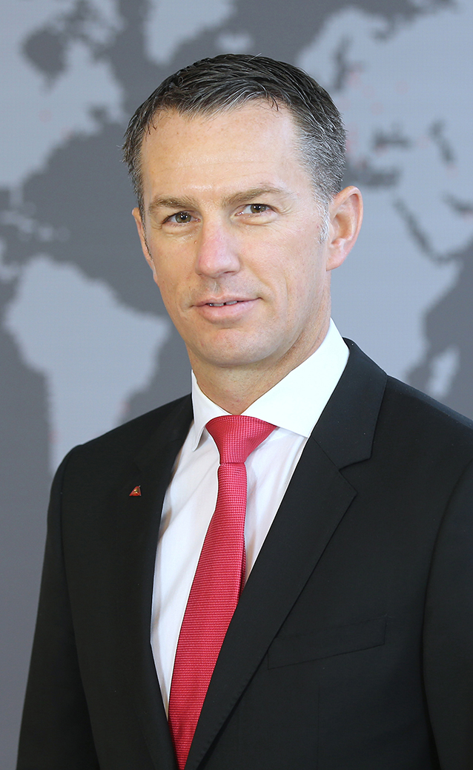

Stephan Hettwer presented the “new performance class” concept in theory and practice to international specialist journalists in mid-November 2019. The Director of Customers and Markets at Roto Frank Dachsystem-Technologie explains that a diverse package of measures is behind this. This package of measures implements into practice the roof window specialist’s motto of always acting from the customer’s point of view.
Photo: Roto / Stephan_Hettwer.jpg

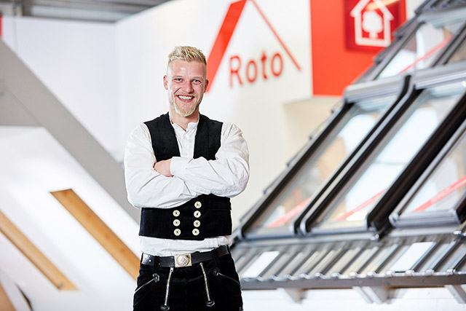
“Satisfied customers are the key to the company’s own growth.” That is the motto of Roto Frank Dachsystem-Technologie. This is why the roof window specialist is focusing on this in all fields.
Photo: Roto / craftsman.jpg

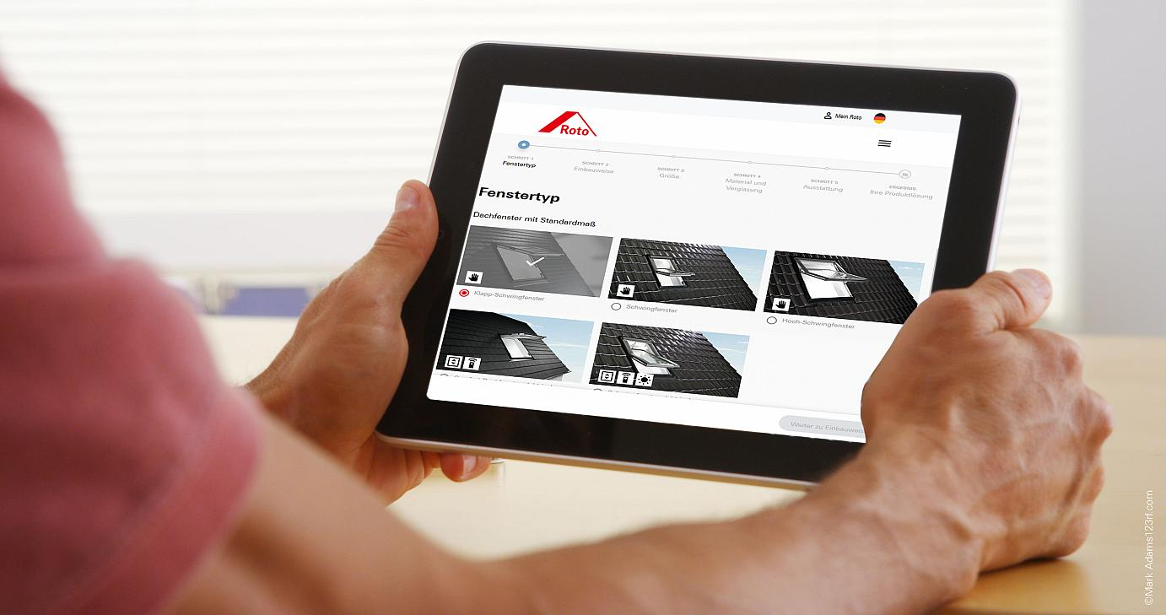
Example of the “new performance class” in the “presales and ordering” sector: with digital support tools, Roto is aiming to make work simpler for roof professionals and actively appeal to new customers. These currently include a product configurator and a chatbot dedicated to “sun protection.”
Photo: Roto / configurator.jpg
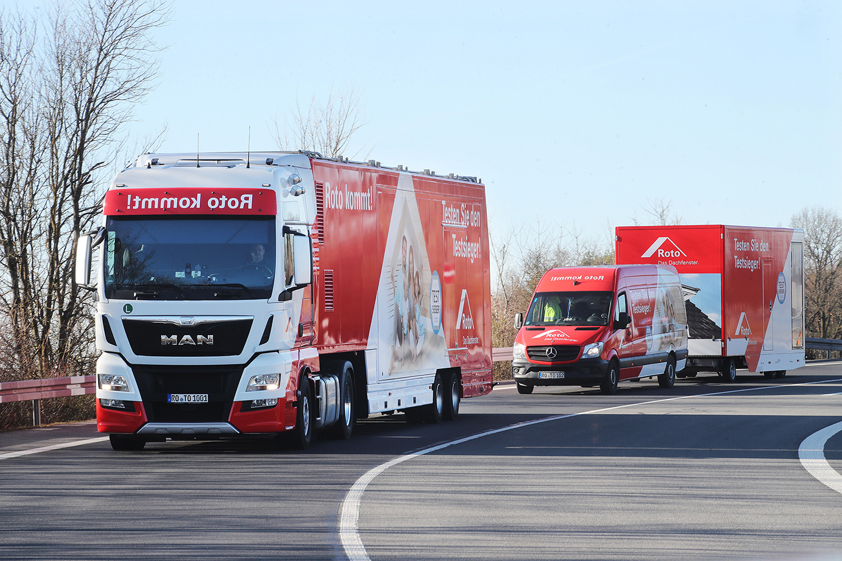
Example of the “new performance class” in the “support” category: the “training truck fleet” from Roto Frank Dachsystem-Technologie. It is designed to provide tradespeople and retailers with information about the roof window range at first-hand and in real time while also intensifying personal partner dialogue.
Photo: Roto / training_truck.jpg

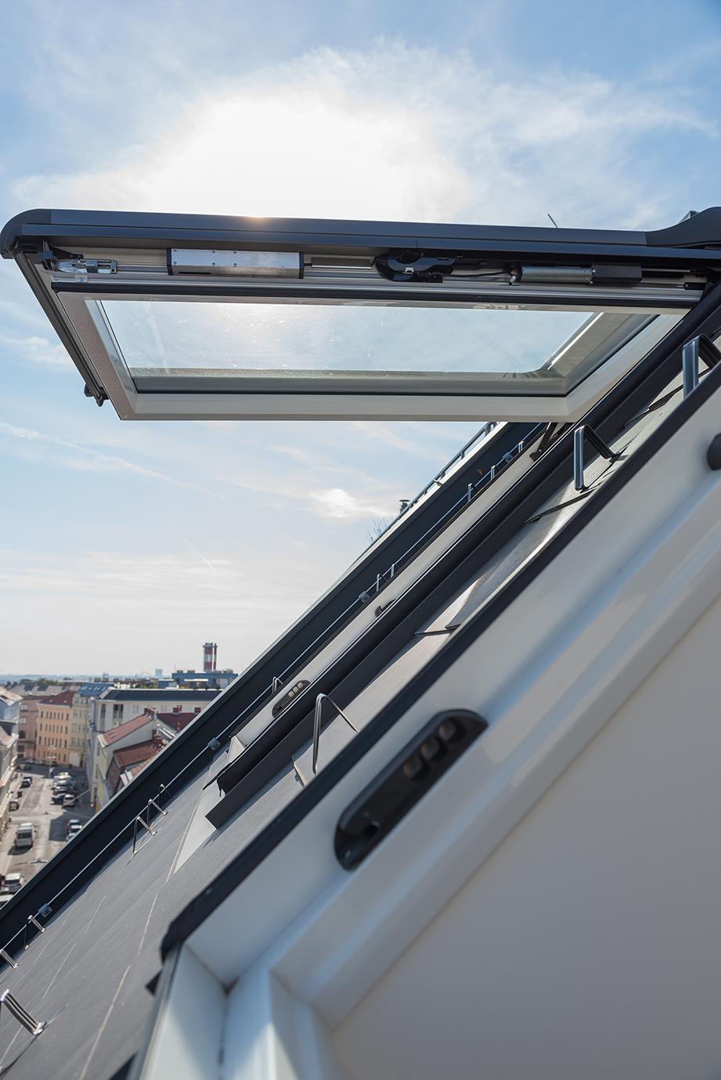
Example of the “new performance class” in the “products” section: the “Designo i8 Comfort” electric Top-Hung pivoting window. According to Roto, it is the only one of its kind on the market. The manufacturer announced that a further improved operating concept would be introduced in spring 2020, which was in particular due to customer feedback.
Photo: Roto / WDC_i8.jpg

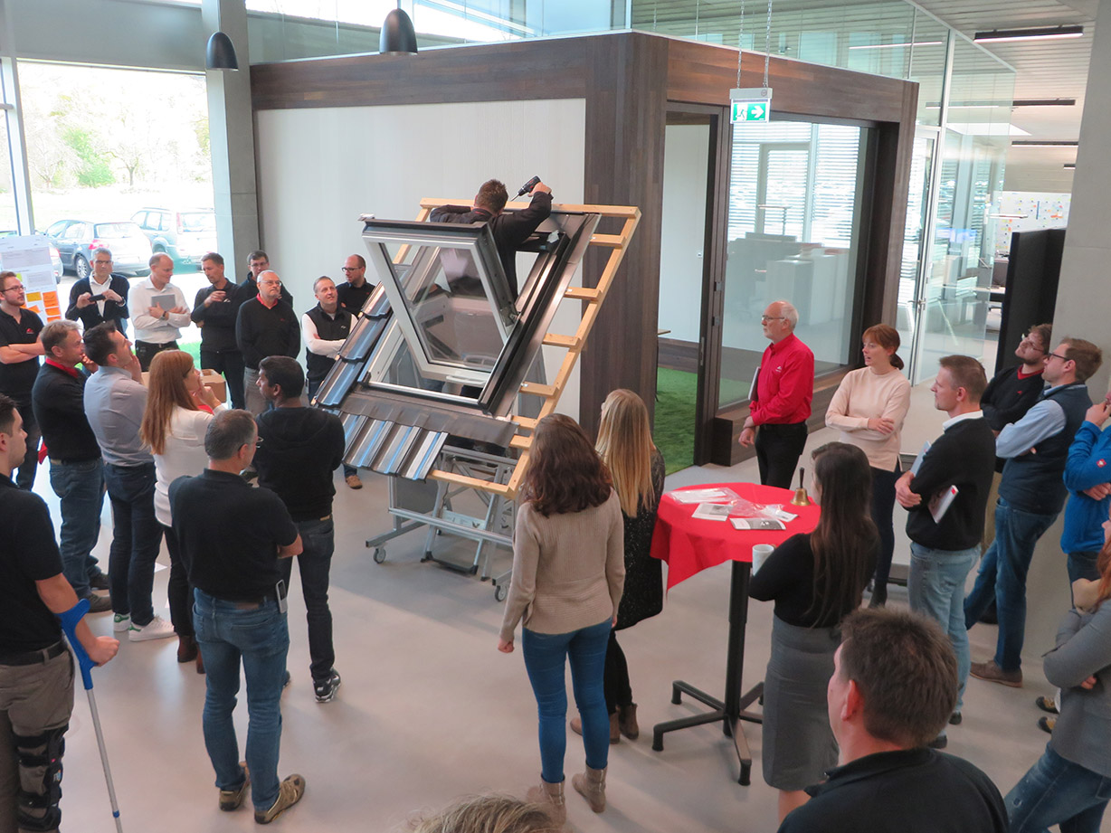
In the Roto innovation centre in Bad Mergentheim, marketing and product development work in close collaboration in order to come up with new practical solutions that are useful for customers. The whole team gets together once a week for ongoing project checks, including critical prototype tests.
Photo: Roto / innovation_centre.jpg

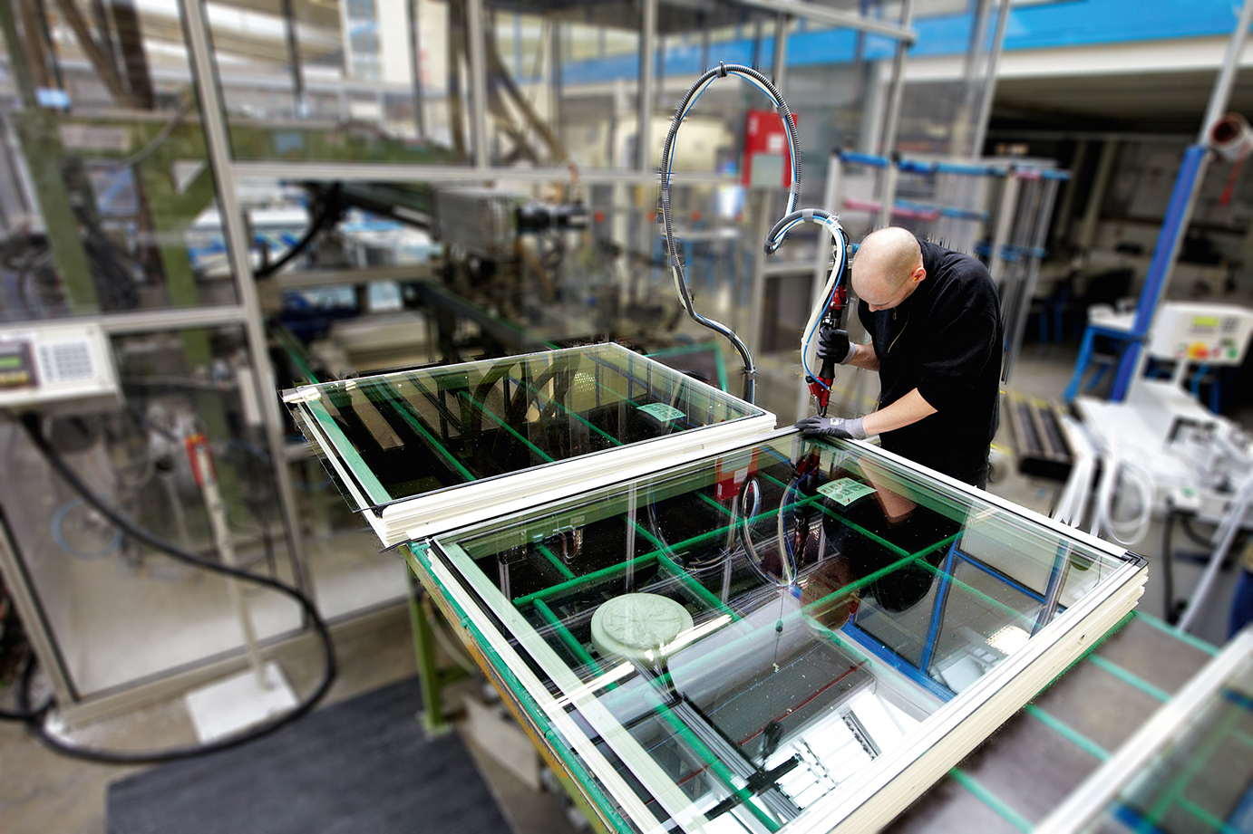
The entire range of PVC roof windows is produced in Roto’s Bad Mergentheim factory, which has already won multiple awards. In mid-November 2019, international specialist journalists had the opportunity to get an insight into how the “Designo i8 Comfort” electric Top-Hung pivoting window came into being.
Photo: Roto / production.jpg

Print free – copy requested

Text and photos are included on the press kit stick in the form of Word and JPEG files. They are also available to download at:
https://www.roto-dachfenster.de/ueber-roto/presse-und-aktuelles

Publisher: Roto Frank Dachsystem-Technologie GmbH • Wilhelm-Frank-Str. 38-40 • 97980 Bad Mergentheim • Germany • Tel. +49 7931 5490 0 • Fax +49 7931 5490 50 • presse@roto-frank.com • www.roto-dachfenster.de
Editor: Linnigpublic Agentur für Öffentlichkeitsarbeit GmbH • Koblenz office • Fritz-von-Unruh-Straße 1 • 56077 Koblenz • Germany • Tel. +49 261 303839 0 • Fax +49 261 303839 1 • koblenz@linnigpublic.de; Hamburg office • Flottbeker Drift 4 • 22607 Hamburg • Germany • Tel. +49 40 82278216 • hamburg@linnigpublic.de

