Date: March 2018

According to its own statements, the manufacturer is making the next big step forward in development with “Roto NX”. During “Fensterbau Frontale”, the manufacturer stated that the “Tilt&Turn hardware system for windows and balcony doors shaping the industry once again” sets standards in topics central to the industry, namely efficiency, security, comfort and design.

Graphic: Roto Roto_NX_Graphic.jpg

Print free – copy requested

Publisher: Roto Frank AG • info@roto-frank.com
Editor: Linnigpublic • koblenz@linnigpublic.de • hamburg@linnigpublic.de

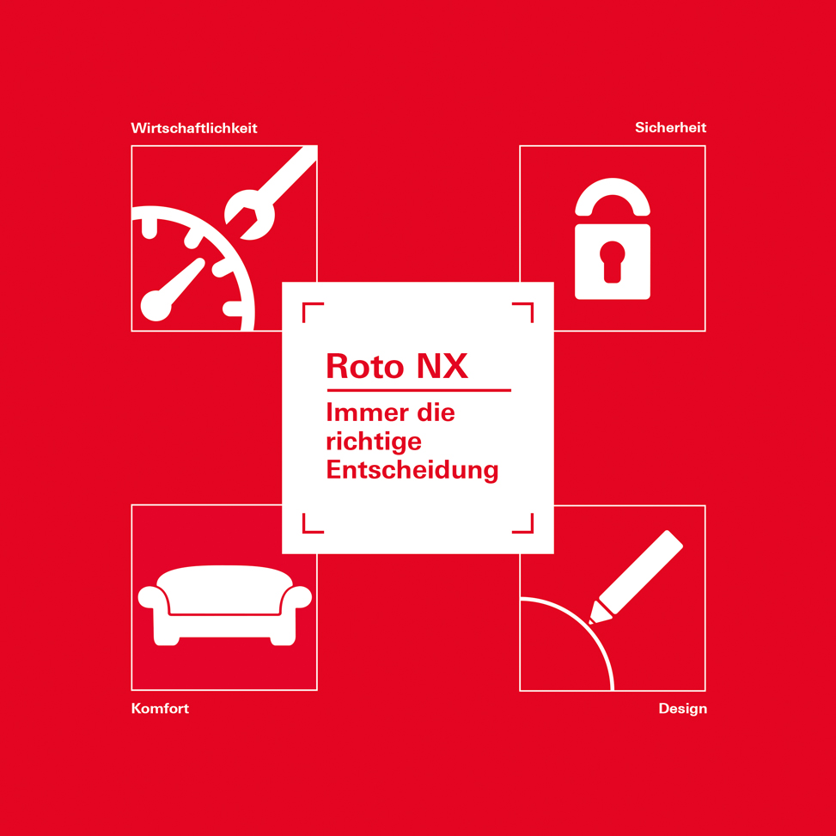

Date: March 2018

It is ultimately the totality of the various processing and application advantages that makes “our new Tilt&Turn flagship” far superior in practice. Roto advocated this conviction during “Fensterbau Frontale”. Changing over to the innovative “Roto NX” hardware system – entirely developed in-house – is therefore “always the right decision” for customers.

Photo: Roto Kampagnen_Model.jpg

Print free – copy requested

Publisher: Roto Frank AG • info@roto-frank.com
Editor: Linnigpublic • koblenz@linnigpublic.de • hamburg@linnigpublic.de

Date: March 2018

According to the manufacturer, the specific benefit of the new “Roto NX” Tilt&Turn hardware system for customers is reflected in numerous intelligent assemblies, among other features. This also includes a high backset espagnolette. Because the floating mullion and gearbox / lock casing are disconnected from a backset of 25 mm and above, the number of items is reduced, while the components can be individually configured at the same time. The “EasyMix system” enables installation to be performed without screws, since individual components can be connected both securely and easily by clipping them in.

Photo: Roto EasyMix_assembly.tif

Print free – copy requested

Publisher: Roto Frank AG • info@roto-frank.com
Editor: Linnigpublic • koblenz@linnigpublic.de • hamburg@linnigpublic.de

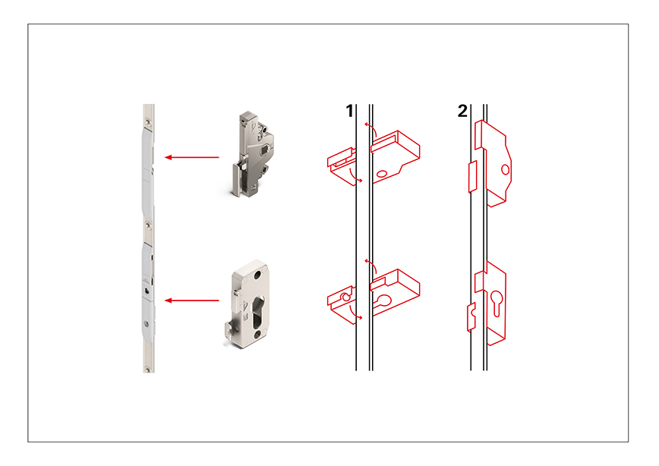
Date: March 2018

New to the “Roto NX” range: during “Fensterbau Frontale”, the hardware specialist underlined that the V locking cam, available from 2019, further increases the efficiency of the entire Tilt&Turn system thanks to time- and cost-efficient adjustment possibilities. The optimised rebate-clearance tolerance range results in reduced installation effort in the factory and on the construction site. Furthermore, it will soon also be possible to adjust the gasket compression and height using a standard size 4 hex key.

Photo: Roto V_Zapfen.jpg

Print free – copy requested

Publisher: Roto Frank AG • info@roto-frank.com
Editor: Linnigpublic • koblenz@linnigpublic.de • hamburg@linnigpublic.de

