Press release

Date: 15th March 2021

Sliding windows – an intelligent solution for schools / Efficient ventilation and much more / Impressive full package / “Roto Patio Inowa” produces a tight seal and reduces costs / Smart hardware system ensures forced and cross ventilation / Wide range of formats and high load bearing capacity / Simple and intuitive operation / Variable handle position / Suitable for demanding everyday use in schools / Certified quality

Clever natural ventilation for classrooms

Leinfelden-Echterdingen – Especially on the ground floor of schools, sliding windows are an intelligent solution – and not only when it comes to the type of efficient ventilation that is required to curb the spread of the coronavirus. They also offer a host of other advantages to meet the wide-ranging demands placed on their function and use. Roto, a leading hardware producer, attests to this. The company supports its statements with a specific example from its own product range.

For instance, a range of products that is ideal for use in schools is available in the form of “Roto Patio Inowa”. It enables sash widths from 710 to 2000 mm and sash heights from 600 to 2500 mm with all frame materials (timber, timber / aluminium, aluminium, PVC), therefore covering a wide range of formats. Through the special closing movement transverse to the frame profile, the circumferential gaskets and the active locking points in the mullion, the “smart” hardware ensures that the system remains tightly sealed at all times, even in severe weather such as storms and heavy rain. It also offers effective insulation of external sound and reduces the energy consumption, therefore also lowering heating and air-conditioning costs.

According to Roto, the large-format sliding elements weighing up to 250 kg are generally on-trend, let a lot of light and brightness into rooms and therefore lay the foundations for a positive learning environment. When open, they ensure forced and cross ventilation, which is absolutely indispensable right now. This solution also saves space and retains the shelf surface on the window sills. Since open elements do not protrude into the classroom, unlike traditional windows, the risk of injury is reduced and the full seating capacity is maintained.

The “Patio Inowa” system impresses when it comes to the heavy-duty use of windows in schools. Firstly, the sliding elements are simple and intuitive to operate. Secondly, there are the “SoftClose” and “SoftOpen” functions, which have a three-fold effect: controlled opening and closing, gentle sash movement and protection against improper use. All of this boosts the durability and therefore the efficiency of the entire sliding system. The comfort features also include the variable handle position, allowing the handle to be placed horizontally at the bottom, for example, so that young children can reach it.

The manufacturer also highlights the possibility of using the system as a sliding door into the playground. This is made possible by the burglary inhibition in accordance with resistance class RC 2 and especially by the accessibility in accordance with DIN 18040. Ultimately, the certified quality of the hardware product range is an “important security feature” for investors. The air permeability meets the requirements of DIN EN 1026 / 12 207 (class 4), and the driving rain impermeability is in line with DIN EN 1027 / 12 208 (class 9A).

Caption

According to Roto, sliding windows meet the specific requirements of schools – and not only when it comes to forced and cross ventilation, which is currently an important issue. They also save on space and energy, remain permanently tightly sealed, provide sound insulation, are easy and intuitive to use, and are safe and durable, and therefore economical. The “Roto Patio Inowa” “smart” hardware system suitable for all frame materials provides this impressive whole package.
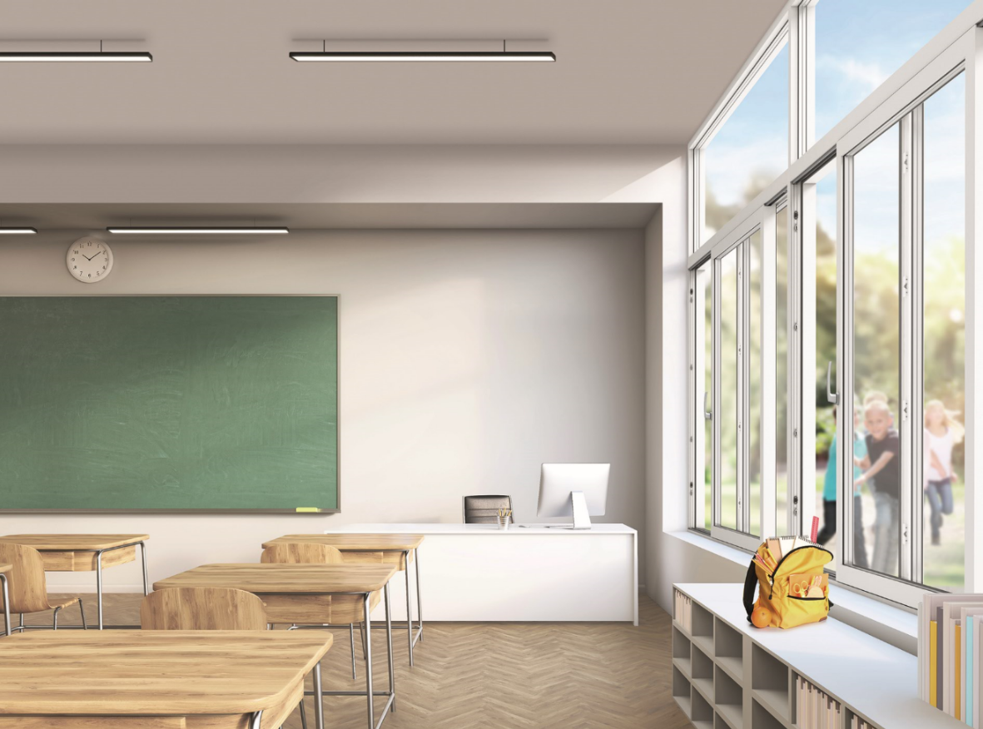
Photo: Roto Roto_Patio_Inowa_school_window.jpg

Print free – copy requested

Publisher: Roto Frank Fenster- und Türtechnologie GmbH • Wilhelm-Frank-Platz 1 • 70771 Leinfelden-Echterdingen • Germany • Tel. +49 711 7598 0 • Fax +49 711 7598 253 • info@roto-frank.com
Editor: Linnigpublic Agentur für Öffentlichkeitsarbeit GmbH • Fritz-von-Unruh-Straße 1 • 56077 Koblenz • Germany Tel. +49 261 303839 0 • Fax +49 261 303839 1 • koblenz@linnigpublic.de

