Press release

Date: 1st March 2021

First-rate quality of “Roto AL” and “Roto AL Designo” confirmed / Hardware for Turn-Only, Tilt&Turn and TiltFirst windows in long-term functional performance class H3 / Corrosion-resistant: class 5 in accordance with DIN EN 1670 / For sash heights of up to 3000 mm without the need for special approval

Roto Aluvision: Tilt&Turn hardware product ranges fully certified according to the latest QM 328 standard

Leinfelden-Echterdingen – The trend for tall, heavy building elements made from aluminium continues. For system suppliers and metal constructors, this involves additional effort in applying for special approvals as required. The higher weights and large formats pose increasing challenges to hardware with respect to resilience, functional safety and overall quality. These challenges are being met by Roto. For example, following extensive testing, the application range for the “Roto AL” and “Roto AL Designo” hardware systems has been extended to a sash height of 3000 mm. In addition, the entire product range for Turn-Only, Tilt&Turn and TiltFirst windows has been tested and certified by ift according to the latest QM 328 standard. This provides confirmation that all of the components in the product ranges meet the requirements of long-term functional performance class H3 (20,000 cycles) and are corrosion-resistant in accordance with class 5 according to DIN EN 1670.

Durability class H3 and corrosion resistance class 5

This means that Roto Aluvision is now the first supplier on the market with a product range of Turn-Only, Tilt&Turn and TiltFirst windows made from aluminium up to a height of 3000 mm without the need for special approval to have been fully certified according to the latest standard. The “AL 300” and “AL” hinge sides, including the heavy hinge sides for up to 300 kg and the “AL Designo” concealed 180 kg, were subject to repeated opening and closing in accordance with EN 13126-8 and EN 1191. Their corrosion resistance was verified by a neutral salt spray test lasting 480 hours.

Switching made easy

The advantage of being certified according to QM 328 is that if a system supplier is planning to switch to Roto products or to add the “AL” and "AL Designo” hardware product ranges to its portfolio, this can be done without any difficulty. This is because initial type testing reports for windows according to EN 14351-1 shall remain valid under two conditions. Firstly, if there is a changeover to hardware with an ift certificate according to QM 328, e.g. to “AL” or “AL Designo”. Secondly, if the window system’s quality is proven to be the same or better in a specified comparison test on a calibrated test rig, e.g. in the International Technology Centre (ITC) at Roto, Leinfelden-Echterdingen.

Using the best as a benchmark

“The QM 328 certification for all Turn-Only and Tilt&Turn configurations of Aluvision is further evidence that Roto is setting the benchmark when it comes to quality standards,” explains Matthias Kosog, Product Manager Tilt&Turn Aluvision. He adds that, at Roto, new components are always checked internally and externally according to QM 328. However, he believes that the certification from ift now provides the proof that the Tilt&Turn product range as a whole meets the latest QM 328 standard. Kosog states that this is also an attestation of Roto’s solid testing practices. “Our customers can be certain that, with “AL” and “AL Designo”, they are purchasing first-rate quality and also benefiting from an extremely wide application range. They are particularly flexible in the offer phase because they can immediately calculate and offer larger elements without waiting time or the need for special approval.”

No special approval required up to a sash height of 3000 mm

The new installation instructions for “Roto AL" and “Roto AL Designo” show the extended range of applications. For example, sashes up to a height of 3000 mm can be produced without the need for special approval. While the “AL” hardware system already passed the required tests in early 2020, one thing has been clear since the start of 2021: With the addition of the “AL Designo” concealed hinge side, even more sash formats can be offered without the need for special approval.

Property-specific consultation for even greater flexibility

If elements taller than 3000 mm are to be made available, Roto Aluvision will continue to support window manufacturers in future by proving fast, binding statements on feasibility and necessary testing or special approval. “When a window cannot be produced with a standard solution included in the installation instructions, we are always the right point of contact because of the outstanding consultation we offer,” emphasises Kosog. “You can always count on Roto! We prove this almost on a daily basis with property-specific solutions which allow window manufacturers to even meet unusual customer requirements.”

The Roto “AL” and “AL Designo” hardware systems for Turn-Only and Tilt&Turn windows made from aluminium have been fully certified according to the latest QM 328 standard.
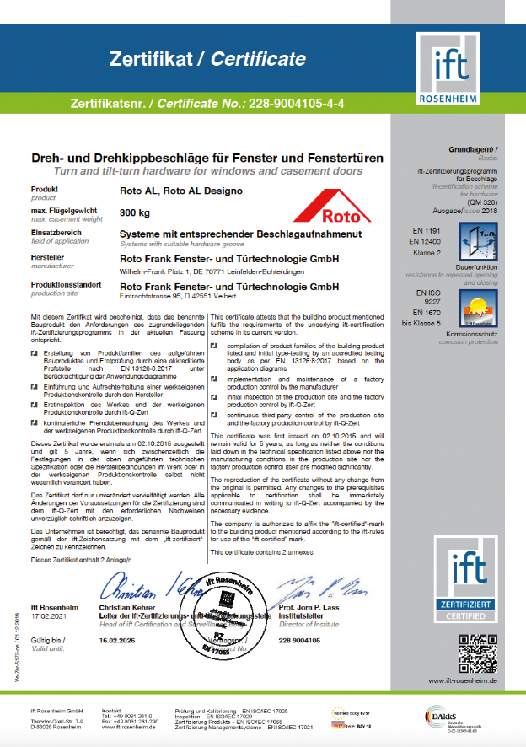
Photo: Roto Roto_QM_328_1.jpg

The “AL” and “AL Designo” hardware product ranges can be used to produce aluminium windows up to a sash height of 3000 mm without the need for special approval. This applies to elements with the Turn-Only, Tilt&Turn and TiltFirst opening types. The Roto Object Business advises on property-specific solutions when even taller and particularly wide sashes are requested.
Photo: Roto Roto_QM_328_2.jpg

Text and images are available to download:
https://ftt.roto-frank.com/int-en/company/press/press-releases/

Print free. Copy requested.
Dr. Sälzer Pressedienst, Lensbachstraße 10, 52159 Roetgen, Germany

Publisher: Roto Frank Fenster- und Türtechnologie GmbH • Wilhelm-Frank-Platz 1 • 70771 Leinfelden-Echterdingen Germany • Tel.: +49 711 7598-0 • Fax: +49 711 7598-253 • info@roto-frank.com
Editor: Dr. Sälzer Pressedienst • Lensbachstraße 10 • 52159 Roetgen • Germany Tel.: +49 2471 92128-65 • Fax: +49 2471 92128-67 • info@drsaelzer-pressedienst.de

