Press release

Date: 1st February 2021

“Roto Safe E” with new features / Retrofittable deadbolt switch contact / Cable junctions which can be combined as required / Error-free installation thanks to coordinated components / Two “Eneo” versions / Quiet and efficient motors / Several access control systems to choose from

Plug & Play progress for external doors

Leinfelden-Echterdingen – The “Roto Safe E” product range boasts new features. According to the manufacturer, these new additions include a retrofittable deadbolt switch contact and cable junctions which can be combined as required. These improvements fit right in with the general product concept, as the manufacturer states. This concept is primarily based on the precise coordination of all components for a fast Plug & Play connection. The product is equipped with a preassembled connector, eliminating the need for wiring. This paves the way for error-free and simple installation.

With the “Roto Safe Eneo A” version, the external door is unlocked electromechanically and locked mechanically automatically. A radio receiver can be integrated in the motor as an option. This is built in as standard with the “Roto Safe Eneo CC” version. The main lock and additional lockings are actuated completely electronically here. Both systems boast a quiet, powerful motor which opens and closes the door effortlessly. Another added advantage is the “extremely short” unlocking time.

The current deadbolt switch contact is used to monitor the door status at the main deadbolt. Since it can be integrated in the standard frame component, it is suitable for retrofitting. It also has VdS approval (class C) and can be integrated in burglar alarms.

The new cable junctions each comprise two sash-side and frame-side alternatives as a modular system. They can be combined in any way depending on the frame material (PVC, timber, aluminium) and installation situation. Roto emphasises in particular the cable junction with integrated power supply unit which is positioned on the frame. This means that a 230 V connection is all that is required for final installation on site.

The window and door technology specialist reports that to activate the motor, both “Eneo” solutions are equipped with different easy-to-use and freely selectable access control systems. While the hand-held transmitter has a range of up to 10 metres, for example, the finger scan with LED lighting and stainless-steel front plate offers an especially high level of security. An app for Android and iOS devices controls settings and user management. The alternative – “Phone & Code” – in turn makes it possible to open the door either with a mobile phone via the Bluetooth interface and by pressing a button, or by setting up a numerical code.

Caption

The “Roto Safe E” product range boasts new features. As the manufacturer states, these include a retrofittable deadbolt switch contact (3) and cable junctions with integrated power supply unit (1) which can be combined as required, among other features. Quiet and efficient motors (2) set the two available “Eneo” versions apart, as does the option of choosing from various different access control systems such as finger scan (4).

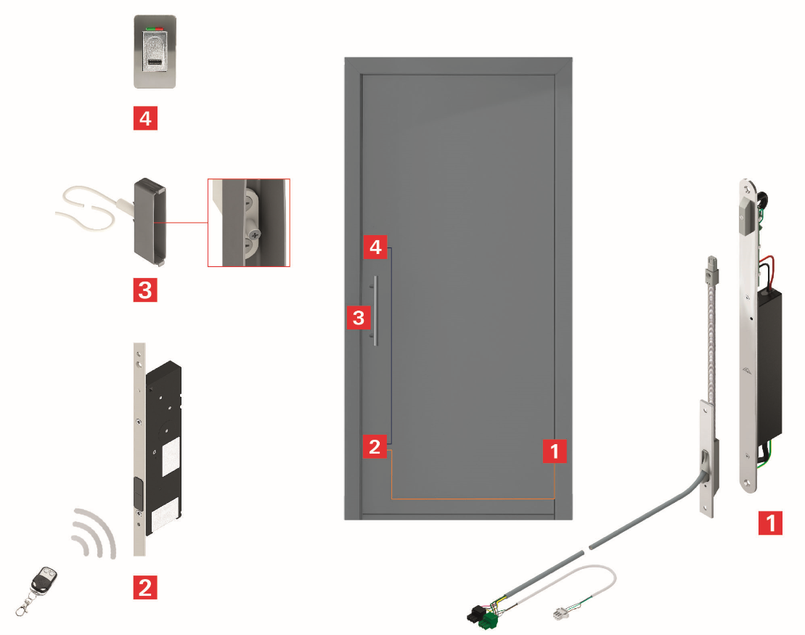
Photo: Roto Roto_Safe_E_Plug_Play.jpg

Print free – copy requested

Publisher: Roto Frank Fenster- und Türtechnologie GmbH • Wilhelm-Frank-Platz 1 • 70771 Leinfelden-Echterdingen • Germany • Tel. +49 711 7598 0 • Fax +49 711 7598 253 • info@roto-frank.com
Editor: Linnigpublic Agentur für Öffentlichkeitsarbeit GmbH • Fritz-von-Unruh-Straße 1 • 56077 Koblenz • Germany Tel. +49 261 303839 0 • Fax +49 261 303839 1 • koblenz@linnigpublic.de

