Press release

Date: 28th January 2020

New generation of the “Roto Solid B | 130 R” clampable butt hinge / For aluminium doors up to a sash weight of 120 kg / Clamping optimised for many profiles with a 15 / 20 Euro-groove / Rapid installation with few tools / Can be used on DIN left and DIN right

Efficient production with a clampable butt hinge:
“Roto Solid B | 130 R” for aluminium doors

Leinfelden-Echterdingen – For aluminium main doors, back doors and balcony doors up to a sash weight of 120 kg, most manufacturers are looking for a butt hinge that supports efficient production in particular and impresses with its durability. The version of the “Roto Solid B | 130 R” two-part clampable butt hinge for aluminium doors which is available now is especially easy to install with few tools. The application range covers profiles with a 15 / 20 Euro-groove. The storage space requirements are reduced because the butt hinge can be used on DIN left and DIN right.

Large application range
The “Roto Solid B | 130 R” has been designed for inward and outward opening main doors. It fits in many door and window profiles with an overlap, meaning that it can be used to produce back doors or patio doors with window profiles. Escape doors are also covered by the range of applications.

Simple and efficient
Like the installation of window hardware from the “Roto AL” range, the butt hinge frame bearing is simply moved in and clamped. The clamping has been optimised for a large number of profile systems.

The sash-side clamping support-strip is secured in the sash using self-tapping screws. The sash hinge itself is then fitted to the clamping support-strip using metric screws, which again is similar to the clamping in operation step 2. All screws and pins for installing the components for the sash are secured as standard with hexalobular socket screws with a drilling diameter of 5 mm. This also makes production simpler and more efficient.

Easy to install and low-maintenance
PVC bearing bushes with Teflon elements and axis pins from rust-resistant or stainless steel ensure a long service life without requiring any maintenance. Installation of the door is simplified by the lateral adjustment of “Roto Solid B | 130 R” with an adjustment range of +/- 1.5 mm. Accurate positioning can still be achieved even if there is just one fitter present.

Variety of surfaces
The new butt hinge is available powder-coated as standard in the colours RAL 9016 Traffic white, RAL 9005 Jet black, RAL 8019 Grey Brown, silver and anodised silver. Coatings in different RAL colours and other anodised surfaces or untreated hinges to be coated by the window and door manufacturer are available upon request.

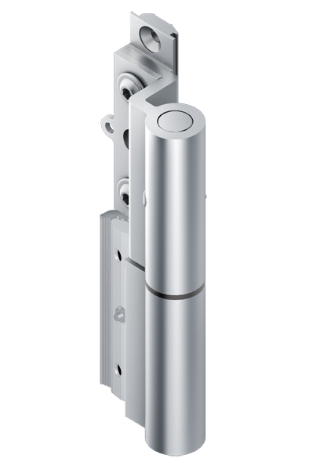
The new generation of the “Roto Solid B | 130 R” clampable butt hinge for aluminium doors up to a sash weight of 120 kg.

Photo: Roto Roto_Solid_B_130R_1.jpg

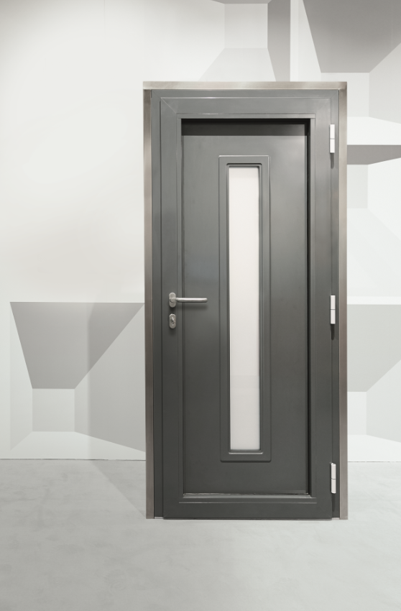
The clamping for the new “Roto Solid B | 130 R” has been optimised for many profile systems with a 15 / 20 Euro-groove.

Photo: Roto Roto_Solid_B_130R_2.jpg
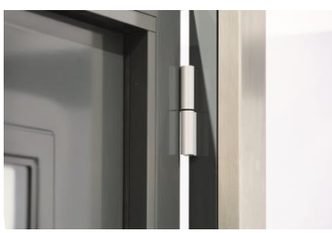
The “Roto Solid B | 130 R” clampable butt hinge has been designed for inward and outward opening main doors, back doors, balcony doors and escape doors. It can be used on DIN left and DIN right.

Photo: Roto Roto_Solid_B_130R_3.jpg

Text and images are available to download:
http://ftt.roto-frank.com/en/press/

Print free. Copy requested.
Dr. Sälzer Pressedienst, Lensbachstraße 10, 52159 Roetgen, Germany

Publisher: Roto Frank Fenster- und Türtechnologie GmbH • Wilhelm-Frank-Platz 1 • 70771 Leinfelden-Echterdingen • Germany • Tel.: +49 711 7598-0 • Fax: +49 711 7598-253 • info@roto-frank.com
Editor: Dr. Sälzer Pressedienst • Lensbachstraße 10 • 52159 Roetgen • Germany • Tel.: +49 2471 92128-65 • Fax: +49 2471 92128-67 • info@drsaelzer-pressedienst.de

