Press release

Date: 5th October 2020

Window handles and geared-handles with antiviral coating / “Roto Line” window handles and geared-handles with “Roto AVT” available for immediate delivery / Metal constructors reporting increased demand / Can be combined with all colours and surfaces / Coating for further component groups in the pipeline

New from Roto Aluvision:
Effective protection against infections transmitted via window handles with
“Roto AVT”

Leinfelden-Echterdingen – Fabricators of the “Roto AL” or “Roto AL Designo” Tilt&Turn hardware product ranges are now able to order “Roto Line” window handles and geared-handles with an antiviral and UV-resistant coating. It is known as “Roto AVT”, which stands for “antiviral technology”, and is proven to be widely effective against viruses, bacteria and fungal infections that could stick to a handle. “Roto AVT” renders them inactive and therefore harmless. In this way, the risk of a smear infection and new infection chains is significantly reduced.

Order-specific coating
“For hospitals and care homes in particular, but also for other public buildings, there is an increasing demand for products with surfaces which inactivate pathogens such as bacteria and viruses,” reports Dr Gregor Stößer, Head of Surface Technology at Roto Frank Fenster- und Türtechnologie GmbH. Since metal construction plays a key role in fitting out care homes and public buildings, Roto Aluvision looked for an option to offer window handles and geared-handles in any colour and surface with an order-specific antiviral coating within a short time, for aluminium windows at first. The ideal technology was found for this in the form of “Roto AVT”.

“This is certainly just the beginning,” explains Matthias Nagat, Head of Roto Aluvision Range Marketing and Product Adaptation. “Window handles and other handles with ‘Roto AVT’ can also be provided for timber and PVC windows if required. Further component groups will follow.”

Safe and easy to clean
“Roto AVT” is transparent, thin-layered, barely perceptible to the touch and simplifies cleaning and disinfection of window handles. This is because the coating produces a very hard, pore-free surface which creates the lotus effect. For example, the hydrophilic membrane of a virus envelope is not able to stick to the surface, and organic substances, moisture and contaminants are repelled. “Roto AVT” also has a biocidal, fungicidal and virucidal effect.

Effective against enveloped viruses
The active ingredients contained in the coating render pathogens inactive before they can cause an infection. They are also proven to be highly effective against influenza (H1N1) and COVID-19 (SARS-CoV-2), because they attack the envelope of these viruses and render them porous. In this way, “Roto AVT” provides protection between cleaning and disinfection cycles against smear infections which could be caused by using a window handle.

Greater protection for a long time
Tests in a certified test centre have shown that “Roto AVT” has a long-lasting effect that is maintained even when a window handle is used very frequently. “Similar coatings are used in hospitals, on sanitary equipment, bed frames and medical equipment,” explains Nagat. “All Roto component groups with this new coating can therefore also be used in good faith for windows designed for areas with stringent hygiene requirements.”

When deciding to make their purchase, window manufacturers receive a certificate for their documentation confirming the effectiveness of the coating, which is subject to an additional charge. Window handles can upon request also be printed with information making the user aware of the window handle’s special surface.

Available now
In Europe, manufacturers of aluminium windows are now able to order “Roto Line” window handles and geared-handles with the “Roto AVT” coating, just like a special colour. The delivery time for individual orders is four weeks. After entering into a framework agreement, defined items can also be provided within the standard delivery time. Plans will be implemented soon to extend deliveries to aluminium window manufacturers so that they cover other continents. The same applies to the use of the coating on other component groups from the Roto handles range. Roto sales representatives can provide advice upon request.

“Roto Line” window handles with the “Roto AVT” coating can also be used for elements designed for areas with stringent hygiene requirements. Window manufacturers receive a certificate for their documentation confirming the effectiveness of the coating, which is subject to an additional charge.

Photo: Roto Roto_AVT.jpg

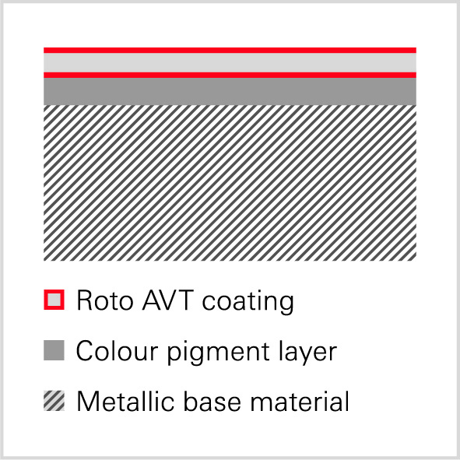

Applying “Roto AVT” produces a very hard, pore-free surface which creates the lotus effect. Enveloped viruses such as influenza (H1N1) and COVID-19 (SARS-CoV-2) are not able to stick to this surface. Organic substances, moisture and contaminants are repelled. “Roto AVT” also has a biocidal, fungicidal and virucidal effect. The active ingredients contained in the coating render viruses inactive before they can cause an infection, because they attack the envelope of these viruses and make it porous.

Photo: Roto Roto_AVT_structure_layer.jpg

Print free – copy requested

Publisher: Roto Frank Fenster- und Türtechnologie GmbH • Wilhelm-Frank-Platz 1 • 70771 Leinfelden-Echterdingen • Germany • Tel.: +49 711 7598-0 • Fax: +49 711 7598-253 • info@roto-frank.com
Editor: Dr. Sälzer Pressedienst • Lensbachstraße 10 • 52159 Roetgen • Germany • Tel.: +49 2471 92128-65 • Fax: +49 2471 92128-67 • info@drsaelzer-pressedienst.de

