Press release

Date: 24th June 2020

New managing director at Deventer / Sealing profile specialist to be managed by Mike Piqeur from 1st July / Even greater emphasis on “hardware and gasket” system with added value in future / Market, industry and company expert / At Roto since 1985 / Most recently managing director of the Western Europe business area / Sales professional with customer expertise / Implement growth plans – increase internationalisation / Support from “experienced management teams”

Piqeur to be appointed managing director of Deventer

Leinfelden-Echterdingen – (rp) Sealing profile specialist Deventer is undergoing a change in its senior management team. As Roto Frank Fenster- und Türtechnologie GmbH (FTT) reports, Mike Piqeur will take on the role of managing director at the manufacturer on 1st July 2020. The current managing director, Lüder Pflügner, who has enjoyed great success in his over 13 years in this position, is reported to be retiring.

As a member of the FTT division, the Deventer Group has further production sites in the Netherlands, Poland and Russia alongside the headquarters in Germany (Berlin-Spandau). The supplier of gaskets made from thermoplastic elastomers (TPE), specific PVC formulations and silicone rubber currently employs around 200 members of staff. They are part of the “system with added value” from Roto, which is “high-performance and sets the company apart from its competitors”. This is reflected in the interaction between the hardware and gasket and therefore ensures the lasting benefit of expertise for customers.

The new Deventer director has a reputation as a market, industry and Roto expert “par excellence”. Piqeur, born in Amsterdam, joined the construction supplier in Leinfelden-Echterdingen back in 1985 as an export product manager. Various other positions followed, then at the end of 2000 he began his current role as managing director of the Western Europe business area including the countries and regions of the United Kingdom, Ireland, Scandinavia and the Benelux Union. But, according to statements, it was not only in this position that he acquired varied sales and project experience focused on his changing tasks. The fact that he has in-depth knowledge about the specific advantages and major market opportunities offered by the integrated system of “hardware and gasket” thanks to his long-standing collaboration with Deventer in the Netherlands, among his other experience, makes his future role “even more interesting” for him.

Piqeur therefore considers a “sustained and effective campaign of system expertise” to be a crucial aspect of his work. This will play a tangible part in implementing growth plans. Systematically increasing the internationalisation of the sealing profile business is another aspect of this. Furthermore, the 58-year-old intends to focus his efforts on active positioning when it comes to “sustainability”. In all these endeavours, he will be able to rely on the expertise and support of the “experienced management teams” at Deventer.

He will report directly to Marcus Sander in his new role as managing director. The Chairman of the FTT Board of Directors is looking forward to continued collaboration: “Alongside extensive market, industry, company and product experience, Mike Piqeur will also bring proven customer expertise to the table. He is highly qualified for this special role as he knows Roto inside out and has supported the company from an early stage.”

Captions

Sealing profile specialist Deventer is undergoing a change in its senior management team: from 1st July 2020, Mike Piqeur will be responsible for the member of the Roto Window and Door Technology division (FTT) with its current total of around 200 employees. In future, there is to be an even greater emphasis on the integrated system of “hardware and gasket”. The photo shows the German headquarters.
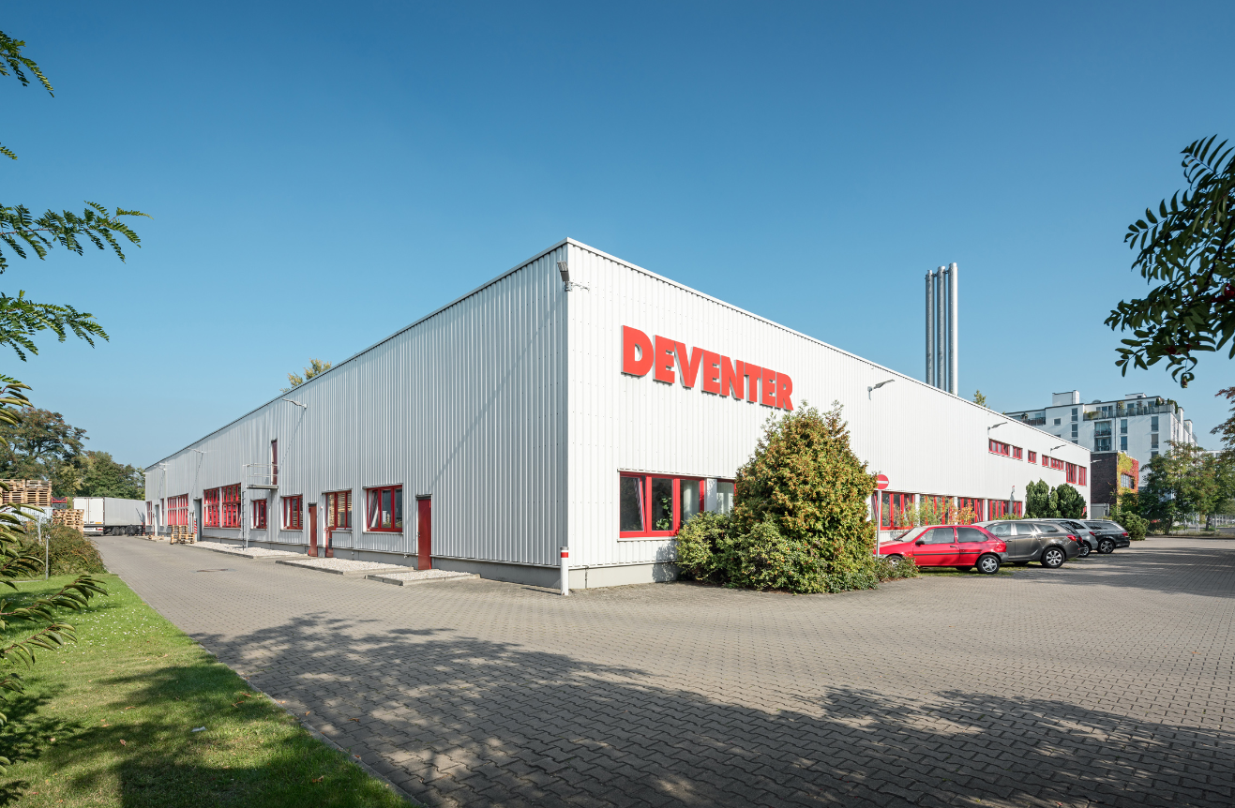
Photo: Roto Deventer_Berlin.jpg

Mike Piqeur will take on the role of managing director at Deventer on 1st July 2020. The sales professional previously managed the Western Europe business area at Roto including the countries and regions of the United Kingdom, Ireland, Scandinavia and the Benelux Union. As a result, alongside extensive market, industry and company experience, he will in particular bring proven customer expertise to the table.
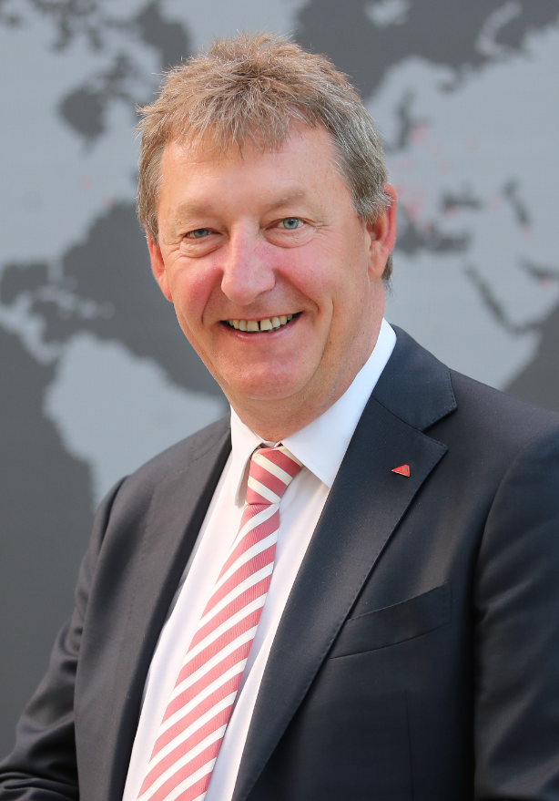
Photo: Roto Mike_Piqeur.jpg

Print free – copy requested

Publisher: Roto Frank Fenster- und Türtechnologie GmbH • Wilhelm-Frank-Platz 1 • 70771 Leinfelden-Echterdingen • Germany • Tel. +49 711 7598 0 • Fax +49 711 7598 253 • info@roto-frank.com
Editor: Linnigpublic Agentur für Öffentlichkeitsarbeit GmbH • Koblenz office • Fritz-von-Unruh-Straße 1 • 56077 Koblenz • Germany • Tel. +49 261 303839 0 • Fax +49 261 303839 1 • koblenz@linnigpublic.de; Hamburg office • Flottbeker Drift 4 • 22607 Hamburg • Germany • Tel. +49 40 82278216 • hamburg@linnigpublic.de

