Press release

Date: 6th May 2020

Roto Fenster- und Türtechnologie: coordinated hardware and gaskets / Set apart through service partnership / Greater security for customers and market partners / Individual TPE sealing profiles from Deventer / Exclusive developments for system manufacturers / Three complex tasks expertly fulfilled

Gaskets: specialities from the specialist

Leinfelden-Echterdingen – (rp) Hardware and gaskets affect the long-term performance of windows and doors “directly and fundamentally”. By harmonising these two components more effectively, the system as a whole will work better. Based on this principle, Roto Fenster- und Türtechnologie (FTT) boasts, in its own words, an “important differentiating feature” that sets itself apart from the competition. This is because whenever possible the hardware configuration and sealing profiles are jointly tailored to customer- and product-specific requirements. For market partners, the service partnership represents “tangible added security”.

In the sealing profile sector, this is ensured by Deventer, a member of this division. It has been part of the Roto Group since 2016 and, besides a wide standard product range, also offers extensive expertise for individual developments. By way of example, this is evident from solutions for three Tilt&Turn windows made from various different materials. TPE (thermoplastic elastomers) – the only material to be used – also confirms the general benefits here. These include a wide range of possible applications in coextrusion and a high degree of flexibility with regard to colours.

For aluminium windows: thermal insulation and recycling

Deventer has developed a frame sealing profile with foamed areas for a European aluminium system supplier. It impresses with an outstanding thermal insulation value and functions reliably in the long term thanks to welded corners. There is the option to have it delivered as a complete frame welded to the specific dimensions required. The profile based with a sliding configuration ensures simple installation without additional lubricants. Thanks to the individual shape of the exclusive solution, the window system boasts a high level of sealing. The same applies to the operating convenience. In addition, the manufacturer underlines the environmental friendliness that is becoming increasingly relevant in the aluminium sector in particular and in construction projects more generally. Cradle-to-cradle certification confirms that the TPE profiles are fully recyclable.

For PVC windows: high-tech and optimal values

The Deventer experts report that special requirements had to be met with the “Kubus” all-glass window system from Gealan. In the interest of ensuring complete transparency, there were to be no gaskets on the frame, for example. Another priority was integrating the different functions of the glazing gasket and frame stop gasket in a single gasket cross section. And since the system concept does away with conventional glazing beads, it had to be possible to attach the gasket securely to the finished window element after it is glazed.

The solution found for the ambitious project is a “high-tech gasket”, which is secured in the sash frame via a jointly coordinated catch mechanism. An adhesive tape attached to the gasket in the factory fixes the profile to the glass as a stop gasket and glazing gasket. A TPE core inserted into the gasket cross section also ensures gasket compression and clearance. The large profile hollow chamber results in excellent tolerance compensation; its foamed area further optimises the thermal properties. Several successfully passed tests are proof of the effectiveness of the development, explains Deventer. For instance, “Kubus” achieved optimal values for driving rain impermeability, wind load and air permeability. The operating convenience was also rated as “excellent”.

For timber / aluminium windows: tailored work and colour adaptation

Specially coordinated – this is the concept behind the new “Mira Contour CTS” window from Gutmann. Individually combining various profiles, for instance, results in tight sealing, ease of operation and an attractive appearance alike. The lip of the central gasket and overlap gasket has also been “tailored” to the installation geometry. While thin profile walls and a minimal build-up of closing pressure make the window effortless to operate, the flexible base lip and the rigid back of the profile simplify installation. The ideal tool for correct corner formation is also included in the delivery programme. The Deventer experts round off the profiles of their latest contributions to the collaboration with Roto by presenting a silicone solution which acts as a glazing gasket with a colour adapted to the TPE central gasket and overlap gasket.

Captions

Systems expertise: the coordination of hardware and gaskets is “of fundamental importance” to ensure that windows and doors operate safely and without any faults in the long term. Roto Fenster- und Türtechnologie (FTT) sees this as one of the particular strengths of its own service partnership, which includes gasket specialist Deventer. The image shoes a TPE frame sealing profile developed for a European aluminium system supplier, which offers an outstanding thermal insulation value thanks to foamed areas, among other features.

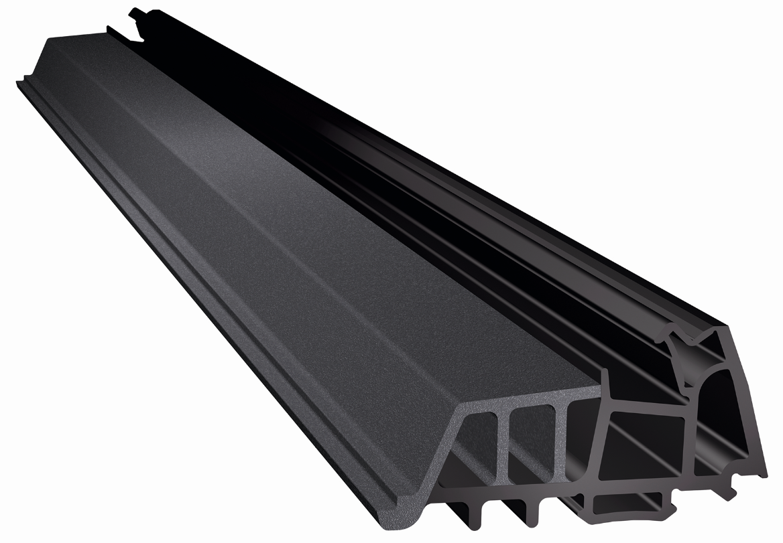
Photo: Roto/Deventer aluminium_window_sealing_profile.jpg

Individuality: the “high-tech gasket” developed by Deventer in line with specific requires for the “Kubus” window system from Gealan locks into the sash frame. The adhesive tape attached to the gasket in the factory fixes the profile to the glass as a stop gasket and glazing gasket. The large profile hollow chamber results in excellent tolerance compensation.

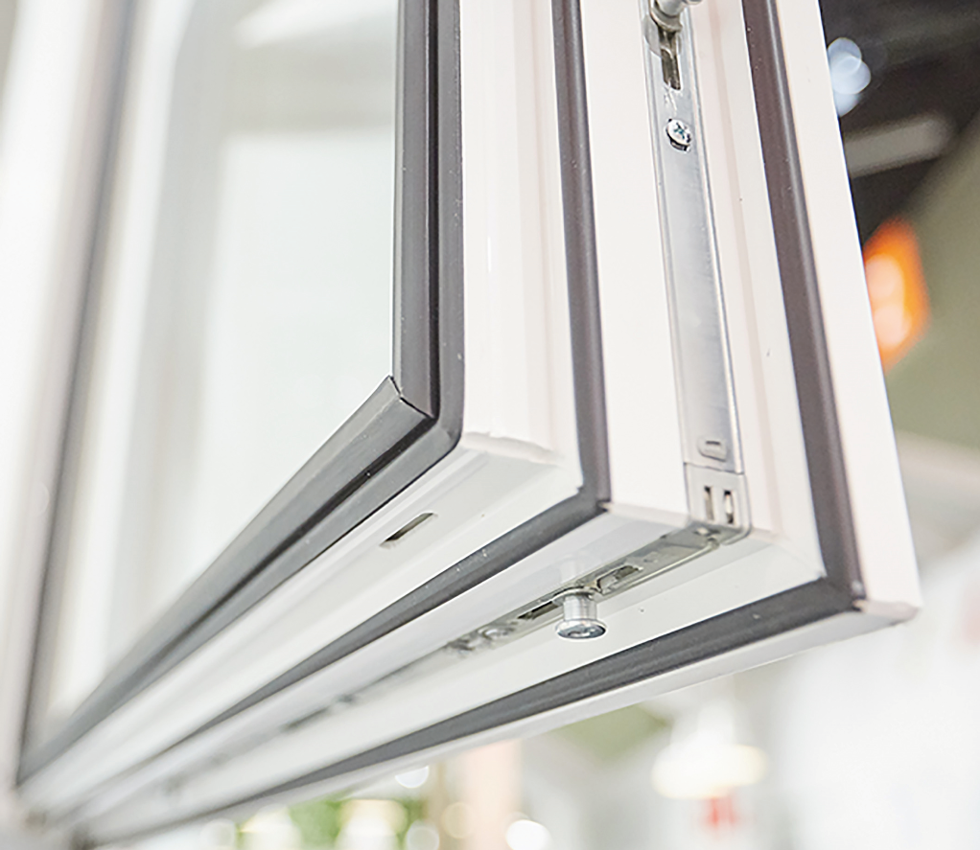
Photo: Roto/Gealan Gealan_Kubus.jpg

Effects: a precisely coordinated system made up of various different sealing profiles results in tight sealing, ease of operation and an attractive appearance alike in the new “Mira Contour CTS” window from Gutmann. Deventer, a member of the Roto Window and Door Technology (FTT) division, explains that the lip of the central gasket and overlap gasket has been specially adapted to the installation geometry.

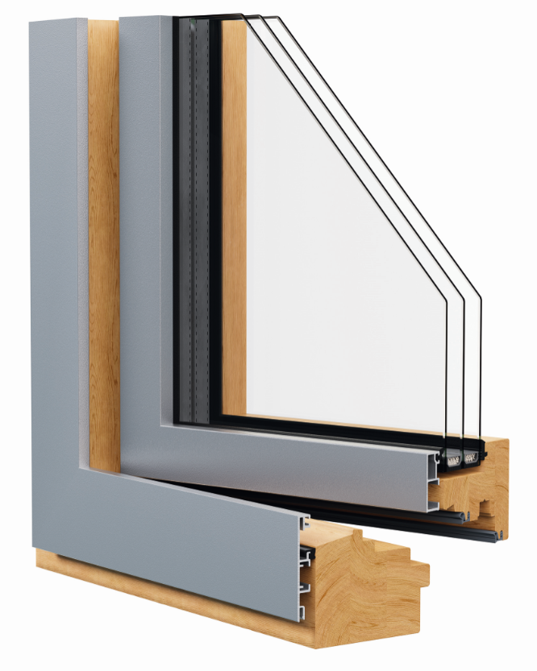
Photo: Roto/Gutmann Gutmann_Mira_Contour.jpg

Print free – copy requested

Publisher: Roto Frank Fenster- und Türtechnologie GmbH • Wilhelm-Frank-Platz 1 • 70771 Leinfelden-Echterdingen • Germany • Tel. +49 711 7598 0 • Fax +49 711 7598 253 • info@roto-frank.com
Editor: Linnigpublic Agentur für Öffentlichkeitsarbeit GmbH • Koblenz office • Fritz-von-Unruh-Straße 1 • 56077 Koblenz • Germany • Tel. +49 261 303839 0 • Fax +49 261 303839 1 • koblenz@linnigpublic.de; Hamburg office • Flottbeker Drift 4 • 22607 Hamburg • Germany • Tel. +49 40 82278216 • hamburg@linnigpublic.de

