Press release

Date: 12th May 2020

Window and door technology specialist will not be going to Munich / Uncertainty surrounding the coronavirus influences decision / Economic responsibility too / Back again in 2023 / Roto Aluvision: large product range and comprehensive project consultation / Varied system solutions for aluminium facades, windows and doors / Direct communication with customers and prospective clients

Roto will not be attending “BAU”

Leinfelden-Echterdingen – (rp) Roto Frank Fenster- und Türtechnologie (FTT) will not be attending “BAU” 2021 in Munich. The plan was to focus on property-specific hardware solutions for aluminium facades, windows and doors at the trade fair. Marcus Sander emphasises that this decision is mainly due to the fact that “despite initial positive signals, it is still not possible at present to predict the future development of the coronavirus pandemic or what the situation will be like in January 2021”. For a global player like Roto, the international nature of the trade fair is the key success factor for “BAU”, explains the Chairman of the Board of Directors. The extent to which international visitors will be able to travel to Munich in January, or whether this will be possible at all, cannot be foreseen at present. Neither is it possible to reliably predict whether attending the trade fair would be entirely without health risks for employees and visitors, and therefore possible without any restrictions.

At the same time, Sander highlights the huge uncertainty that can be currently felt around the world with regard to future business development. “A leading international trade fair like ‘BAU’ entails a great deal of expenditure and time for us. It must be reasonably proportionate to the likelihood of the trade fair resulting in the desired successful outcome for us. Since we cannot reliably estimate this in the present circumstances, our decision is based on economic responsibility for the company, its owners and our staff.”

After the cancellation of this year’s “Fensterbau Frontale” event, it has been “very difficult” for the company to now be unable to attend a second trade fair within a short space of time. But when all factors are considered, it is ultimately a “reasonable step”. Regardless of this, everyone is obviously aware of the significance of “BAU” for the Roto Aluvision division. This is why the company is planning to attend the trade fair again in 2023, according to Sander.

A large product range for aluminium windows and doors and the extensive scope of consultation services for all parties involved in a project for designing and constructing windows and facades (Roto Object Business) make the global player a valued partner of architects, planners, system providers and metal constructors around the world. The fact that the Roto Group offers an extraordinary number of quality-relevant components for aluminium projects, with its hardware, handles, locks, glazing methods and sealing profiles, is attracting considerable interest.

The specialist for window and door technology is now focusing on how to best give advice and support to its customers during and after the coronavirus crisis. Sander: “We are using the varied elements of modern communication and are bringing our solutions directly to our customers via various channels.”

Caption

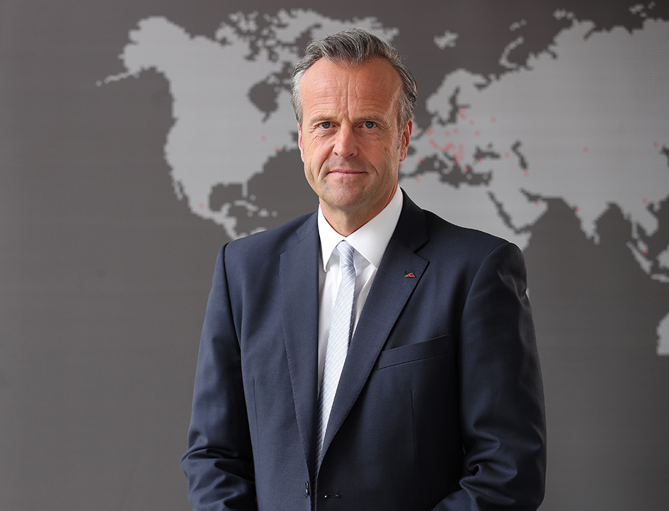

Roto Frank Fenster- und Türtechnologie (FTT) will not be attending “BAU” 2021. Marcus Sander, Chairman of the Board of Directors, reports that this decision is mainly due to the fact that it is still not possible at present to predict the future development of the coronavirus pandemic or what the situation will be like in January 2021.

Photo: Roto Marcus_Sander.jpg

Print free – copy requested

Publisher: Roto Frank Fenster- und Türtechnologie GmbH • Wilhelm-Frank-Platz 1 • 70771 Leinfelden-Echterdingen • Germany • Tel. +49 711 7598 0 • Fax +49 711 7598 253 • info@roto-frank.com

