Press release

Date: 22nd April 2020

Aluminium doors often first choice / Increased popularity in the long term / “Roto Solid C”: new version for outward opening doors / Ten-year performance warranty / Concealed door hinge with numerous practical advantages / Appearance, benefits for the user and durability / Twice-tested quality / Simple processing

Premium-level door hinge

Leinfelden-Echterdingen – (rp) Aluminium main doors and flat entrance doors are more and frequently the first choice for builders. This applies to high-quality, large models in particular. They win over investors mainly due to their attractive design characterised by sleek outlines on the one hand, and their material-specific durability on the other hand. The manufacturer reports that door producers can now also equip outward opening versions with the “Roto Solid C” concealed hinge. The member of the “Door” portfolio, which includes multipoint lockings and thresholds alongside door hinges, offers a ten-year performance warranty.

The new version impresses in practice with various advantages. For instance, it ensures that even doors weighing 140 kg are easy to open and close at an angle of up to 110°. It also supports the burglar inhibiting design of aluminium doors in accordance with RC 2. The concealed mechanics combine the “aesthetic” factor with the user benefit of simple and easy door cleaning. While the continuous gasket level minimises heat losses, the self-lubricating hinge bush eliminates the need for maintenance on the door. Important proof of quality: the continuous operation characteristics tested on the basis of DIN EN 1191 ensure fault-free functionality even over 200,000 cycles according to Roto.

The extremely high corrosion resistance of the surface of all components in accordance with DIN EN 1670 Class 5 underlines the premium character of “Solid C”. The door hinge, available in silver and black, is suitable for many standard profiles. To process the outward opening version, compared to the inward opening type, only additional mounting accessories and a different height adjustment module are required. According to the predictions, aluminium doors may therefore continue to enjoy increased popularity – regardless of the opening type.

Captions

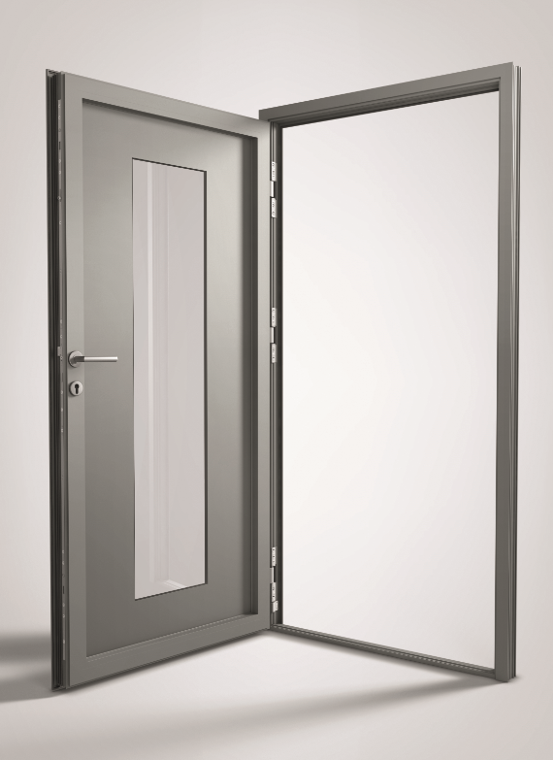
High-quality aluminium main doors and flat entrance doors are on-trend. The “Roto Solid C” concealed door hinge is now also available for outward opening versions. According to the manufacturer, it stands out thanks to the practical advantages it offers in terms of appearance, functionality and processing.
Photo: Roto Roto_Solid_C_aluminium_door.jpg

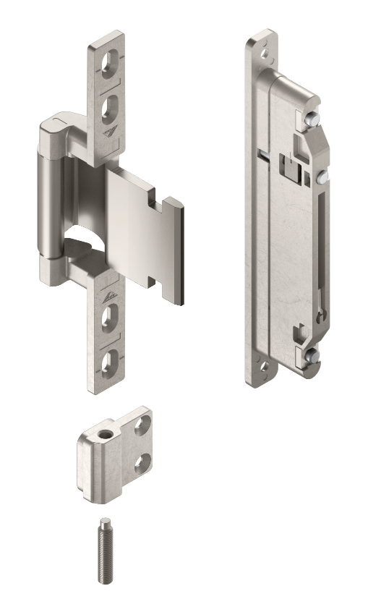
The producer is now offering the “Roto Solid C” concealed door hinge for outward opening aluminium doors, too. Compared to the “inward opening” version, only additional mounting accessories and a different height adjustment module are required for processing. The important quality features of the new version include the extremely high corrosion resistance of the components in accordance with DIN EN 1670 Class 5.
Photo: Roto
Roto_Solid_C_door_hinge_and_height_adjustment_module.jpg

Print free – copy requested

Publisher: Roto Frank Fenster- und Türtechnologie GmbH • Wilhelm-Frank-Platz 1 • 70771 Leinfelden-Echterdingen • Germany • Tel. +49 711 7598 0 • Fax +49 711 7598 253 • info@roto-frank.com
Editor: Linnigpublic Agentur für Öffentlichkeitsarbeit GmbH • Koblenz office • Fritz-von-Unruh-Straße 1 • 56077 Koblenz • Germany • Tel. +49 261 303839 0 • Fax +49 261 303839 1 • koblenz@linnigpublic.de; Hamburg office • Flottbeker Drift 4 • 22607 Hamburg • Germany • Tel. +49 40 82278216 • hamburg@linnigpublic.de

