Press release

Date: 8th April 2020

Roto sees a bright future for sliding systems / Numerous arguments for the modern sliding generation / Rational production thanks to an intelligent range of hardware / “Roto Patio Alversa”: High efficiency / Four variants for Parallel Sliding and Tilt&Slide windows / “Roto Patio Inowa”: Smart range for high-density elements / New “SoftClose” function

Sliding systems: High-performance hardware technology

Leinfelden-Echterdingen - (rp) Roto classifies advanced sliding systems as a “clear growth segment”. The window and door technology specialist therefore expects its share of the global hardware market to continue to rise gradually. There are a number of arguments for this positive assessment. The opening type has the necessary potential to efficiently meet the framework conditions and requirements, which are changing considerably, even in the future. That applies, for example, for the consequences of the living situation, which is increasingly critical in large cities in particular, the consequences of climate change, and the consequences of the new demographic parameters.

Furthermore, modern sliding product ranges now score highly in all relevant trends. All of these factors form the basis for the company's forecast. Specifically, this indicates the clearly noticeable shift in demand for more light and therefore towards large glass surfaces and floor-to-ceiling windows, slimline profiles, integrated, invisible hardware, energy efficiency and sound insulation. Furthermore, the increasing popularity of accessible and convenient solutions is also underpinning the rise of the modern sliding generation. However, it has to be affordable and offer impressive quality.

The range from the hardware producer is making numerous specific contributions to this. Examples include the “Roto Patio Alversa” and “Roto Patio Inowa” series. Thanks to its intelligent and rational production technologies, large quantities of sliding elements can be manufactured on the predominantly automated production lines of window manufacturers. Added to this is the fact that components from the “Roto NX” Tilt&Turn range can be used. Overall, this results in extremely economical production as the basis for continued market coverage at affordable prices.

Minimised effort and maximised features

For example, in the “Alversa” range, one Tilt&Slide solution and three Parallel Sliding solutions, including different ventilation functions, can be manufactured on one production line. In general, the high level of efficiency of the modular range is achieved primarily by the universal central locking system and the distinctive use of the same parts for all four variants. The effect of this? Expenditure on production, storage and logistics is reduced to a minimum.

The integrated night ventilation function, the compatibility with RC 2, and the ball-bearing-mounted roller unit with the integrated anti-jemmy protection, which was launched in 2019, are further advantages of the overall system. Type-specific improvements, such as an additional lock-in position in the sliding scissor stay and tilt support for heavy sashes, offer increased safety and comfort. The appeal of the Parallel Sliding versions is also based on intuitive operation, which adapts the habits that are learned and trusted for Tilt&Turn windows.

International expertise and “soft” premiere

“Patio Inowa” also offers this important relief for users. Roto is positioning this as “smart hardware for high-density and RC 2-compatible sliding systems” above all due to the special closing movement of the sash transverse to the frame profile, the surrounding gasket and the active locking points in the mullion. At the same time, the hidden technology allows for straight, narrow profiles. The wide range of uses as a window or balcony door extends to buildings in regions with extreme weather conditions, for example. According to the manufacturer, the international expertise of the range also includes numerous reference projects in many countries, as well as neutral awards in the USA.

They are announcing the premiere of the “SoftClose” function for “Patio Inowa” for summer 2020. The universal solution for all materials (PVC, timber, timber/aluminium, aluminium) increases comfort and durability in equal measures. It allows the sash to be pulled shut and closed automatically with a slow, gentle movement. A specially developed clamping tool is used to activate this function. Furthermore, technical adjustments should make the “smart hardware” easier to install. Complementing the latest sliding information, Roto explains that this is achieved, for example, by reducing the number of screws from six to four per assembly.

Captions

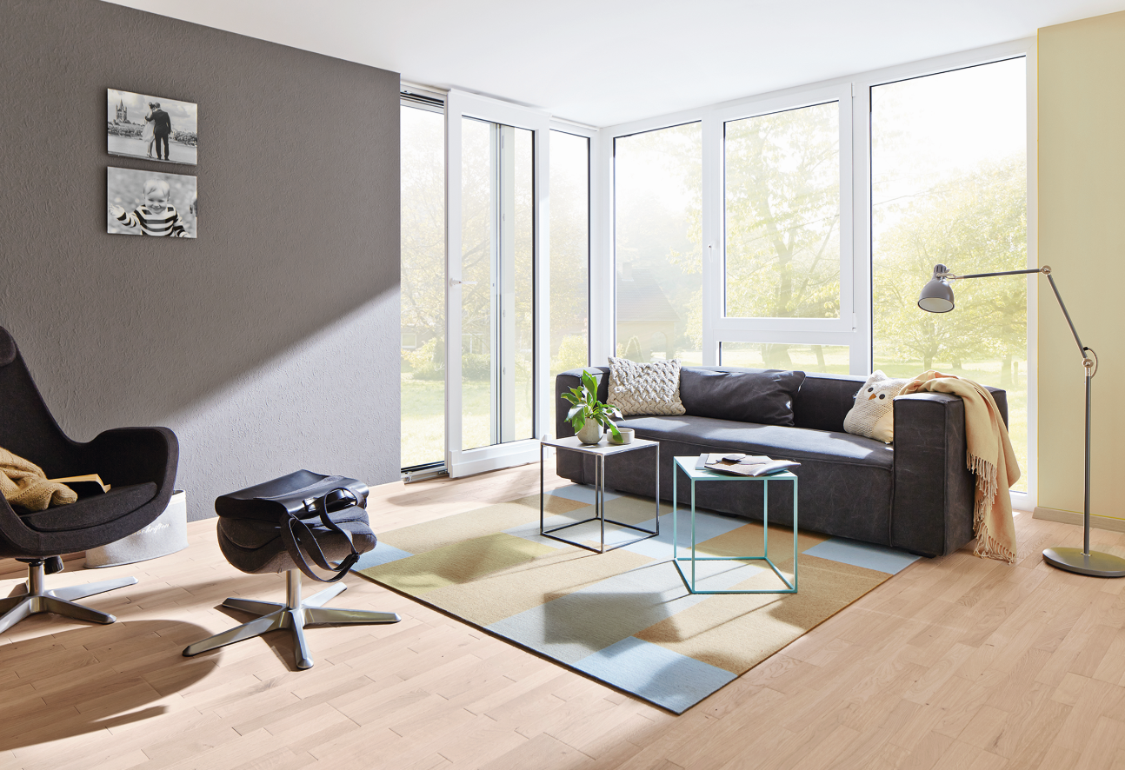

According to the producer, the “Roto Patio Alversa” hardware system for Parallel Sliding and Tilt&Slide windows is characterised in particular by its high level of efficiency. This is ensured primarily by the universal central locking system and the distinctive use of the same parts for all four variants. The integrated night ventilation function and the compatibility with RC 2 are additional “comfort” advantages of the modular range.
Photo: Roto Roto_Patio_Alversa_housing_situation.jpg

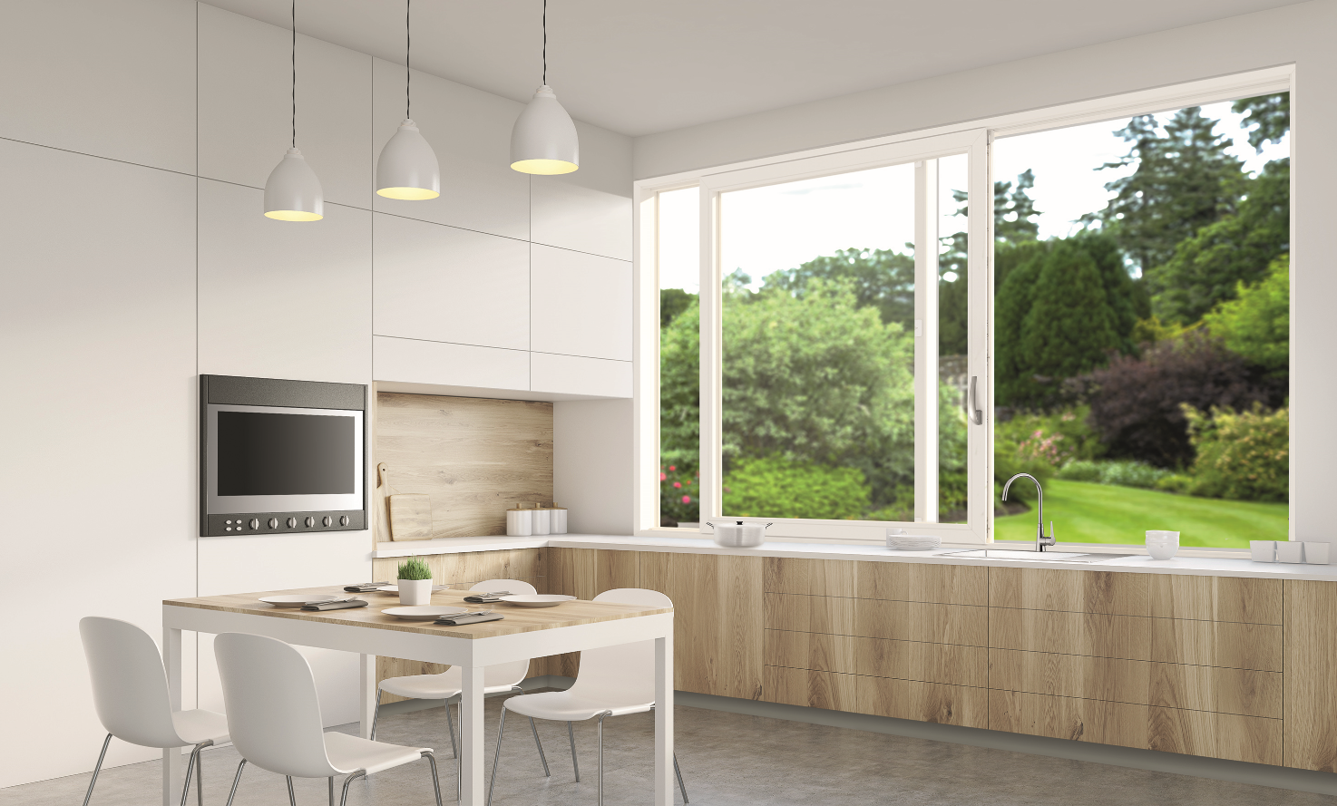

The manufacturer is positioning the “Roto Patio Inowa” range as “smart hardware for high-density and RC 2-compatible sliding systems”. The special closing movement of the sash transverse to the frame profile, the surrounding gasket and the active locking points in the mullion are all impressive. From summer 2020, the new “SoftClose” function will lead to increased comfort and durability.
Photo: Roto Roto_Patio_Inowa_housing_situation.jpg

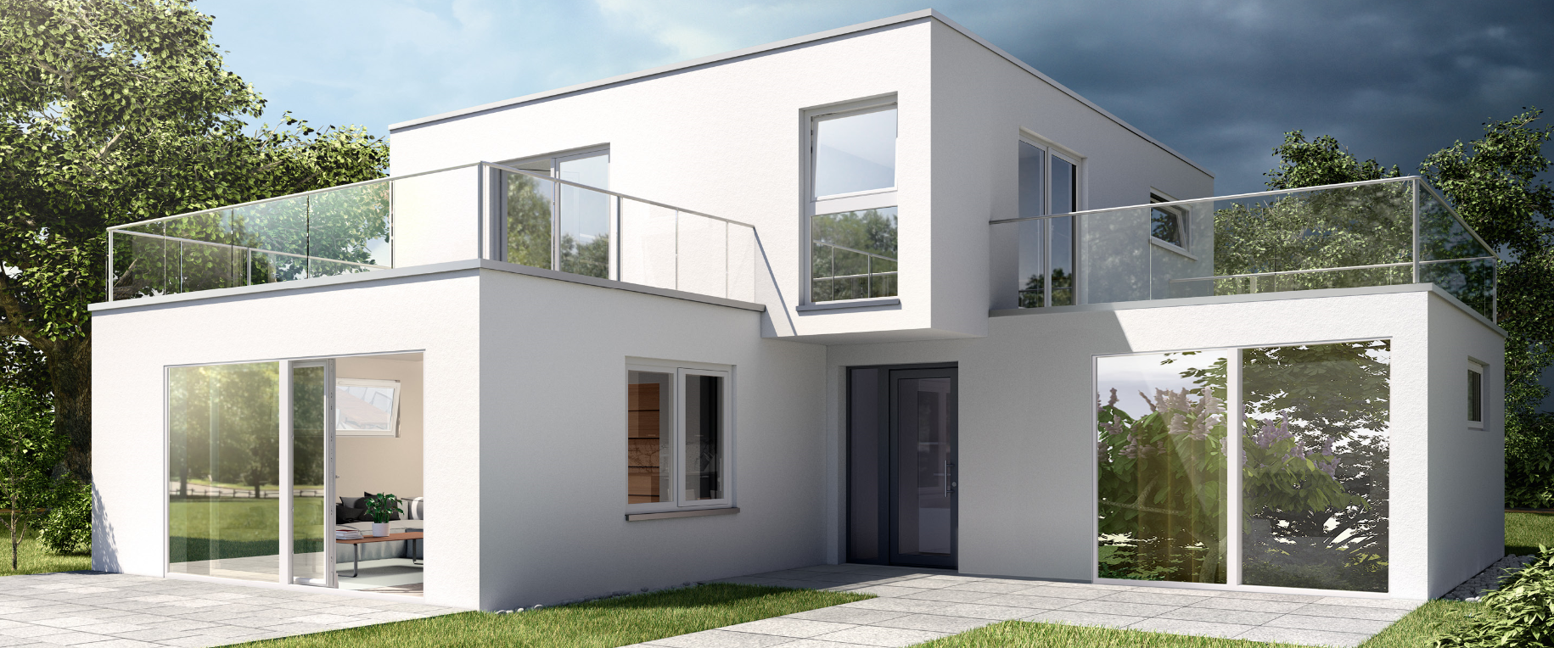
Interlinked hardware technology makes houses more comfortable and safer, and makes production more rational and quicker. Roto practises this systems approach and, in doing so, wants to create benefits for both the user and the customer. Specific example: Components from the “NX” Tilt&Turn range can also be used for the “Patio Alversa” and “Patio Inowa” sliding product ranges.
Photo: Roto Roto_system_concept.jpg

Print free – copy requested

Publisher: Roto Frank Fenster- und Türtechnologie GmbH • Wilhelm-Frank-Platz 1 • 70771 Leinfelden-Echterdingen • Germany • Tel. +49 711 7598 0 • Fax +49 711 7598 253 • info@roto-frank.com
Editor: Linnigpublic Agentur für Öffentlichkeitsarbeit GmbH • Koblenz office • Fritz-von-Unruh-Straße 1 • 56077 Koblenz • Germany • Tel. +49 261 303839 0 • Fax +49 261 303839 1 • koblenz@linnigpublic.de; Hamburg office • Flottbeker Drift 4 • 22607 Hamburg • Germany • Tel. +49 40 82278216 • hamburg@linnigpublic.de

