Press release

Date: 10th July 2019

“Roto AL Designo” without load transfer now for aluminium window sashes up to 130 kg / Reinforced corner hinge and reinforced pivot rest replace load transfer / Suitable for all common sash widths and heigh from a minimum sash width of 735 mm / Can be used for aluminium windows of the Turn-Only, Tilt&Turn and TiltFirst opening types / Technical consultation and special approval are provided promptly by Roto Aluvision

Produce aluminium windows even more efficiently:
Now without load transfer with “Roto AL Designo” from a sash width of 735 mm and up to 130 kg

Leinfelden-Echterdingen – The size and weight of window sashes are continuing to increase in aluminium window construction, too. Additionally fitted load transfer extends the application range of standard hardware. However, every extra component increases the installation effort for each window. In addition, installing load transfer interrupts the normal production process. This is detrimental to efficient production.

Safe without load transfer
Using a reinforced corner hinge and a pivot rest – also reinforced – from the “Roto AL Designo” hardware product range completely does away with the need to install load transfer up to a sash weight of 130 kg. This has been proven by tests involving various profile systems. “It has been proven that the new component combination can absorb higher tractive forces than in standard hardware,” explains Product Manager for Tilt&Turn at Roto Aluvision. “It has since been successfully tested with various profile and window versions

in the Roto ITC (International Technology Centre) in Leinfelden, as well as by external institutes.”

Technical consultation and special approval are provided promptly
The “Roto AL Designo” fully concealed hardware is therefore opening up new possibilities in the design of window elements with regard to their height / width ratio, too. From a minimum sash width of 735 mm, the new component combination can be used to produce all common sash widths and heights. Window manufacturers can submit a request for special formats to the Roto Aluvision specialists in Velbert. A prompt response and special approval are guaranteed. All that is required for approval is details of the planned height / width ratio and the envisaged sash weight.

Adoption into the standard range possible
Aluminium system manufacturers can incorporate the new component combination with the reinforced “Roto AL Designo” corner hinge and pivot rest into their standard product range. The team from the Roto Object Business will assist you in taking this step by advising on which sash formats are suitable for testing.

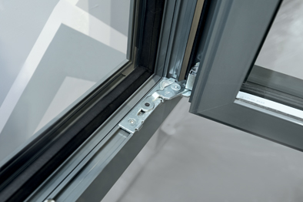
Manufacturers have got the choice: Using a reinforced corner hinge and a pivot rest – also reinforced – from the “Roto AL Designo” hardware product range completely does away with the need to install load transfer when producing aluminium windows up to a sash weight of 130 kg.

Photo: Roto Roto_AL_Designo_ohne_Lastabtragung_130kg.jpg

Text and images are available to download:
http://ftt.roto-frank.com/en/press/

Print free. Copy requested.
Dr. Sälzer Pressedienst, Lensbachstraße 10, 52159 Roetgen, Germany

Publisher: Roto Frank Fenster- und Türtechnologie GmbH • Wilhelm-Frank-Platz 1 • 70771 Leinfelden-Echterdingen • Germany • Tel.: +49 711 7598-0 • Fax: +49 711 7598-253 • info@roto-frank.com
Editor: Dr. Sälzer Pressedienst • Lensbachstraße 10 • 52159 Roetgen • Germany • Tel.: +49 2471 92128-65 • Fax: +49 2471 92128-67 • info@drsaelzer-pressedienst.de

