Press release

Date: 30th January 2019

Roto Aluvision with numerous innovations at BAU / RC 2 security thanks to new security strikers in the mullion of the “Roto Patio Inowa” sliding system / For aluminium windows of any opening type with Euro-groove: lockable opening restrictor with lockable handle / Safe installation, simple adjustment in the Euro-groove: pre-clampable security strikers for “Roto AL”

Ten years of Roto Aluvision at the BAU 2019 trade fair:
More comfort and security for aluminium windows and doors

Leinfelden-Echterdingen – System manufacturers, metal constructors and architects discovered interesting innovations at the stand of the hardware specialist Roto at the BAU trade fair in Munich. For instance the “Roto Solid C” concealed door hinge is setting standards in design and ease of installation. Thanks to new security strikers in the mullion of “Roto Patio Inowa”, it will be possible to produce tightly sealed sliding systems up to resistance class RC 2 in future. New security strikers were presented for the “Roto AL” Tilt&Turn range as well. They are pre-clampable and easy to adjust.

Increased quality, efficient production
More comfort, more security, modern design, high efficiency – manufacturers of aluminium windows and doors around the world are working on continuously developing their products. Roto Aluvision is always there for you. At the BAU 2019 trade fair, many exhibits and new products proved this once again. The majority of the hardware solutions presented are suitable for use in all common profile systems.

New: opening restrictor with locking function
The “Roto AL” hardware product range offers window manufacturers virtually everything they need to produce high-quality aluminium windows. Roto Aluvision was also requested to develop an innovative opening restrictor with locking function. This was demonstrated in an outward opening Turn-Only window at BAU. The added convenience provided by this innovation is that the window sash can only be opened up to a distance that is individually adjustable based on customer requirements. Otherwise, it can also be locked when open, controlled by the self-contained window handle. If the sash is locked, the handle is turned downwards into the 0° position after the sash is opened. If the sash has to be opened beyond the defined distance for cleaning or maintenance purposes, this is only possible once the cylinder in the handle has been unlocked. To do so, the handle is turned to 180° after unlocking. The sash then reaches its full opening width.

Now also available in the RC 2 resistance class: tightly sealed sliding systems with “Roto Patio Inowa”
The proof is there: the RC 2 resistance class can be achieved when the “Roto Patio Inowa” smart sliding hardware is used together with the security strikers specially developed by Roto. The sliding system by a well-known manufacturer recently passed the relevant test. “Many manufacturers are now using ‘Roto Patio Inowa’ to produce tightly sealed, extremely easy to use aluminium sliding systems,” explains Matthias Nagat, Head of Aluvision Range Marketing and Product Adaptation. “These systems also impress with their attractive design because the technology remains fully concealed. The fact that RC 2-compatible systems can now also be manufactured thanks to the new strikers for the mullion makes ‘Roto Patio Inowa’, in our opinion, an unbeatably attractive system.”

Correct installation, simple adjustment
Incorrect measurements, incorrect drilling – in the past, many manufacturers found upgrading an aluminium window with additional strikers for more burglary protection to be an arduous exercise in concentration during daily production. The new security strikers for the “Roto AL” and “Roto AL Designo” product ranges make this a thing of the past, at least for people who use profiles with Euro-groove. This is because these security strikers are only clamped in the groove with a piercing screw at first. Only after the correct positioning of all strikers has been checked and ensured through the connection with the sash are the strikers screwed in like usual.

“We have calculated various profile systems with Euro-groove,” reports Nagat. “The new security strikers mean that all systems are RC 2-compatible. This applies to sashes up to a height of 3000 mm and a weight of maximum 150 kg.” If a striker has to be adjusted after the window is installed, this is really simple thanks to the slots which are used to screw the strikers into the groove. Slightly undo the fixing screws, adjust the striker and fix it in place again – guaranteed comfort.

From the object service for series production
Jordi Nadal, Managing Director of Aluvision Europe, America, Middle East and Africa provided the following explanation of the stand design: “Roto is involved in groundbreaking projects with trend-setting architects all over the world. At BAU 2019, we exhibited some solutions that were created in this process.” Visitors were given plenty to talk about by various ventilation flaps from well-known facade manufacturers for whom Roto Aluvision developed customised hardware solutions. “As recognised experts, we have the best knowledge of the requirements of various architects and markets, and we are also able to demonstrate this at this BAU trade fair,” explains Nadal. Roto Aluvision has been exhibiting at this trade fair for ten years now. The multilingual team of advisers are rewarded for their commitment by a constantly increasing number of visitors from all over the world.

For variety and individuality
When taking a look back at the many conversations he had during the trade fair, Stefano Gianfreda is pleased to note that “in fact, Roto is firmly established in the minds of many metal constructors and facade designers nowadays thanks to our project work.” He is responsible for the regional customers and markets process for Europe, the Middle East and Africa. “This shows that 2019 has a lot of exciting things in store for my colleagues and I. We have our finger on the pulse of architecture at BAU and will initiate other exciting development processes straight after the trade fair.”

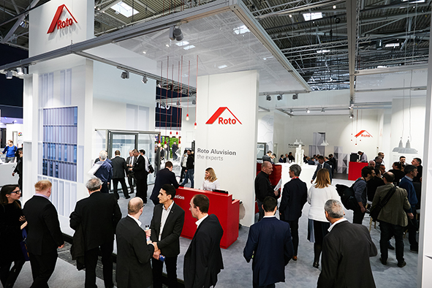
Roto Aluvision has been exhibiting at the BAU trade fair for ten years.

Photo: Roto Roto_Aluvision_BAU_2019.jpg

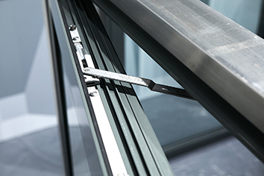
Highly regarded: an innovative opening restrictor with locking function for use in combination with hardware from the “Roto AL” range. The sash is opened up to a distance defined by the customer, where it is then also locked. The locking function is controlled by the self-contained geared-handle. It is possible to use a similar solution in windows of any opening type.

Photo: Roto Roto_AL_Roto_AL_opening_restrictor.jpg

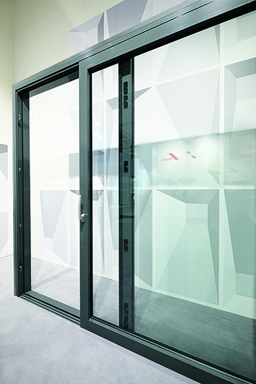
Tightly sealed and RC 2-compatible sliding systems are created with “Roto Patio Inowa”.

Photo: Roto Roto_Patio_Inowa_RC2.jpg

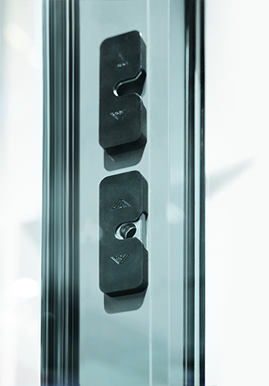
New security strikers have been developed for the mullion of the “Roto Patio Inowa” sliding system.

Photo: Roto Roto_Patio_Inowa_mullion.jpg

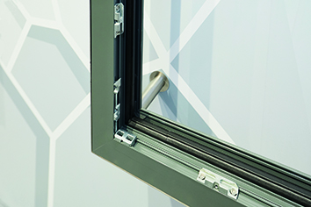
The new “Roto AL” security strikers for Turn-Only and Tilt&Turn windows comprising aluminium profiles with Euro-groove are only clamped with a piercing screw at first. Only when it has been ensured that the cams in the sash and the strikers in the frame are positioned correctly with millimetre precision are the strikers screwed in like usual.

Photo: Roto Roto_AL_security_strikers.jpg

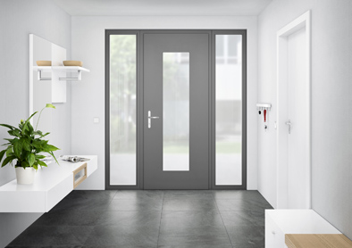
The new “Roto Solid C” concealed door hinge makes it possible to produce high-quality, burglar inhibiting aluminium entrance doors with a design that caters to the trend for sleek outlines.

Photo: Roto Roto_Solid_C.jpg

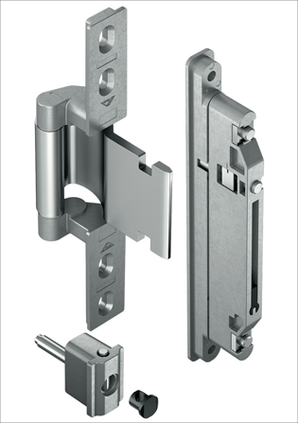
The “Roto Solid C” concealed door hinge with self-lubricating bush ensures lasting safe and convenient use of the entrance door, even without any maintenance.

Photo: Roto Roto_Solid_C_frame_and_sash_hinge.jpg

Jordi Nadal, Managing Director of Aluvision Europe, America, Middle East and Africa: “As recognised experts, we have the best knowledge of the requirements of various architects and markets, and we are also able to demonstrate this at this BAU trade fair.”

Photo: Roto Roto_Jordi_Nadal.jpg

Text and images are available to download:
http://ftt.roto-frank.com/en/press/

Print free. Copy requested.
Dr. Sälzer Pressedienst, Lensbachstraße 10, 52159 Roetgen, Germany

Publisher: Roto Frank AG • Wilhelm-Frank-Platz 1 • 70771 Leinfelden-Echterdingen • Germany • Tel.: +49 711 7598-0 • Fax: +49 711 7598-253 • info@roto-frank.com
Editor: Dr. Sälzer Pressedienst • Lensbachstraße 10 • 52159 Roetgen • Germany • Tel.: +49 2471 92128-65 • Fax: +49 2471 92128-67 • info@drsaelzer-pressedienst.de

