Press release

Date: 31st July 2019

Comfort combined with energy efficiency: Roto hardware concept for innovative ventilation flaps from FKN Fassaden

Leinfelden-Echterdingen / Frankfurt – The constantly increasing importance of Frankfurt as a financial metropolis manifests itself in particular in the imposing buildings in the Central Business District (CBD). In the pulsating heart of the CBD, directly opposite Deutsche Bank, is where the Marienturm was constructed. The element facade was designed by the renowned facade specialist FKN Fassaden, a company in the FKN Group based in Neuenstein. FKN used four versions of the “Roto AL Designo” hardware for the Turn-Only windows with a sash weight of up to 180 kg. As a solution for the inward-opening ventilation flaps, the Roto Object Business recommended parallel projecting scissor stays from the “Roto PS Aintree” product range combined with a special corner drive.

The eye-catching architecture of the 155-metre Marienturm was developed by the Berlin architectural firm Thomas Müller Ivan Reimann. An even division of the facades by elegant aluminium elements in a shimmering warm silver tone highlights the sculptural shape of the building. The facade manufacturer FKN produced almost 4300 Turn-Only windows with the “Roto AL Designo” hardware and 1675 inward-opening ventilation flaps.

Inward-opening ventilation flaps
A small ventilation sash 120 mm wide and 1500 mm high was requested. It had to be extremely easy to operate and combine maximum operating convenience with superb sealing, recalls Heiko Straub, consultant in the Roto Object Business. The idea was to use a ventilation flap that is not turned but rather opened using parallel projecting scissor stays. After just a few discussions with Roto, it became clear that scissor stays from the“Roto PS Aintree” product range could also be used for this kind of product concept. These scissor stays usually open window sashes outwards, but in this application they have to open ventilation flaps inwards.

Impressive solution for LEED-certified Marienturm
The Roto Object Business also developed a special corner drive specifically for FKN and the Marienturm. Thanks to this special corner drive, the ventilation flaps are locked all the way round their circumference, which improves the sealing of the closed ventilation flap and therefore the thermal insulation in the facade. Straub is certain that “in this respect, the hardware solution Roto developed for FKN exceeds all expectations.”“The Marienturm is certified in accordance with the Platinum LEED system. Sustainable product solutions for high energy efficiency therefore play a major role here. The facade solution from FKN meets the requirements of builders who purchase long-lasting systems and have to ensure all rooms have high thermal insulation and are pleasant to spend time in to attain certification.”

Partner for the provision of samples and continuous operation tests
FKN was awarded the contract for production of all facade components, including all Turn-Only windows and ventilation flaps, after providing samples for the project solution developed. “The samples provided impressed planners and investors,” recalls Franz Ebert, Sales Manager at FKN. The innovative ventilation flaps then underwent a continuous operation test in the Roto ITC test centre – International Technology Centre – in Leinfelden, with the results proving to be impressive. “With this product development, we are able to offer a solution that is first class in terms of functionality and quality, and Roto gave us crucial support at all times,” concludes Ebert.

From the design to production
All of the sashes in the Turn-Only windows on the Marienturm are just 905 mm wide, but between 2815 and 3555 mm high. This is why the Roto Object Business developed four hardware configurations consisting of components from the “Roto AL Designo” fully concealed Tilt&Turn hardware product range depending on the weight, which was between 125 and 180 kg according to the size of the sashes. “The Roto Object Business also provided comprehensive consultation on this matter too,” recalls Ebert. “Even when the production of windows and ventilation flaps was just beginning, Roto employees were already on site. We made good progress in close contact with each other.”

Construction sign
Project developer: Pecan Development GmbH, Frankfurt am Main
Architect: Thomas Müller Ivan Reimann Architekten, Berlin
Facade
and window construction: FKN Fassaden GmbH & Co. KG, Neuenstein
Hardware systems: Roto AL Designo, Roto PS Aintree
Hardware manufacturer: Roto Frank Fenster- und Türtechnologie GmbH, Velbert (Aluvision)

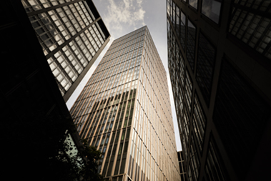
In the pulsating heart of the Frankfurt Central Business District, directly opposite Deutsche Bank, is where the Marienturm was constructed on the basis of drafts by the Berlin architects Thomas Müller and Ivan Reimann. The element facade was designed by FKN Fassaden, a company in the FKN Group based in Neuenstein. Innovative: inward-opening ventilation flaps with parallel projecting scissor stays from the “Roto PS Aintree” product range.

Photo: Lars Behrendt
Source: Roto Roto_Marienturm_1.jpg

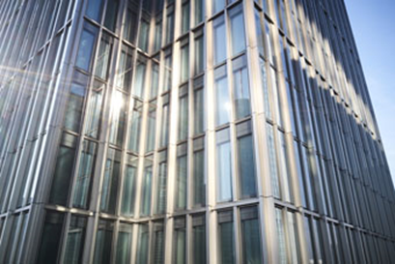
The even division of the facade by elegant aluminium elements in a shimmering warm silver tone highlights the sculptural shape of the 38-storey Frankfurt Marienturm. Facade specialist FKN used the fully concealed “Roto AL Designo” hardware for the Turn-Only windows.

Photo: Lars Behrendt
Source: Roto Roto_Marienturm_2.jpg

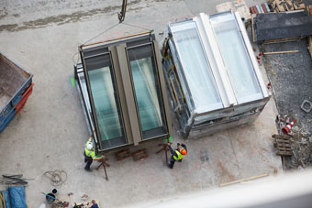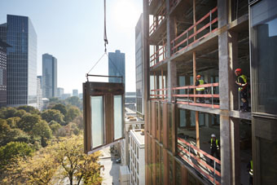
The facade manufacturer FKN produced facade elements and 4293 Turn-Only window sashes, equipped with the “Roto AL Designo” premium hardware, for the Marienturm in the banking metropolis of Frankfurt.

Photos: Lars Behrendt
Source: Roto Roto_Marienturm_3.jpg | Roto_Marienturm_4.jpg

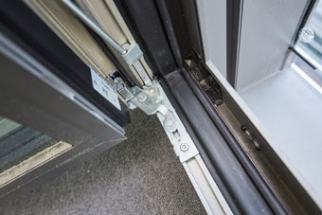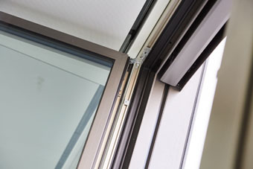
For the Turn-Only windows on the Frankfurt Marienturm, the Roto Object Business developed four hardware configurations consisting of components from the “Roto AL Designo” fully concealed Tilt&Turn hardware product range depending on the weight of the sashes..

Photos: Lars Behrendt
Source: Roto Roto_Marienturm_5.jpg | Roto_Marienturm_6.jpg

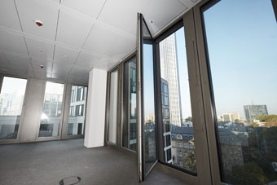
The facade specialist FKN used four versions of the “Roto AL Designo” hardware for the Frankfurt Marienturm’s Turn-Only balcony doors with a sash weight of up to 180 kg.

Photo: Lars Behrendt
Source: Roto Roto_Marienturm_7.jpg

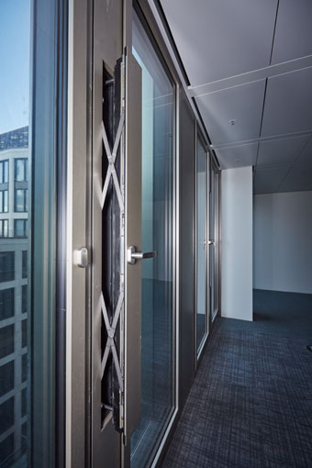
The inward-opening ventilation flaps on the Frankfurt Marienturm feature parallel projecting scissor stays from the “Roto PS Aintree” product range and Roto special corner drives. When open, the ventilation flaps in the facade manufactured by FKN ensure an extremely high air exchange rate.

Photo: Lars Behrendt
Source: Roto Roto_Marienturm_8.jpg

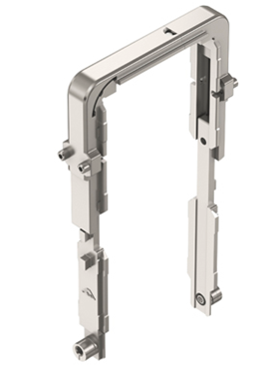
Thanks to a special corner drive specifically developed by Roto, the ventilation flaps which are integrated in the facade in addition to the Turn-Only windows are locked all the way round their circumference. This improves the sealing of the closed ventilation flap and therefore the thermal insulation in the facade.

Image: Roto Roto_Eckumlenkung.jpg

Text and images are available to download:
http://ftt.roto-frank.com/en/press/

Print free. Copy requested.
Dr. Sälzer Pressedienst, Lensbachstraße 10, 52159 Roetgen, Germany

Publisher: Roto Frank Fenster- und Türtechnologie GmbH • Wilhelm-Frank-Platz 1 • 70771 Leinfelden-Echterdingen • Germany • Tel.: +49 711 7598-0 • Fax: +49 711 7598-253 • info@roto-frank.com
Editor: Dr. Sälzer Pressedienst • Lensbachstraße 10 • 52159 Roetgen • Germany • Tel.: +49 2471 92128-65 • Fax: +49 2471 92128-67 • info@drsaelzer-pressedienst.de

