Press release

Date: 6th November 2019

Technical advice from the specialist: Roto solutions for ventilation flaps of the turning opening type and parallel swivel flaps / Concealed hardware even for very narrow sashes / Innovation: integrated turn restrictor / Special corner drives and active locking points for ventilation flaps of resistance class RC 2 / Reliable protection against sash warpage / Turning with suitable strikers without restrictions

Property-specific or with standard solutions:
Roto hardware concepts for aluminium ventilation flaps

Leinfelden-Echterdingen – Very high requirements on the energy efficiency of a building with large areas of fixed glazing or aspects such as necessary fall protection in high-rise buildings can lead to the installation of ventilation systems that are not controlled by users. However, it is now common knowledge that people often feel uncomfortable and anxious in rooms without any natural ventilation. This is why the demand for hardware solutions for narrow ventilation flaps, which are integrated in aluminium facades with fixed glazing, is growing. They give the users of the buildings the opportunity to supply outside air themselves. The technical consultants at Roto Aluvision have now developed, tested and produced individual hardware concepts for many modern aluminium facades and the ventilation flaps used in these systems.

In demand: intelligent hardware solutions for ventilation flaps
“The demand for hardware for ventilation flaps is growing dynamically,” explains Matthias Nagat, Head of Aluvision Range Marketing and Product Adaptation. At BAU 2019, Roto therefore presented a variety of project solutions that had already been implemented. When developing hardware configurations for ventilation flaps, close cooperation between the system supplier and Roto is always necessary so that the hardware can be designed to be compatible with the profile system. As a rule, ventilation flaps would be manufactured with sash widths of 170 mm to a maximum of 300 mm. According to Nagat, the installation space in which the hardware, which often has complex functions and many components, has to be placed is therefore very limited. Furthermore, mostly concealed hardware is requested, which requires more installation space in the rebate than surface-mounted hardware. Nevertheless, Roto now offers numerous sophisticated solutions.

Limited opening: ventilation flap with special hinge side
For the most popular opening type, turning, it was, for example, possible to limit the travel and opening angle of special hinge sides based on the “Roto AL Designo” in such a way that the ventilation flap virtually has an integrated opening restrictor. In this way, the opening width of a ventilation flap can be individually restricted on request, therefore preventing damage to the fittings or adjacent components, for example. A separate assembly for opening restriction with very short turn restrictor rods was also specially developed for a manufacturer.

Suitable for RC 2: ventilation flap with special corner drive
For high-quality ventilation flaps, Roto recommends the use of special corner drives which allow active locking points to be set on the hinge side by means of a connecting rod. This makes it possible to produce tightly sealed flaps, which can be suitable for RC 2, even where space is limited in the rebate of narrow sashes. At the same time, these active locking points counteract sash warpage, which can become a problem with ventilation flaps.

Protected: ventilation flaps with active locking
Ventilation flaps are usually continuous, often room-high, aluminium panels with a dark coating and without glass. The profiles are often exposed to extreme temperature fluctuations and the associated bimetallic effect. This can lead to sash warpage. Active locking also on the hinge side counteracts this. It pulls the ventilation flap back into the correct locking position during the closing process despite the tolerances caused by temperature fluctuations. At the same time, several active locking points ensure permanently tight sealing.

Plannable: mounting groove for special corner drive
If the system supplier and Roto agree on detailed project-related details, a suitable mounting groove for a special corner drive can often already be provided during development. If this is not possible, the special corner drive is fitted below the end cover of a ventilation flap by means of an opening (milling operation).

Special strikers for optimum opening characteristics
Ventilation flaps also present the hardware manufacturer with a particular challenge on the closing and locking side, as very narrow sash widths have an unfavourable effect on the kinematics and opening characteristics of a sash. Often, standard strikers cannot be used in this case because there would be a collision between the sash and the striker during opening. Critical geometric points of the sash cannot then turn beyond the strikers. Thermal separation would deteriorate. To solve this problem, Roto has also now developed tried-and-tested project solutions that aluminium window manufacturers can rely on. If, for example, flat strikers or strikers milled into the frame are installed, a very narrow sash can also be opened fully. Strikers and cams offset in the axial position are another possibility.

Roto Object Business advises and supports you
The consultants of the Roto Object Business build the bridge between facade planners, modern aluminium construction companies and the hardware developers of the Roto Aluvision division. Architects benefit from the consultants’ wealth of experience, the short response times of the Roto organisation to their enquiries and binding statements on the feasibility of a design. Metal constructors can be confident that the Roto range includes both surface-mounted and concealed hardware for very narrow window sashes and ventilation flaps.
Arrived: system suppliers offer solutions in their catalogues
Quite a few of the hardware configurations for ventilation flaps initially developed as a special solution for individual properties have found their way into the standard product range of the Roto Aluvision division. With this statement, Nagat sums up the success of the development work undertaken over recent years. Some of these solutions can also be found in the catalogues of system suppliers. However, the wealth of experience Roto has developed jointly with them goes far beyond this range. Contact with the Roto Object Business as early as the facade planning stage could therefore lead to optimised, tested solutions.

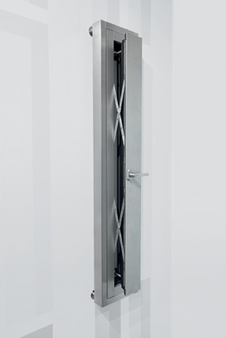
This ventilation flap with parallel projecting scissor stays from the “Roto PS Aintree” series ensures a very high air exchange rate when open.

Photo: Roto Roto_ventilation_flaps_1.jpg

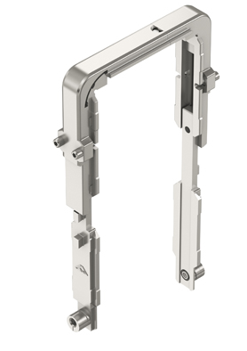
Ventilation flaps are locked around their circumference by a specially developed special corner drive. This improves the sealing of the closed ventilation flap and therefore the thermal insulation in the facade.

Photo: Roto Roto_ventilation_flaps_2.jpg

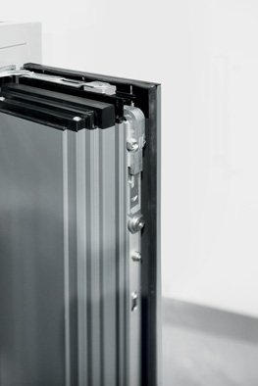
For high-quality ventilation flaps, Roto recommends the use of special corner drives which allow active locking points to be set on the hinge side by means of a connecting rod. This makes it possible to produce tightly sealed flaps, which can be suitable for RC 2, even where space is limited in the rebate of narrow sashes. At the same time, these active locking points counteract sash warpage, which can become a problem with ventilation flaps.

Photo: Roto Roto_ventilation_flaps_3.jpg
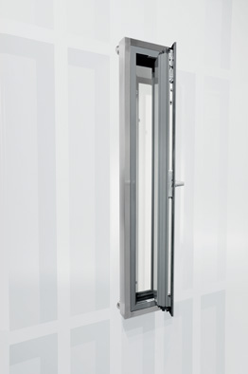
For the most popular opening type, turning, Roto made it possible to limit the travel and opening angle of special hinge sides based on the “Roto AL Designo” in such a way that the ventilation flap virtually has an integrated opening restrictor. In this way, the opening width of a ventilation flap can be individually restricted on request, therefore preventing damage to the fittings or adjacent components, for example.

Photo: Roto Roto_ventilation_flaps_4.jpg

Text and images are available to download:
http://ftt.roto-frank.com/en/press/

Print free. Copy requested.
Dr. Sälzer Pressedienst, Lensbachstraße 10, 52159 Roetgen, Germany

Publisher: Roto Frank Fenster- und Türtechnologie GmbH • Wilhelm-Frank-Platz 1 • 70771 Leinfelden-Echterdingen • Germany • Tel.: +49 711 7598-0 • Fax: +49 711 7598-253 • info@roto-frank.com
Editor: Dr. Sälzer Pressedienst • Lensbachstraße 10 • 52159 Roetgen • Germany • Tel.: +49 2471 92128-65 • Fax: +49 2471 92128-67 • info@drsaelzer-pressedienst.de

