Press release

Date: 11th June 2019

For aluminium windows with different opening types: new lockable opening restrictor from Roto for the Euro-groove / Opening width can be individually selected / Lockable handle prevents unlocking by unauthorised individuals / Open, turn, lock – intuitively using the window handle / Easy to clamp / No additional work needed on the profiles

New from Roto for aluminium windows: opening restrictor which locks in the end position and is controlled by the handle

Leinfelden-Echterdingen – The demand for Turn-Only windows with an opening width that can be individually restricted for certain users is increasing across the world. While the facility management team should be able to fully open every sash at all times, the turning movement is purposely limited for employees or hotel guests, for example. For years now, the experts from the Roto Object Business team have been developing ideal hardware concepts for buildings, no matter what they are used for.

Custom solutions in series production
This has given rise to a product concept which has been generating a great deal of interest among specialist planners and metal constructors since being presented at the BAU 2019 trade fair. An opening restrictor that is ideal for both inward opening and outward opening aluminium windows which are opened by turning, folding and lowering then folding was on display at the trade fair. This restrictor boasts impressive installation advantages.

Insert, clamp – done!
The lockable opening restrictor is available in both a screw-in (shown in the image) and clampable version. No additional work needs to be performed on the frame profile or sash profile when installing the clampable version. In this case, the compatible assembly is simply inserted into the sash groove and clamped with piercing screws. On the frame, the opening restrictor is attached using a frame bearing which is also clamped with piercing screws. This means that the opening restrictor technology is fully concealed in the groove and is not visible from the outside.

Controlled by the handle and intuitive to operate
The opening restrictor is controlled by the handle only. Using the proven “Roto TiltFirst” window handle technology means that users only have the 0° or 90° handle positions to choose from. They are therefore only able to close or open a sash as far as the defined end stop position and lock it there. The handle then prevents the opened sash at the defined opening width from slamming shut in windy and draughty conditions. The sash is locked by moving the handle at the end stop from the 90° position back into the 0° locked position. Only authorised staff are able to unlock the handle on the cylinder using a removable key when the sash is closed and disable the turn restrictor by turning the handle to 180°.

Ideal for rooms where the users are constantly changing
Using this innovative Roto opening restrictor results in a convenient solution that ensures that sashes stop at a defined opening width and are locked in this end stop position using the handle. Its intuitive operation and sturdy design also make the new opening restrictor suitable for buildings and rooms where the users are constantly changing, such as hotels.

Technical consultation from the Roto Object Business
The specialists at the Roto Object Business advise aluminium window manufacturers and specialist planners to use the new opening restrictor. On the basis of the sash width, sash depth and required opening width, the Roto Object Business assesses a custom hardware configuration for its technical feasibility, adapts it to the specific property and visualises it in model form to start with. If an order is placed, the metal constructor receives an installation drawing that is specifically tailored to this application. It is recommended that you involve the Roto Object Business in the planning process at the earliest possible stage. This ensures that the required version of the opening restrictor which locks in the end position can be delivered on time.

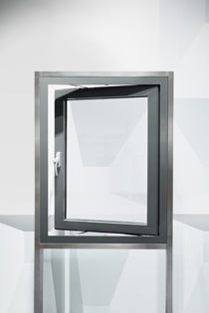
New for aluminium windows: the lockable opening restrictor from Roto. The sash is locked by moving the handle at the end stop from the 90° position back into the 0° locked position. Only authorised staff are able to unlock the handle using a removable key on the cylinder when the sash is closed and disable the turn restrictor by turning the handle to 180°.

Photo: Roto Roto_AL_turn_opening_restrictor_1.jpg

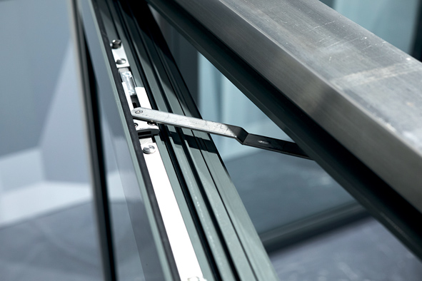
The robust solution for protecting high-quality aluminium Turn-Only windows: using Roto’s innovative opening restrictor makes it possible to open a window sash up to a defined opening width and lock it in the end stop position simply using the handle.

Photo: Roto Roto_AL_turn_opening_restrictor_2.jpg
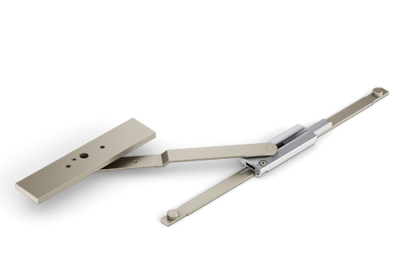
The lockable opening restrictor is available in both a screw-in (shown in the image) and clampable version. No additional work needs to be performed on the frame profile or sash profile when installing the clampable version. In this case, the compatible assembly is simply inserted into the sash groove and clamped with piercing screws. On the frame, the opening restrictor is attached using a frame bearing which is also clamped with piercing screws. This means that the opening restrictor technology is fully concealed in the groove and is not visible from the outside.

Photo: Roto Roto_AL_turn_opening_restrictor_3.jpg

Text and images are available to download:
http://ftt.roto-frank.com/en/press/

Print free. Copy requested.
Dr. Sälzer Pressedienst, Lensbachstraße 10, 52159 Roetgen, Germany

Publisher: Roto Frank AG • Wilhelm-Frank-Platz 1 • 70771 Leinfelden-Echterdingen • Germany • Tel.: +49 711 7598-0 • Fax: +49 711 7598-253 • info@roto-frank.com
Editor: Dr. Sälzer Pressedienst • Lensbachstraße 10 • 52159 Roetgen • Germany • Tel.: +49 2471 92128-65 • Fax: +49 2471 92128-67 • info@drsaelzer-pressedienst.de

