Press release

Date: 4th December 2019

Extended application range of “Roto AL” for room-height windows and balcony doors / Tested security as standard for Turn-Only, Tilt-Only, Tilt&Turn and TiltFirst windows / Save time in the offer phase without the need for special approval / Production time reduced thanks to preassembled component

Range of applications is extended once again: “Roto AL” for sash heights up to 3000 mm

Leinfelden-Echterdingen – The trend for really tall windows and balcony doors made of aluminium is showing no sign of abating and is driving the need for special approvals for hardware solutions. In response to this, this year Roto subjected further hardware configurations from the “Roto AL” product range to extensive testing for sashes up to 3000 mm high. This way, window manufacturers will in future be able to submit their offer for an even greater number of elements without having to wait for special approval.

Tests passed
A new set of installation instructions will be released in January 2020 on the basis of the tests that were passed. After publication, the solutions from the “Roto AL” product range presented in these instructions can be manufactured up to a sash height of 3000 mm without the need for special approval. Aluminium windows of the Turn-Only, Tilt-Only, Tilt&Turn and TiltFirst opening types were put through their paces.

“Roto AL” with extended standard from January 2020
Included in the new installation instructions is the new and special “Roto AL” hinge side set for elements up to a sash height of 3000 mm. This set consists of the familiar components for the 130 kg hinge side and a reinforced corner hinge. The corner hinge and pivot rest are available in the form of preassembled components for DIN right and DIN left sashes, which reduces the installation time in window production. The height can be conveniently adjusted directly via the sash roller when the sash is either tilted or turned. An adjusting screw integrated in the corner hinge can be adjusted using a hex key, size 4 mm, across a distance from +1.5 mm to -1 mm. The new hinge side set is offered in any colour of your choice.

Strong consultation
If windows taller than 3000 mm are to be made available, Roto Aluvision will continue to support window manufacturers in future by proving fast, binding statements on feasibility and necessary testing or special approval. Matthias Kosog, Category Manager Tilt&Turn Aluvision, points out that: “It goes without saying that Roto is working on continuously expanding the application range of ‘Roto AL’ with standard components. The fact remains, however, that when a window cannot be produced with a standard solution included in the installation instructions, we are also the right point of contact because of the outstanding consultation we offer. ‘You can always count on Roto!’ We prove this almost on a daily basis with property-specific solutions which allow window manufacturers to meet virtually any customer requirement.”

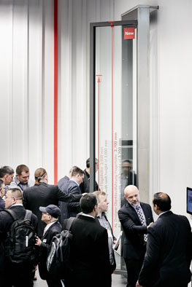
The new “Roto AL” hinge side set for large aluminium windows will become part of the Roto Aluvision standard product range in January 2020. This means that special approval is no longer necessary in order to use “Roto AL” for sash heights up to 3000 mm. The new hinge side set is available in any colour of your choice.

Photo: Roto Roto_AL_up_to_3000_mm.jpg
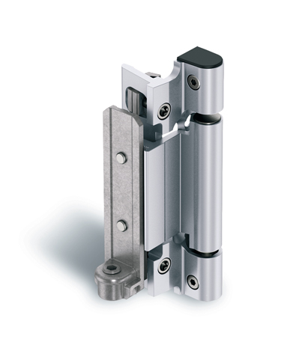
Tested security for aluminium windows and balcony doors up to a sash height of 3000 mm: the new, reinforced “Roto AL” corner hinge / pivot rest for elements up to a sash height of 3000 mm is supplied preassembled for DIN right and DIN left sashes. This saves time in production and increases process reliability when manufacturing large windows.

Photo: Roto Roto_AL_corner_hinge_pivot_rest_up_to_3000_mm.jpg

Text and images are available to download:
http://ftt.roto-frank.com/en/press/

Print free. Copy requested.
Dr. Sälzer Pressedienst, Lensbachstraße 10, 52159 Roetgen, Germany

Publisher: Roto Frank Fenster- und Türtechnologie GmbH • Wilhelm-Frank-Platz 1 • 70771 Leinfelden-Echterdingen • Germany • Tel.: +49 711 7598-0 • Fax: +49 711 7598-253 • info@roto-frank.com
Editor: Dr. Sälzer Pressedienst • Lensbachstraße 10 • 52159 Roetgen • Germany • Tel.: +49 2471 92128-65 • Fax: +49 2471 92128-67 • info@drsaelzer-pressedienst.de

