Press release

Date: 14th January 2019

“Roto Solid C” concealed door hinge suitable for use in many conventional profiles as standard / Can be used on the right and left / “FixClick” function simplifies fast and safe installation, even of heavy doors / Three centrally adjustable hinges / Optional installation assistance set available from Roto / Video about installation and adjustment

Heavy doors the easy way: producing and installing entrance doors efficiently with “Roto Solid C”

Leinfelden-Echterdingen / Munich – The “Roto Solid C” concealed door hinge is full of innovations which simplify the production and installation of heavy aluminium doors. Roto has systematically developed the hinge so that it is already suitable for use in many conventional profiles as standard, explains Matthias Nagat, Head of Aluvision Range Marketing and Product Adaptation.

Ready for series production
The sash hinge and frame hinge in the new Roto door hinge come packaged separately. This allows sashes and frames to be equipped with the relevant components at different workstations. Because it is symmetrical on the left and right-hand side, “Solid C” reduces the storage space requirements at both workstations and prevents possible sources of error. Carrying out work on the door hinge is efficient because the routing for the hinge and lock is performed with the same tool – and all this even in the smallest possible routing space. Application engineers from Roto Aluvision or Roto Door Sales can provide training to a user’s employees on request, explaining how to work with the new door hinge directly at their workstations.

Door installation made easy
The “Solid C” reveals its other strengths during door installation: the FixClick function, developed in-house, enables the leaf to be hinged quickly and securely and permanently holds the door in the support-bracket. A clear “click” provides visual and audible confirmation that the sash has locked into place. Installation of the leaf is also made simpler when the tools from the installation set are used, which can be ordered as an accessory. With the combination tool and the patented locking wedges, installation is no trouble. The wedges fix the hinge supports in position, so that they do not move during hinging.

Centrally adjustable
Once the door leaf is hinged, the height is adjusted between -2 to +4 mm centrally and quickly only at the bottom-most hinge. Because all hinges are easy to access in most profile systems, it is possible to adjust the height and gasket compression (±1.2 mm) as well as perform lateral adjustment (±3 mm) at a later stage without any problems. The Roto combination tool can also be used to loosen the spring clip again extremely simply, if the leaf needs to be unhinged again. The anti-jemmy device is also fitted conveniently with this tool after hinging. It is also possible to order all components in the installation assistance set separately.

Installation video
Roto Aluvision also demonstrates online how installing the door and adjusting the “Solid C” is particularly simple: an installation video guides the viewer through each step of the installation process in detail. Fitters can use a QR code for direct access to the website www.roto-frank.com and installation video via smartphone. Roto recommends that you take a sales document with this QR code with you to the construction site.

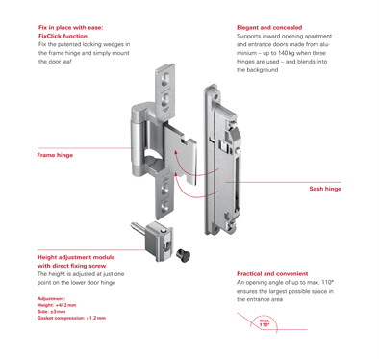
The “Roto Solid C” concealed door hinge reduces the time and costs required for producing, installing and maintaining an entrance door. It is already suitable for use in many conventional profiles as standard. Custom solutions for additional profile systems are also possible.

Photo: Roto Roto_Solid_C_Rahmen_und_Fluegelband_caption.jpg

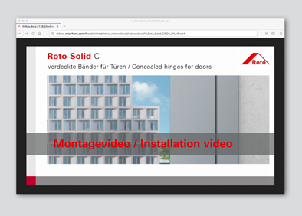
Step-by-step door installation and adjustment of the “Roto Solid C”: an installation video on Roto’s website shows how it’s done.

Photo: Roto Roto_Solid_C _Montagevideo.jpg

Text and images are available to download:
http://ftt.roto-frank.com/en/press/

Print free. Copy requested.
Dr. Sälzer Pressedienst, Lensbachstraße 10, 52159 Roetgen, Germany

Publisher: Roto Frank AG • Wilhelm-Frank-Platz 1 • 70771 Leinfelden-Echterdingen • Germany • Tel. +49 711 7598 0 • Fax +49 711 7598 253 • info@roto-frank.com
Editor: Dr. Sälzer Pressedienst • Lensbachstraße 10 • 52159 Roetgen • Germany • Tel.: +49 2471 92128-65 • Fax: +49 2471 92128-67 • info@drsaelzer-pressedienst.de

