Press release

Date: 14th January 2019

New Roto door hinge for aluminium entrance doors with sleek outlines / Suitable for use in many conventional profile systems as standard / Burglar inhibiting in accordance with RC 2 / Maximum corrosion resistance in accordance with Class 5 of DIN EN 1670

New in the Roto Door range: “Roto Solid C” concealed door hinge for modern aluminium main doors

Leinfelden-Echterdingen / Munich – Demands for a new main entrance door are constantly increasing. This is because a main entrance door creates a visitor’s first impression of a home, and it should ideally be a welcoming one. For this reason, its design has particular significance for many builders. At the same time, this door should be able to reliably withstand burglary attempts without the retrofitted surface-mounted visible locks and deadbolts spoiling its appearance. With the new “Roto Solid C” concealed door hinge, Roto is now offering manufacturers of aluminium doors a particularly attractive system for producing this kind of main door. It is already suitable for use in many conventional profiles as standard. Custom solutions for additional profile systems are also possible.

For modern doors with sleek outlines
An increasing number of builders are opting for large main entrance doors with sleek outlines, a robust appearance and a modern look. The “Solid C” concealed door hinge presented by Roto Aluvision at the BAU 2019 trade fair caters to this trend. At the same time, it meets the increasingly stringent requirements for a high level of burglary protection and durability. It reliably ensures that even doors weighing 140 kg are easy to open and close. In addition, the concealed hinge helps achieve burglar inhibiting door equipment in accordance with RC 2.

Main entrance doors for the premium segment
“Solid C” is available in the colours silver and black. Its surface meets the highest requirements for corrosion resistance in accordance with Class 5 of DIN EN 1670. The concealed “Solid C” has proven its effortless durability even over 400,000 cycles.

Thanks to the concealed mechanics, a main entrance door equipped with “Solid C” is extremely easy and convenient to clean. The uninterrupted gasket level minimises heat losses. The self-lubricating bush in the new door hinge means that no maintenance on the door is required..

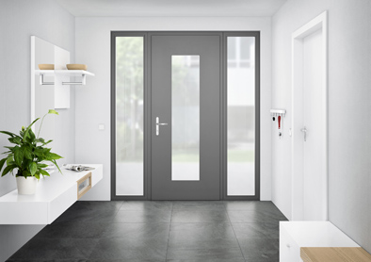
The new “Roto Solid C” concealed door hinge makes it possible to produce high-quality, burglar inhibiting aluminium entrance doors with a design that caters to the trend for sleek outlines.

Photo: Roto Roto_Solid_C.jpg

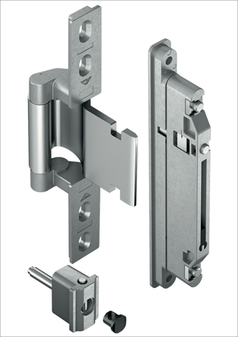
The “Roto Solid C” concealed door hinge with self-lubricating bush ensures lasting safe and convenient use of the entrance door, even without any maintenance.

Photo: Roto Roto_Solid_C_Rahmen_und_Fluegelband.jpg

Text and images are available to download:
http://ftt.roto-frank.com/en/press/

Print free. Copy requested.
Dr. Sälzer Pressedienst, Lensbachstraße 10, 52159 Roetgen, Germany

Publisher: Roto Frank AG • Wilhelm-Frank-Platz 1 • 70771 Leinfelden-Echterdingen • Germany • Tel.: +49 711 7598-0 • Fax: +49 711 7598-253 • info@roto-frank.com
Editor: Dr. Sälzer Pressedienst • Lensbachstraße 10 • 52159 Roetgen • Germany • Tel.: +49 2471 92128-65 • Fax: +49 2471 92128-67 • info@drsaelzer-pressedienst.de

