Press release

Date: 14th May 2019

On trend: aluminium windows and ventilation flaps flush with the surface with property-specific hardware from Roto / Internationally recognised: Roto special hardware for aluminium Turn-Only sashes up to 250 kg / Additional ventilation function: Roto turn restrictor in windows flush with the surface / Proper operation ensured in the long term with extremely high sash weights thanks to Roto sash lifter

For aluminium windows flush with the surface: Roto hardware concepts based on requirements

Leinfelden-Echterdingen – The trend for room-height window elements with high thermal and sound insulation is showing no signs of abating in the aluminium facade market. At the same time, concealed hardware is also in demand here for the best design, even on heavy, large sashes. The requirement for concealed heavy-duty hardware which can also be used in profiles for aluminium windows flush with the surface is also new in an increasing number of markets. Roto offers comprehensive technical consultation and property-specific custom solutions for this.

Many years of experience
Thanks to the long-standing work of the specialists at the Roto Object Business, Roto has, according to its own statements, a huge wealth of experience in designing hardware configurations for aluminium windows flush with the surface. Numerous custom solutions have already been developed and tested, which can function reliably in ventilation flaps and Turn-Only windows made of aluminium, even with high sash weights up to 250 kg. In the case of extremely high sash weights, the hinge side is screwed into both the frame and the sash with special self-tapping screws by Roto.

Sash lifter for heavy sashes
In the case of extremely high sash weights, the hardware specialist recommends using a sash lifter for increased comfort, as this lifts the sash during the closing movement and therefore ensures that the sash is closed gently without any collisions. At the same time, the sash lifter protects the hinge side when closed. This has the effect of relieving the load on the sash, as it provides additional support for the sash.

Ventilation function with turn restrictor
If a ventilation function is required in addition to the turning movement, Roto recommends using one or two turn restrictors. These can be installed either horizontally only at the top or only at the bottom or alternatively one at the top and one at the bottom. Until now, Roto had been avoiding producing special hardware for aluminium windows that are flush with the surface, are of the Tilt&Turn opening type and have a sash weight of over 200 kg. The reason for this is that, from the manufacturer’s point of view, sashes in this weight class cannot be operated conveniently. The force required to move this kind of sash from the tilt position and back into the locked position to close it is considerable and not very user-friendly.

Tested solutions
In aluminium profile systems that are flush with the surface, a 17.5 mm rebate clearance must be ensured for the hardware instead of the usual 11.5 mm in the Euro-groove. This is the only way to fit a hardware configuration for sashes with a high weight. Roto produces the necessary hardware in the batch size corresponding to the specific construction project, in other words in the individual quantities required the window manufacturer. Joint, careful planning with the system provider is essential here.

Virtually invisible
Since, in window systems that are flush with the surface, a shadow joint of around 6 mm where the hardware components are visible forms between the sash and frame, Roto offers special hardware for windows flush with the surface that is also chrome-plated or painted black – and all this without any surcharge. The appearance of the hardware, shadow joint and black EPDM central gasket are then combined to form a single unit.

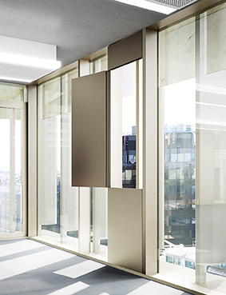
The demand for hardware for aluminium profiles to produce windows or ventilation elements flush with the surface is coming from an increasing number of markets. The Roto Object Business draws on its many years of experience to advise on custom solutions, even for sashes with high weights.

Photo: Roto Roto_AL_flush_1.jpg

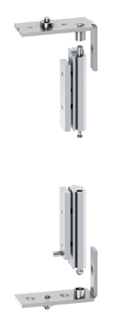

Roto Aluvision configures property-specific heavy-duty hardware for profiles flush with the surface that achieve a load of up to 250 kg sash weight. The image shoes the pivot rest and corner hinge at the top and bottom. In the case of high sash weights, they are attached using special self-tapping screws.

Photo: Roto Roto_AL_flush_2.jpg

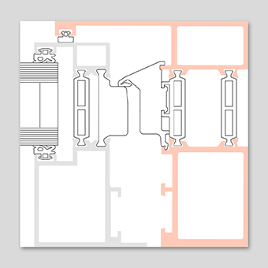

Profiles for a window that is flush with the surface must offer a 17.5 mm rebate clearance for the hardware instead of the usual 11.5 mm in the Euro-groove. This is the only way to fit a user-friendly hardware configuration for sashes with a high weight.

Photo: Roto Roto_AL_flush_3.jpg

Text and images are available to download:
http://ftt.roto-frank.com/en/press/

Print free. Copy requested.
Dr. Sälzer Pressedienst, Lensbachstraße 10, 52159 Roetgen, Germany

Publisher: Roto Frank Fenster- und Türtechnologie GmbH • Wilhelm-Frank-Platz 1 • 70771 Leinfelden-Echterdingen • Germany • Tel.: +49 711 7598-0 • Fax: +49 711 7598-253 • info@roto-frank.com
Editor: Dr. Sälzer Pressedienst • Lensbachstraße 10 • 52159 Roetgen • Germany • Tel.: +49 2471 92128-65 • Fax: +49 2471 92128-67 • info@drsaelzer-pressedienst.de

