Press release

Date: 12th March 2018

New accessory in Roto’s range of friction scissor stays / Retainer with multi-stage locking function for Top-Hung windows / Reliable locking of window sashes / For sash formats up to 900 mm x 2500 mm

New retainer from Roto for Top-Hung windows

Leinfelden-Echterdingen – In many regions where outward opening windows are popular thanks to their tight seal, high wind loads place a key role in designing windows. The high-quality “Roto FS Kempton” friction scissor stays ensure that window sashes can be opened outwards in a controlled and safe manner, even in strong winds. Roto has now added a useful accessory to the range in the form of a new retainer for Top-Hung windows, i.e. outward opening hinged windows.

The new retainer for Top-Hung windows features a multi-stage locking function and also allows the window sash to be reliably locked in the selected opening position. This ensures that the sash does not slam shut or swing open in sudden gusts of wind.

The retainer is available in three different sizes so that it can be ideally combined with the Roto friction scissor stays from the HX, TH and HB TH series in sizes of 16", 22" and 26". The Roto retainer can be used on the left and right and must be fitted to the sash in pairs. Sashes up to a maximum size of 900 mm x 2500 mm can be equipped with the retainer.

Extremely corrosion-resistant
The new retainer is manufactured from austenitic stainless steel (grade 1.4301) in the same way as the friction scissor stays from the “Roto FS Kempton” range. This makes it highly resistant to corrosion and ideal for use near the coast or in heavily industrialised regions. The retainer is also tested in accordance with BS 6375-2:2009.

All information about the new retainer and Roto’s range of friction scissor stays is compiled in the “Roto FS Kempton” general catalogue, which is available to download in German and English at www.roto-frank.com.

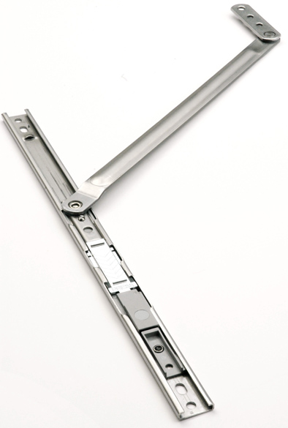
The new Roto retainer from the “Roto FS Kempton” range for Top-Hung windows features a multi-stage locking function and also allows a window sash to be reliably locked in the selected opening position. This ensures that the sash does not slam shut or swing open in sudden gusts of wind.

Photo: Roto

Print free. Copy requested.

Publisher: Roto Frank AG • Wilhelm-Frank-Platz 1 • 70771 Leinfelden-Echterdingen Germany • Tel.: +49 711 7598-0 • Fax: +49 711 7598-253 • info@roto-frank.com
Editor: Dr. Sälzer Pressedienst • Lensbachstraße 10 • 52159 Roetgen • Germany Tel.: +49 2471 92128-65 • Fax: +49 2471 92128-67 • info@drsaelzer-pressedienst.de

