Press release

Date: 27th November 2018

On-trend
Stainless-steel design and gold for visible hardware technology on aluminium windows

Leinfelden-Echterdingen – Extremely large-scale window elements and high weights are posing particular challenges in the construction of aluminium windows. This is because the design of these elements must be impressive even when heavy-duty hardware with a surface-mounted hinge side is required. For this reason, Roto Aluvision coats this hardware as well as espagnolette handles and various accessories from the “Roto AL” and “Roto AL Designo” product ranges according to the needs of the manufacturer or their customers. The electroplated surfaces in a stainless-steel design and gold are becoming ever more popular.

“For example, demanding designers want door lever handles, sanitary fittings and even the smallest details on the window to produce a uniform, harmonious appearance,“ reports Matthias Nagat, Head of Aluvision Range Marketing and Product Adaptation. “This is why our customers are happy that we can supply hardware components with a suitable surface. In particular, the demand for the fine surfaces in a stainless-steel design and gold is continuing to increase.”

Variety for demanding designers
Roto Aluvision offers these electroplated surfaces and powder coatings for hinges, espagnolette handles and accessories such as turn locks from the “AL” and “AL Designo” hardware product ranges. “Of course the concealed Designo hinges don’t need to be coated, but we also offer support with designing the surfaces for all visible components from this product range.”

Combined to form a unit
When what matters is letting the technology on the window play a more minor role, the aforementioned components can be coated in the colour of the window profile. By being coated in the same colour, the hinge side, espagnolette handles and window profile are combined to form a single unit. This way, surface-mounted heavy-duty hinges are barely noticeable.

For strong branding
“An increasing number of window manufacturers are now using hardware to set themselves apart from the competition,” continues Nagat. This is why Roto has been printing its logo on handles and geared-handles for years now. A hinge and handle colour tailored to this logo helps to make the product stand out on the market.

Roto can coat the components within seven working days with the RAL colours that are in stock. A surcharge for special colours other than the 200 defined RAL colours will only be charged for small quantities. Hinges and espagnolette handles with electroplated surfaces in gold and a stainless-steel design are ready for delivery within three to four weeks.

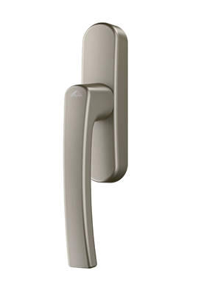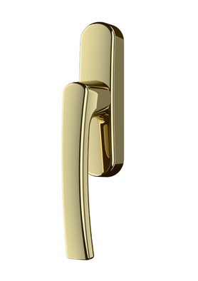
Elegant surfaces: stainless-steel design and gold for espagnolette handles, hinge sides or accessories such as turn locks from the “AL” and “AL Designo” product ranges. Roto can add its logo to the handle or the geared-handle on request. It is also possible for the handle or geared-handle to be supplied without the printed logo. Handles come with the Roto logo as standard.

Photos: Roto

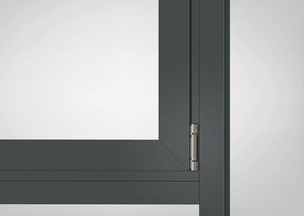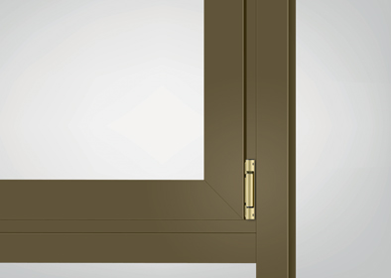
Good design for load-transfer components: Roto Aluvision not only supplies surface-mounted “AL” window hinges powder-coated in RAL colours, but also with a fine gold or stainless-steel appearance.

Photos: Roto

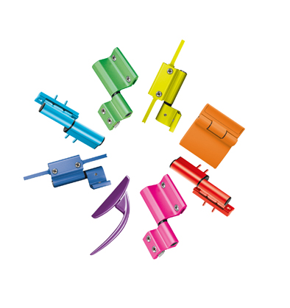
Roto powder-coats espagnolette handles, hinge sides and various accessories from the “AL” and “AL Designo” product ranges with more than 200 RAL colours or a special colour on request.

Photo: Roto

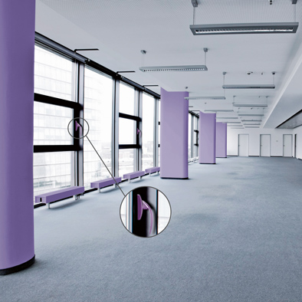
Hardware components with a coloured coating help to implement colour concepts for individual floors or rooms in a building.

Photo: Roto

Text and images are available to download:
http://ftt.roto-frank.com/en/press/

Print free. Copy requested.
Dr. Sälzer Pressedienst, Lensbachstraße 10, 52159 Roetgen, Germany

Publisher: Roto Frank AG • Wilhelm-Frank-Platz 1 • 70771 Leinfelden-Echterdingen • Germany • Tel.: +49 711 7598-0 • Fax: +49 711 7598-253 • info@roto-frank.com
Editor: Dr. Sälzer Pressedienst • Lensbachstraße 10 • 52159 Roetgen • Germany • Tel.: +49 2471 92128-65 • Fax: +49 2471 92128-67 • info@drsaelzer-pressedienst.de

