Press release

Date: 14th May 2018

Expanded application range of “Roto AL” / New Turn-Only hinge for Top-Hung and Side-Hung windows / Equipped to meet special requirements in outward opening windows / Proven technology for windows that remain reliable in the long term

New Turn-Only hinge for outward opening windows

Leinfelden-Echterdingen – The Tilt&Turn hinge from the “Roto AL” product range has been proving its strengths in inward opening aluminium windows for years now. The range is being supplemented by a newly developed Turn-Only hinge with special modifications for outward opening Top-Hung and Side-Hung windows, which is now available to processors of “Roto AL”. Window manufacturers and builders benefit from its robust, durable quality.

Since Turn-Only hinges on outward opening windows are exposed to the weather, Roto has made the new “Roto AL” Turn-Only hinges weatherproof and UV-resistant. For instance, the pivot support bushes in the Turn-Only hinge are made from UV-resistant and weatherproof PVC, which also has optimum sliding properties. The new “Roto AL” Turn-Only hinge for outward opening Top-Hung and Side-Hung windows therefore ensures functional safety for a long window service life. It is screwed into the sash and also into the frame. This allows even high tractive forces to be handled.

Threaded pin protects against external access
The “Roto AL” Turn-Only hinge for outward opening Top-Hung and Side-Hung windows has a threaded pin, which prevents the bearing pin newly developed for this application from being removed from the outside. The threaded pin can only be loosened when the window sash is open, which means that unauthorised access by third parties is impossible.

Proven solutions for sashes up to 70 and 100 kg
Top-Hung windows with a sash weight of up to 70 kg, a height of up to 1200 mm and a width of up to 2400 mm are equipped with three “Roto AL” Turn-Only hinges. Roto stipulates that five Turn-Only hinges must be used for sashes weighing up to 100 kg. This application is suitable for sashes with a height of up to 2000 mm and a width of up to 2000 mm. The new “Roto AL” Turn-Only hinges are also ideal for Side-Hung windows with a sash weight of up to 70 kg, a maximum height of 2285 mm and a width of 1435 mm. Three hinges are installed in this application.

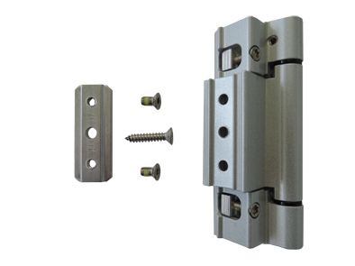
The Tilt&Turn hinge from the “Roto AL” product range has been impressing with its robustness and reliable functionality for years now. A Turn-Only hinge for outward opening Top-Hung and Side-Hung windows is a new development.

Photo: Roto Roto_AL_Drehband_1.jpg

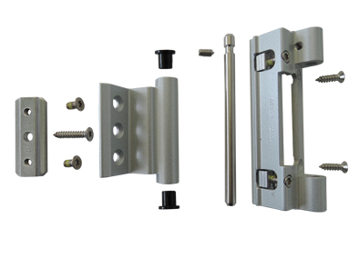
Since Turn-Only hinges on outward opening windows are exposed to the weather, Roto has made the components affected, such as the pivot support bushes, from UV-resistant and weatherproof PVC. It also has optimum sliding properties.

Photo: Roto Roto_AL_Drehband_2.jpg

Print free. Copy requested.
Dr. Sälzer Pressedienst, Lensbachstraße 10, 52159 Roetgen, Germany

Publisher: Roto Frank AG • Wilhelm-Frank-Platz 1 • 70771 Leinfelden-Echterdingen Germany • Tel.: +49 711 7598-0 • Fax: +49 711 7598-253 • info@roto-frank.com
Editor: Dr. Sälzer Pressedienst • Lensbachstraße 10 • 52159 Roetgen • Germany Tel.: +49 2471 92128-65 • Fax: +49 2471 92128-67 • info@drsaelzer-pressedienst.de

