Press release

Date: 17th September 2018

Sliding hardware by Roto ensures flexibility in designing aluminium windows / Easy to use, tightly sealed, burglar inhibiting: Roto sliding hardware for comfort and security / Advice from Roto on the best solution for a specific property

Creating the ideal aluminium sliding system with Roto hardware: comfort and security according to needs and requirements

Leinfelden-Echterdingen – Large aluminium balcony doors are popular for good reason, as they bring light into homes and provide direct access to gardens or balconies. Nowadays, planning engineers and builders prefer to rely on sliding systems which offer a crucial advantage – in addition to a wider opening – compared to balcony doors with Tilt&Turn opening: opening the sliding sashes in such a way that they take up little space enables the room to be used optimally since no sash projects into the living area. In cooperation with hardware specialist Roto, window manufacturers are now producing sliding systems which offer a great deal of comfort and convenience for various building types and applications. They feature versatile ventilation functions and provide effective resistance to burglary attempts thanks to special components. The following article offers a brief overview of solutions that are especially sought-after in the construction of aluminium windows.

Triple or sun protection glazing in window sashes, as well as the window widths and heights that are standard today, lead to high sash weights and increasing challenges for window manufacturers and hardware. The crux of the matter is that users still expect even large sliding systems with a heavy sash to be easy to use and to provide the same tight seal as a Tilt&Turn window. In many cases, there are also demands for a high level of ventilation comfort and reliable burglary resistance. With its range of different sliding hardware solutions, Roto offers solutions for each of these requirements.

Durable thanks to high level of corrosion protection
Even the entry-level “Roto Patio Inline” sliding system provides functional safety and outstanding comfort. It has a modular design and makes sashes weighing up to 200 kg easy to slide. As fully concealed hardware with multipoint locking, “Roto Inline” boasts an attractive appearance, while its good burglary resistance impresses, depending on the number of Roto security components that are installed. Thanks to the “Roto Sil” surface finish, “Roto Inline”, like all of Roto’s hardware, is also extremely scratch-resistant and features outstanding protection against corrosion, even in regions with high air humidity.

For heavy and large sashes
Roto recommends its “Roto Patio Lift” Lift&Slide system for particularly large and heavy elements. This hardware succeeds in moving aluminium sashes with ease, even when they reach weights of up to 400 kg. And the possible sash heights and widths of up to 3000 mm make this hardware the right choice for properties where exceptionally large building elements are intended to bring a lot of light into the living areas. “Roto Patio Lift” opens and closes a sash in the conventional manner, by lifting, sliding, lowering and locking. Optional locking components make it possible for the system to be designed as a Lift&Slide system with night ventilation. In this version, Invisible from the outside when open, the slightly retracted sash ensures a permanent exchange of air. The “Roto Patio Lift” can also be adapted to meet various safety and security requirements.

Maximum operating and ventilation convenience
The “Roto Patio Alversa” universal Parallel Sliding and Tilt&Slide hardware, with its innovative locking and opening mechanism, provides maximum operating convenience. This mechanism and special damping elements mean that the sash is particularly quiet when moved and can be opened and closed without using force. Depending on the variant chosen, “Roto Patio Alversa” helps create Parallel Sliding and Tilt&Slide systems up to a sash weight of 200 kg with different opening versions and integrated night and tilt ventilation. The installation of Roto security components, such as security mushroom cams, security strikers and lockable handles, provides a particularly high level of burglary protection.

Tightly sealed on each floor
The “Roto Patio Inowa” hardware product range impresses with convenient and quiet operation and, above all, a tight seal. A sliding system’s high level of resistance against wind and driving rain, which is frequently necessary in the upper floors of multi-storey buildings, can be reliably achieved with this hardware. The thermal insulation also benefits from use of the tightly sealed “Roto Patio Inowa” system. Thanks to the hardware’s closing movement perpendicular to the frame profile and a circumferential sealing profile, sliding systems equipped with this hardware are not only tightly sealed but can also be opened and closed particularly conveniently and with little force. The entire technology remains invisible and the hardware is fully concealed. A “Roto Patio Inowa” sliding system can also be equipped with Roto security components on request.

For accessible sliding systems
“Roto Patio Fold” serves as an accessible, especially wide transition between indoor areas and a patio. This hardware opens and closes Fold&Slide systems with up to seven elements at a width of up to six metres. These systems can be folded and pushed to the side to save space. An eighth element can take the form of a Tilt&Turn or Turn-Only sash on the opposite reveal. Posing no trip hazard and accessible in accordance with DIN 18040, “Roto Patio Fold” Fold&Slide systems are equipped with the “Roto Eifel” enhanced threshold. The sliding system produced in this way complies with the Thermal Insulation Ordinance applicable in Germany.

Advice on special solutions
The specialists from the Roto Object Business support planning engineers, builders and manufacturers of aluminium windows when selecting and producing sliding systems that are optimised for specific properties. If required, they also assist with designing and constructing customised hardware solutions, make binding statements about technical feasibility and demonstrate alternative hardware technology for different demands. This involves testing the requirements for the hardware to be designed and designing tailored standard or special solutions for the property. Visualising the envisaged hardware solution using a prototype makes discussing possible optimisations simpler for the product that is later manufactured in series production, and accelerates the design process. For this purpose, the experts from the Roto Object Business produce samples of standard and special components in next to no time by means of 3D printing.

Tested and certified
In Roto ITC (International Technology Centre), the company’s own, certified test centre, window and hardware tests are performed, and project solutions and individual guarantee extensions are certified, in compliance with national and international standards, in the proper manner and in good time. This makes Roto one of the preferred partners of many specialist planning engineers and gives the company its excellent reputation as a competent supplier for window and facade manufacturers.

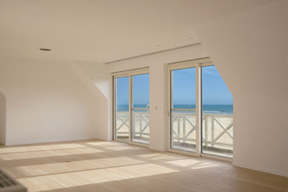
As fully concealed hardware with multipoint locking, “Roto Inline” boasts an attractive appearance. Depending on the locking and striker versions used, “Roto Inline” offers the possibility of creating a sliding system with Class RC 2 burglary resistance, even in the entry-level segment. Thanks to the “Roto Sil” surface finish, “Roto Inline” hardware is extremely scratch-resistant and features outstanding protection against corrosion, even in regions with high air humidity.

Photo: Roto Roto_Inline.jpg

The “Roto Patio Lift” Lift&Slide system succeeds in moving aluminium sashes with ease, even when they reach weights of up to 400 kg. And the possible sash heights and widths of up to 3000 mm mean that this hardware is also recommended for properties where exceptionally large building elements are intended to bring a lot of light into the living areas. Optional locking components make it possible for the system to be designed as a sliding system with night ventilation. In this version, Invisible from the outside when open, the slightly retracted sash ensures a permanent exchange of air.

Photo: Roto Roto_Patio_Lift_1.jpg

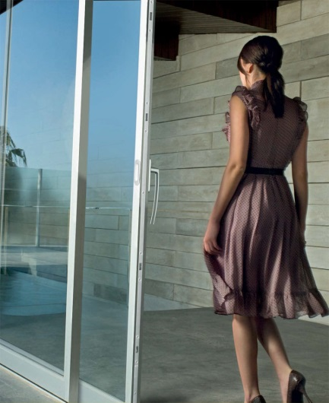
When an expansion kit is used, the “Roto Patio Lift” hardware product range is also suitable for particularly large sashes weighing up to 400 kg, such as triple-glazed sashes. The comfort espagnolette makes operating “Roto Patio Lift” sliding solutions particularly safe and convenient for end customers.

Photo: Roto Roto_Patio_Lift_2.jpg

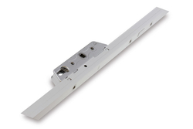
The espagnolette in the “Roto Patio Lift” is designed for mounting a profile cylinder as standard. As a result, it complies with various safety and security requirements.

Photo: Roto Roto_Patio_Lift_3.jpg

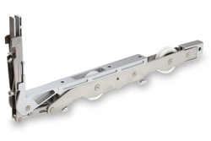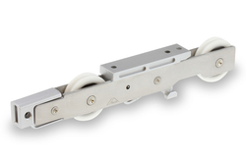
The high-quality roller technology used in the “Roto Patio Lift”, with rollers made of high-performance PVC and mounted on ball bearings, ensures that the sliding doors can be moved simply and quietly. The housing of the roller unit and espagnolette is made from resistant stainless steel and zinc die-cast.

Photos: Roto Roto_Patio_Lift_4.jpg Roto_Patio_Lift_5.jpg

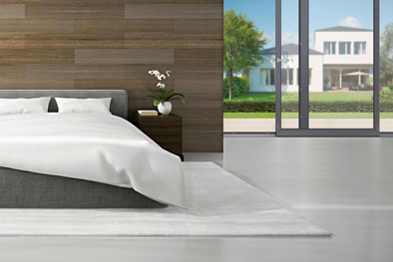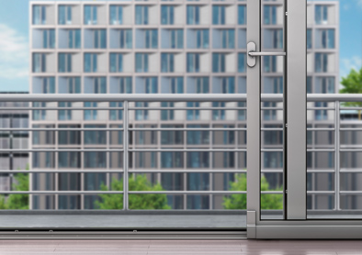
With the innovative “Roto Patio Alversa” hardware product range, both Tilt&Slide and Parallel Sliding systems with various ventilation functions can be produced. The “Roto Patio Alversa | PS Air Com” Parallel Sliding system offers particular operating convenience. Turning the handle tilts the sash automatically. There is no need to use force to pull the sash manually. This way, even large and heavy sliding doors with a weight of up to 200 kg can be operated and tilted effortlessly.

Photos: Roto Roto_Patio_Alversa_1.jpg Roto_Patio_Alversa_2.jpg

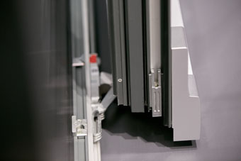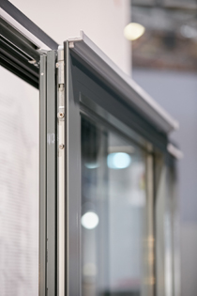
Depending on the variant chosen, “Roto Patio Alversa” helps create Parallel Sliding and Tilt&Slide systems with different opening versions and integrated night and tilt ventilation. The installation of Roto security components, such as security mushroom cams, security strikers and lockable handles, provides a particularly high level of burglary protection.

Photos: Roto Roto_Patio_Alversa_3.jpg Roto_Patio_Alversa_4.jpg

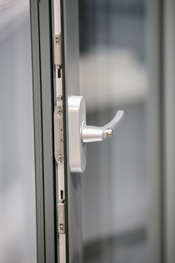
A Parallel Sliding and Tilt&Slide system with “Roto Patio Alversa” offers burglary protection up to resistance class RC 2 or RC 2 N when used in combination with proven security components from the “Roto AL” range.

Photo: Roto Roto_Patio_Alversa_5.jpg

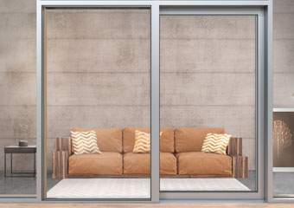
The “Roto Patio Inowa” hardware product range impresses with convenient and quiet operation and, above all, a tight seal. The entire technology remains invisible and the hardware is fully concealed. A “Roto Patio Inowa” sliding system can be equipped with Roto security components on request.

Photo: Roto Roto_Patio_Inowa_1.jpg

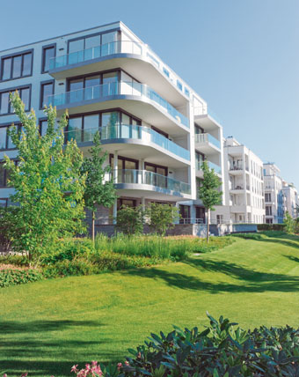
A balcony door’s high level of resistance against wind and driving rain, which is necessary in multi-storey buildings, can be reliably achieved with “Roto Patio Inowa”. The thermal insulation also benefits from use of the tightly sealed system. Thanks to the hardware’s closing movement perpendicular to the frame profile and a circumferential sealing profile, balcony doors equipped with this hardware are not only tightly sealed but can also be opened and closed particularly conveniently and with little force.

Photo: Roto Roto_Patio_Inowa_2.jpg

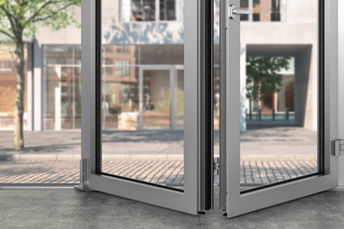
The “Roto Patio Fold” premium hardware can be used to open large aluminium Fold&Slide systems inwards and outwards elegantly and efficiently. The “Roto Eifel” threshold, which boasts optimised isothermal efficiency and is accessible in accordance with DIN 18040, ensures tight sealing and reliable protection against condensation and mould growth when closed. A Fold&Slide door equipped with “Roto Patio Fold” and “Roto Eifel” complies with the German Thermal Insulation Ordinance (Wärmeschutzverordnung) and is suitable for use in accessible buildings in accordance with DIN 18040.

Photo: Roto Roto_Patio_Fold.jpg

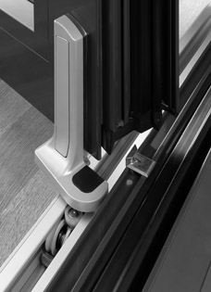
The roller units are guided with precision thanks to PVC rollers that are guided on the sides and mounted on ball bearings. This technology ensures that even tall and heavy Fold&Slide elements can be operated simply, quietly and conveniently for many years.

Photo: Roto Roto_Eifel_1.jpg

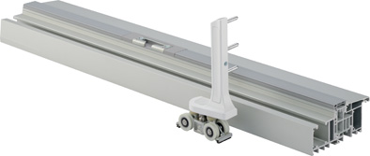
The “Roto Eifel” energy-efficient enhanced threshold for aluminium Fold&Slide doors enables accessibility in accordance with DIN 18040. The roller units of the up to seven foldable sashes are moved with precision thanks to PVC rollers that are guided on the sides and mounted on ball bearings.

Photo: Roto Roto_Eifel_2.jpg

Text and images are available to download:
http://ftt.roto-frank.com/en/press/

Print free. Copy requested.
Dr. Sälzer Pressedienst, Lensbachstraße 10, 52159 Roetgen, Germany

Publisher: Roto Frank AG • Wilhelm-Frank-Platz 1 • 70771 Leinfelden-Echterdingen • Germany Tel.: +49 711 7598-0 • Fax: +49 711 7598-253 • info@roto-frank.com
Editor: Dr. Sälzer Pressedienst • Lensbachstraße 10 • 52159 Roetgen • Germany Tel.: +49 2471 92128-65 • Fax: +49 2471 92128-67 • info@drsaelzer-pressedienst.de

