Press release

Date: September 11th, 2018

Concealed door hinge from Roto supports aluminium door leaves with a weight of up to 140 kg / New FixClick function enables the leaf to be hinged quickly and securely / Burglar inhibiting door equipment in accordance with RC 2 / Highest corrosion resistance in accordance with Class 5 of DIN EN 1670 / Centrally adjustable / Self-lubricating bush / Optional installation assistance set / Video guides viewers through each step of the installation process

Attractive and modern:
Main doors and apartment doors with “Roto Solid C” concealed door hinge

Leinfelden-Echterdingen – Many renowned door manufacturers put their faith in the screw-on hinges and butt hinges from the “Roto Solid” product range when it comes to producing a durable, reliable join between a leaf and door frame. Roto recently launched a concealed door hinge for aluminium doors – “Roto Solid C” – which is suitable for use in many conventional profiles. Customised solutions for other profiles based on the hinges from the standard product range are possible. The new door hinge is available in the colours silver and black. Thanks to a self-lubricating bush, “Roto Solid C” moves any aluminium door for many years without ever requiring maintenance.

Impressively powerful – reliable installation
“Roto Solid C” door hinges support aluminium door leaves with a weight of up to 140 kg and an opening angle of up to 110°. During installation, they audibly engage, helping to prevent installation errors. The concealed door hinge has proven its effortless durability even over 400,000 cycles. With this impressive functional life, the new “Roto Solid C” by far exceeds the standard. The surface of the “Roto Solid C” meets the highest demands for corrosion resistance in accordance with Class 5 of DIN EN 1670. More good news for builders: the concealed door hinge from Roto helps achieve burglar inhibiting door equipment in accordance with RC 2.

Door installation made easy
The new addition to the product range reveals its other strengths to fabricators during door installation. The FixClick function, developed in-house, enables the leaf to be hinged quickly and securely and permanently holds the door in the support-bracket. Installation of the leaf is also made simpler when the tools from the installation set are used, which can be ordered as an accessory: with the combination tool and locking wedges, installation is no trouble. The wedges fix the hinge supports in position, so that they do not move during hinging.

Centrally adjustable
Once the door leaf is hinged, the height is adjusted between -2 to +4 mm centrally and quickly only at the bottom-most hinge. Because all hinges are easy to access, it is possible to adjust the height and gasket compression (±1.2 mm) as well as perform lateral adjustment (±3 mm) at a later stage without any problems. The Roto combination tool can also be used to loosen the spring clip again, if the leaf needs to be unhinged again. The anti-jemmy device is also fitted conveniently with this tool after hinging. It is possible to order all components of the installation assistance set separately.

Installation video
The door hinge expert Roto also demonstrates online how installing the door and adjusting the “Roto Solid C” is particularly simple: an installation video guides the viewer through each step of the installation process in detail. Fitters can use a QR code for direct access to the installation video via smartphone. Roto recommends that you take a sales document with this QR code with you to the construction site.

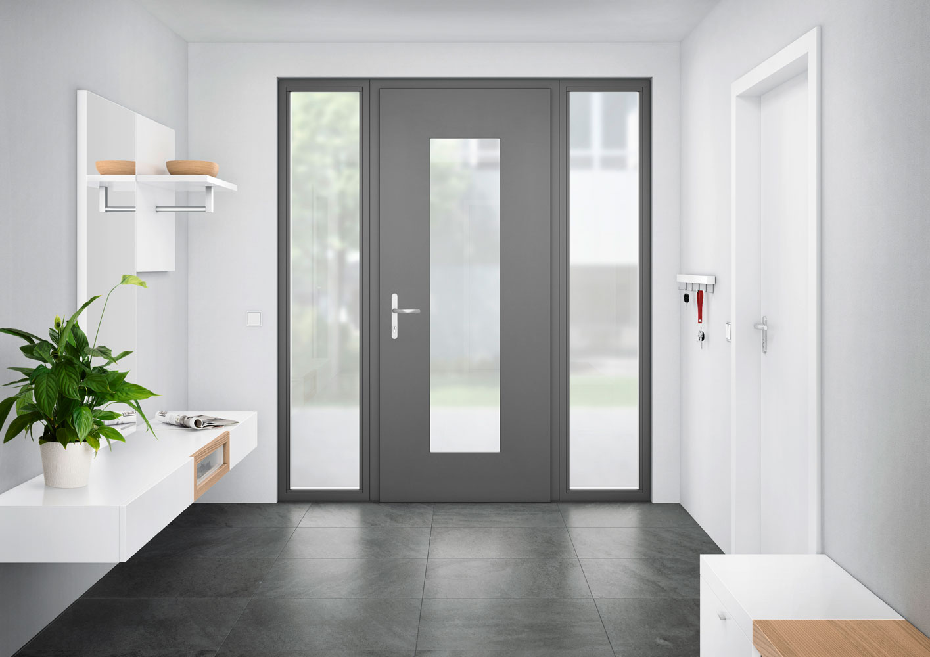

With the new “Roto Solid C” concealed door hinge for aluminium doors, manufacturers are creating a visually appealing, reliable and durable join between frame and leaf.

Photo: Roto Roto_Solid_C_Kampagnenmotiv.jpg

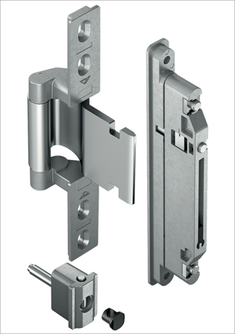
The “Roto Solid C” concealed door hinge with self-lubricating bush reduces the maintenance effort. The new FixClick function enables the leaf to be hinged quickly and securely and permanently holds the door in the support-bracket.

Photo: Roto Roto_Solid_C_Rahmen_und_Fluegelband.jpg

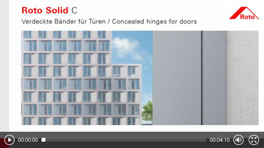
Step-by-step door installation and adjustment of the “Roto Solid C”: an installation video is available on Roto’s website.

Photo: Roto Roto_Solid_C_Screenshot_Montagevideo.jpg

Print free – copy requested

Publisher: Roto Frank AG • Wilhelm-Frank-Platz 1 • 70771 Leinfelden-Echterdingen • Germany Tel. +49 711 7598 0 • Fax +49 711 7598 253 • info@roto-frank.com
Editor: Dr. Sälzer Pressedienst • Lensbachstraße 10 • 52159 Roetgen • Tel.: +49 2471 92128-65 • Fax: +49 2471 92128-67 • info@drsaelzer-pressedienst.de

