Press release

Date: 13th December 2017

“Roto AL” preassembled hinge side for aluminium windows and balcony doors up to 130 kg / Hardware set from the “Roto AL” system for Tilt&Turn, TiltFirst and Turn-Only windows and balcony doors made of aluminium / “Roto AL” preassembled hinge side in the DIN left and DIN right versions saves time during installation

Faster production with the “Roto AL” preassembled hinge side

Leinfelden-Echterdingen – The “Roto AL” hardware system provides metalworkers with a preassembled hinge side for DIN R and DIN L sashes for Tilt&Turn, TiltFirst and Turn-Only windows and balcony doors made of aluminium up to 130 kg. “The standard assembly of individual parts on a hinge side, consisting of pivot rests, corner hinges, the sash stay, the stay bearing and various components on the central locking system, is no longer required for metalworkers if it is clear before ordering whether a sash will be installed on the right or left,” explains Matthias Nagat, Head of Product Adaptation / Aluvision Range Marketing. “This saves time in production and increases process reliability when manufacturing window elements.”

In addition to saving on production time and increasing process reliability, the preassembled hinge side impresses when it comes to durability with an additional decisive advantage thanks to improved access for adjusting the window sash: the height adjustment for the new hinge side can be conveniently accessed directly via the hinge roller both when the sash is in the tilted and open position. This optimised access means that the time-consuming process of undoing screws on the clampable corner bracket for the conventional hinge-side version is no longer required. As a result, the sash can now remain under load while the height is adjusted. In short, the preassembled hinge side offers increased comfort and security during window installation and adjustment.

Simplified installation with clampable corner drive and combination tilt striker
The “Roto AL” clampable corner drive, which can be used universally for all standard and security windows up to RC 3, is another feature which simplifies production. It is secured without the need for tools using an insertable clamping fork. At the same time, striker “A” is no longer required. This also speeds up processing and results in an additional reduction in production costs.

Furthermore, just one component is now required, which acts as a tilt striker, anti-jemmy device and striker at the same time. Until now, three components were required for this with the conventional hinge-side version. This combination tilt striker therefore also makes a significant, quantifiable contribution towards the more efficient and reliable production of window elements.

Required torques are achieved effortlessly
The screwdriving tools for the preassembled unit consisting of hinge side, sash stay, pivot rests and central locking system have been changed to a hexalobular socket screwdriver 10 and a hexalobular socket screwdriver 25. Fabricators of “Roto AL” benefit because this allows the required torques to be reached reliably and effortlessly in equal measure. Installation is more reliable, takes less time and requires less effort. As a result, window manufacturers benefit from low production costs and consistently high-quality workmanship. The preassembled hinge side from the “Roto AL” system is available in silver, Traffic white and in special colours.

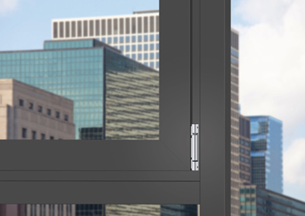
Flexible and reliable production with universal hardware for aluminium windows and balcony doors: as part of the “Roto AL” system, Roto also offers a preassembled hinge side for DIN R and DIN L Tilt&Turn, TiltFirst and Turn-Only windows and balcony doors up to 130 kg. The assembly of the hinge side with the pivot rests, corner hinges, sash stay, stay bearing and central locking system is no longer required. This saves time in production and increases process reliability when manufacturing window elements.

Photo: Roto

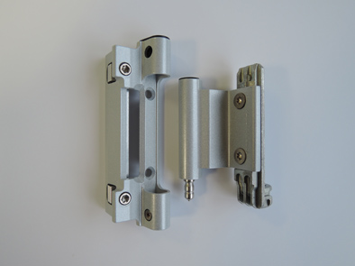
In addition to saving on production time and increasing process reliability, the “Roto AL” preassembled hinge side impresses when it comes to durability with an additional decisive advantage thanks to improved access for adjusting the window sash: the height adjustment for the new hinge side can be conveniently accessed directly via the hinge roller both when the sash is in the tilted and open position.

Photo: Roto
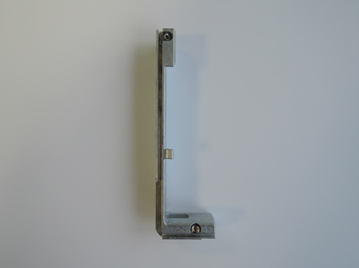
Results in quantifiable added value during production: the new combination tilt striker for the “Roto AL” preassembled hinge side acts as a tilt striker, anti-jemmy device and striker. Until now, three components were required for this with the conventional hinge-side version.

Photo: Roto

Text and images are available to download:
http://ftt.roto-frank.com/en/press/

Print free. Copy requested.
Dr. Sälzer Pressedienst, Lensbachstraße 10, 52159 Roetgen, Germany

Publisher: Roto Frank AG • Wilhelm-Frank-Platz 1 • 70771 Leinfelden-Echterdingen Germany • Tel.: +49 (0) 711 7598-0 • Fax: +49 (0) 711 7598-253 • info@roto-frank.com
Editor: Dr. Sälzer Pressedienst • Lensbachstraße 10 • 52159 Roetgen • Germany Tel.: +49 (0) 2471 92128-65 • Fax: +49 (0) 2471 92128-67 • info@drsaelzer-pressedienst.de

