Press release

Date: 10th October 2019

Packaged according to requirements: hardware components from the “Roto AL” and “Roto AL Designo” product ranges / Customised packaging for streamlined production logistics / Informative labels for efficient incoming goods inspections / Hardware components with the system manufacturer’s logo on request / Roto after sales service is always ensured

Roto Aluvision increases efficiency in the production of aluminium windows: customised packaging for efficient internal logistics

Leinfelden-Echterdingen – The just-in-time availability of components, even in small quantities, and the space-saving provision of these components at the assembly bench are instrumental in the economical production of windows and doors. This is why Roto Aluvision has developed packaging for the “Roto AL” and “Roto AL Designo” product ranges that can be individually customised to the fabricator’s hardware requirements in coordination with renowned system suppliers. Aluminium window manufacturers who require specific packaging concepts to optimise manufacturing processes and production logistics can consult with their system supplier and Roto for this purpose.

Packaged according to requirements
Roto designs special film packaging and cardboard boxes, as well as the associated parts lists, individually based on requirements so that, for example, all components for a window or project by the window manufacturer can be dispatched together in the same bundle. Roto Aluvision keeps a modular system with various packaging units available for this purpose.

Everything for a window – everything for a project
Deliveries to a manufacturer can be based on one-pack basic cartons, for example. These contain all hardware components for the standard configuration of a window and can be made up for windows of any opening type.

Roto offers ten-pack packaging units as an alternative. These contain ten of the same type of components, such as the hinge side, locking, sash stay or espagnolette in ten film packages. The film packages are labelled in the same way as the cardboard box, so that it is always possible to allocate film bags that have been removed. At the request of a customer, Roto also produces five-pack packaging units, for example, based on the same principle.

Industrial packaging contains a larger number of identical components. It is often used when the hardware components for sash and frame installation are to be delivered separately. Industrial packaging contains 50 or 100 units, depending on the weight of the component.

“With these varied packaging options, Roto Aluvision is helping window manufacturers who want to provide the exact quantity of a component that is required at each workstation for an order or for a single day, for example,” explains Matthias Nagat, Head of Roto Aluvision Range Marketing and Product Adaptation. “To save not only space but also time, we ensure that the hardware components can be removed from the packaging designed for them in a space-saving, safe way.”

Barcode for the exchange of information
A barcode based on the specifications of the system manufacturer can also be printed on the label of customer-specific packaging. This barcode provides information about the type and number of components included in the packaging. This barcode corresponds to the data structure of the ERP system at the system owner. The same barcode can, on request, also be added to all film packaging included in the cardboard box. This way, it is possible to establish what this packaging contains and the master data of the component included at all times, even when the component has been removed from the packaging and without the need for the cardboard box. The window manufacturer stores their hardware without any loss of information and has an accurate overview of their stock at all times.

Pictographs for fast incoming goods inspections
On request, Roto Aluvision also produces labels on which pictographs of each hardware component contained in a set are printed. This simplifies incoming goods inspections and quality checks at the profile system manufacturer and the aluminium window manufacturer. The catalogue item number of the system manufacturer is also printed to make it easier for the window producer to allocate the hardware delivery.

With the system supplier’s logo
The system supplier’s logo can, on request, be added to all labels and the documents that accompany the packaging. This way, Roto strengthens the branding right up to the processing location. The logo can, on request, also be added to hardware components such as tilt lock bolts, corner drives, strikers or geared-handles and other handle types.

“This service is particularly important to some of our customers,” reports Stefano Gianfreda, Head of Customers and Markets in Europe. This is not a problem for Roto as, thanks to the digital archiving of product and transport data, the origin of Roto hardware can be traced at any time, even if only the system supplier’s logo is visible in a prominent location. “The after sales service is provided without any restrictions for installed Roto hardware sets.” Gianfreda guarantees that “needless to say, this applies for 10 or 20 years.”

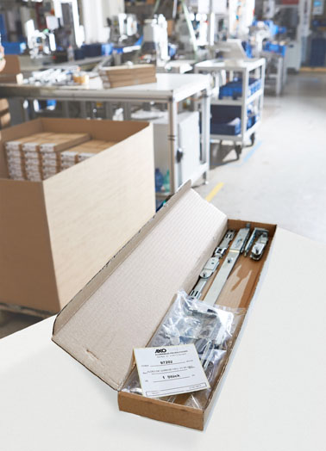
This one-pack basic carton for Akotherm GmbH contains a complete Roto “AL Designo” Tilt&Turn hardware set.

Photo: Roto Roto_customized_packaging_1.jpg

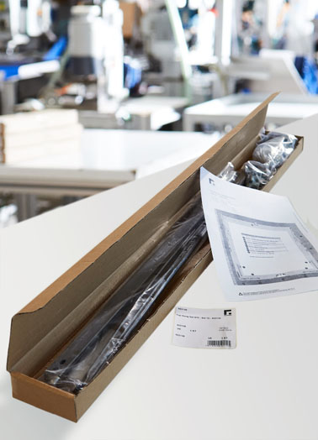
This one-pack basic carton for Gutmann Bausysteme GmbH combines all components for an “FS Kempton” Top-Hung window including an illustrated parts list.

Photo: Roto Roto_customized_packaging_2.jpg

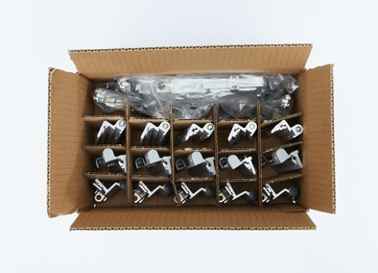
A packaging unit filled with five hinge locking sides and five Tilt&Turn locking sides from the “Roto AL” product range for a Tilt&Turn window according to the requirements of Raico Bautechnik GmbH

Photo: Roto Roto_customized_packaging_3.jpg

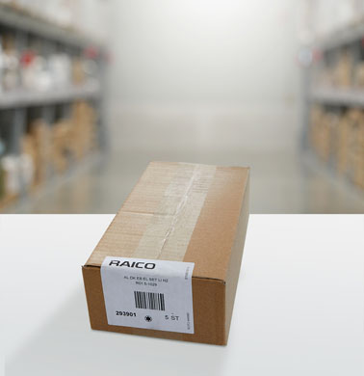
This customer-specific label on five-pack packaging is printed with the system supplier’s logo, its customer item number, a barcode and the date of production in the Roto factory.

Photo: Roto Roto_customized_packaging_4.jpg

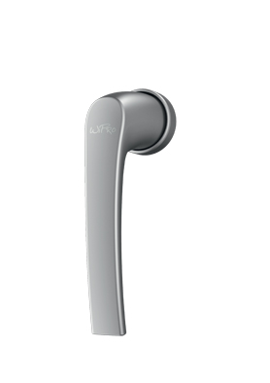
Wipro System GmbH & Co. KG obtains handles with its own logo from Roto.

Photo: Roto Roto_customized_packaging_5.jpg
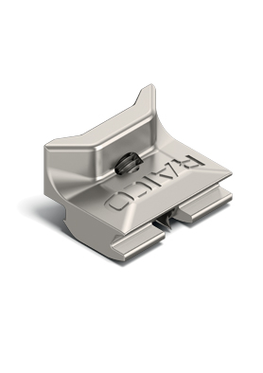
All “Roto AL” strikers delivered to customers of Raico Bautechnik GmbH already bear the system supplier’s logo, which is engraved by Roto.

Photo: Roto Roto_customized_packaging_6.jpg

Text and images are available to download:
http://ftt.roto-frank.com/en/press/

Print free. Copy requested.
Dr. Sälzer Pressedienst, Lensbachstraße 10, 52159 Roetgen, Germany

Publisher: Roto Frank Fenster- und Türtechnologie GmbH • Wilhelm-Frank-Platz 1 • 70771 Leinfelden-Echterdingen • Germany • Tel.: +49 711 7598-0 • Fax: +49 711 7598-253 • info@roto-frank.com
Editor: Dr. Sälzer Pressedienst • Lensbachstraße 10 • 52159 Roetgen • Germany • Tel.: +49 2471 92128-65 • Fax: +49 2471 92128-67 • info@drsaelzer-pressedienst.de

