Press release

Date: 11th September 2019

Impressive solution: new hinge side based on the “Roto AL” modular hardware system for aluminium Turn-Only and Tilt&Turn windows with profile view that is flush with the surface / Special hinge geometry for window profiles with integrated offset edge in the frame / Compatible with the “Roto AL 300” economical modular hardware system / Ready for a new design trend from South America

Extended range of applications for “Roto AL 300”:
New hinge side for aluminium windows that are flush with the surface up to 80 kg

Leinfelden-Echterdingen – In Southern Europe and South America in particular, manufacturers of aluminium profiles are reporting the return of window designs where the sash is resting on a frame with integrated offset edge. Roto has prepared itself for this design trend, explains Matthias Nagat, Head of Roto Aluvision Range Marketing and Product Adaptation. When the window sash is closed, these window designs stand out because the sash looks like it is resting flush on the surface of the frame. The challenge for the hardware manufacturer is that the profile design calls for a special hinge geometry so that the sash can overcome the offset edge in the frame.

Special hinge geometry
Roto Aluvision developed a solution with the required geometry based on the proven “Roto AL 300” surface-mounted hinge side. The new hinge side created in this way can be installed on the left- and right-hand side and once again drastically expands the application range of the “Roto AL 300” modular hardware system. Roto Aluvision specialists provide prospective customers with advice relating to both the design and the product.

Demand is growing
“In Argentina, it has already reached the stage where interest in the Tilt&Turn opening type has measurably grown since Roto started offering an impressive hinge side for profile systems with integrated offset edge,” reports Nagat. Roto expects the profile design with the view that is flush with the surface to soon become more established in other markets, too. Establishing a link with “Roto AL 300” at an early stage through the new hinge side was therefore a crucial step so that users of a profile view that is flush with the surface could also have access to this particularly economical hardware.

“What this hardware represents is Roto quality for affordable aluminium windows with a good design,” explains Nagat. “This is because, thanks to preassembled, clampable components, ‘Roto AL 300’ reduces the installation effort and installation time, regardless of which hinge side and which profile system the manufacturer uses.” It is used up to a sash weight of 80 kg in Tilt&Turn and Turn-Only windows, with the latter requiring the use of an adjustable rebate sash stay.

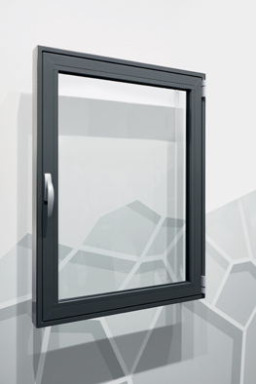
Overall view of a window design with “Roto AL 300” for profile systems with integrated offset edge

Photo: Roto Roto_AL_300_1.jpg

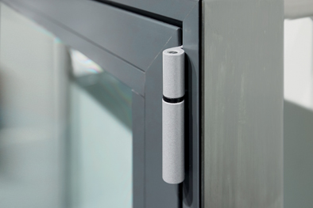
“Roto AL 300” stay hinge and stay bearing for profile systems with integrated offset edge

Photo: Roto Roto_AL_300_2.jpg

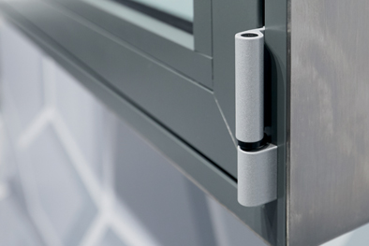
“Roto AL 300” pivot rest and corner hinge for profile systems with integrated offset edge

Photo: Roto Roto_AL_300_3.jpg

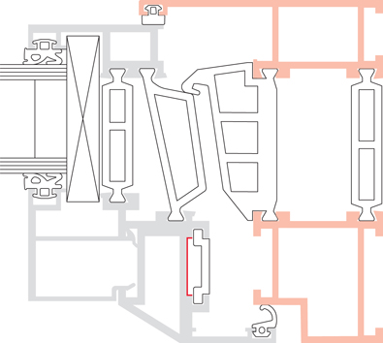

Sectional drawing of a profile system with integrated offset edge

Drawing: Roto Roto_AL_300_4.jpg

Text and images are available to download:
http://ftt.roto-frank.com/en/press/

Print free. Copy requested.
Dr. Sälzer Pressedienst, Lensbachstraße 10, 52159 Roetgen, Germany

Publisher: Roto Frank Fenster- und Türtechnologie GmbH • Wilhelm-Frank-Platz 1 • 70771 Leinfelden-Echterdingen • Germany • Tel.: +49 711 7598-0 • Fax: +49 711 7598-253 • info@roto-frank.com
Editor: Dr. Sälzer Pressedienst • Lensbachstraße 10 • 52159 Roetgen • Germany • Tel.: +49 2471 92128-65 • Fax: +49 2471 92128-67 • info@drsaelzer-pressedienst.de

